AWS CONCEPTS AND   
SETUPS 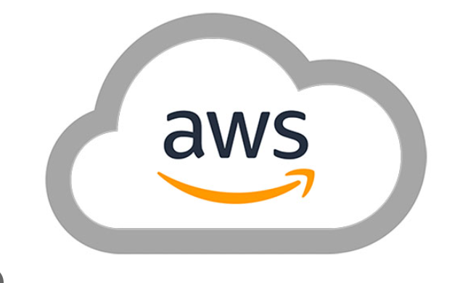

Table of Contents

1. AWS ELB 6

What is AWS ELB? 6

**Types of Load Balancer in AWS** 6

a. Classic Load Balancers 6

b. Application Load Balancers 7

Benefits of Application Load balancers- 8

c. Network Load Balancers 8

Benefits of Network Load Balancers- 9

Conclusion 9

2. AWS ELB setup 10

Application Load Balancer setup: 10

Steps: 11

Step1: Create Two instances: Orders & Payments 11

Step2: Target Group creation 11

Step3: Load Balancer Creation 13

3. AWS Scaling-group setup 18

Working: 18

Launch Templates: 18

Steps: 19

Step1: Create Image of an instance 19

Step2: Create Autoscaling group using Launch template 20

4. AWS EKS Setup 25

• Setup kubectl 25

• Setup eksctl 25

• Create an IAM Role and attache it to EC2 instance 26

• Create your cluster and nodes 26

• To delete the EKS clsuter 26

• Validate your cluster using by creating by checking nodes and by creating a pod 27

5. AWS ROUTE53 DNS Records 27

1- SOA (Start of Authority Records) 27

2- NS Record (Name Server Records) 28

1- A Record ( URL to IPv4) 29

2- CNAME (Canonical Records- URL to URL) 29

3- Alias Record: 30

4- AAAA: (URL to IPv6) 31

5- MX Record (Main Exchange Record) 31

6. Routing Policy 32

1- Simple Routing Policy: 32

2- Weighted Routing Policy 33

3- Latency Routing Policy 35

4- Failover Routing Policy 36

5- Geo Location Routing Policy 38

6- Multi Value Routing Policy 39

7. Amazon Elastic Disaster Recovery 40

Definition: 40

Recovery-why? 40

Process: 41

Architecture: 41

How it works? 42

EDR Dashboard: 42

Steps: 43

Step1: Settings 43

Step2: IAM Role setup 43

Step3: Install Agent 43

Step4: Recovery Job 44

Step5: Failback 45

8. VPC 46

Architecture: 46

Process: 46

Steps: 46

Step1: Create VPC 46

Step2: Create Internet Gateway and attach it to VPC 47

Step3: Create Subnets in Different Availability Zones 47

Step4: Create and Assign public route table to public subnet 1 & 2 49

Step5: Create Two Private Route tables and attach it to 4 subnets 53

Step6: Create two Elastic IP’s 54

Step7: Create NAT Gateway 55

9. AWS 3-Tier Architecture with VPC, RDS, ELB: 56

Steps required for the 3-tier Setup 57

Steps: 57

Step1: Create VPC 57

Step2: Create Subnets 58

Step3: Setting up the Internet Gateway 59

Step4: Create Route Table & Subnet Associations 60

Step4.1: Create Two Private Route tables and attach it to 4 subnets 64

Step5: Create the Elastic IP’s 65

Step5.1: Create NAT Gateway 66

Step6: Launch Template 67

Step7: Create Database 70

Step8: Enable connection between the 3 Tiers 74

10. AWS CloudWatch Setup 75

Four Pillars: 75

How CloudWatch Works? 76

Implementation of Four Pillars: 77

CloudWatch Alarms: 78

Design- Autoscaling with CloudWatch Alarms: 80

Create Alarm with SNS notification for CPU utilization: 80

Steps: 80

Create Alarm with Autoscaling Group for CPU Utilization 83

Steps: 83

Step1: Update Dynamic scaling policy in Auto-scaling group 83

Step2: Create CloudWatch Alarm 84

11. Amazon Elastic Container Service(ECS creation) 88

Steps: 88

12. AWS DEVOPS 92

Code Commit: 92

Steps: 92

Step1: Create a New Repository 92

Step2: Create a new user 92

Step3: Clone repository 94

Step4: Push to CodeCommit Repository 95

Code Build : 97

Steps: 97

Step1: Create Code Build Project 97

Code Deploy 101

Steps: 102

Step1: Create IAM Role & Ec2 instances 102

Step2: Code Deploy Application 103

Step3: Code Deploy: Deployment group creation 103

Code Pipeline 105

Steps: 105

Step1: Create Code Pipeline 105

Step2: Source Stage 106

Step3: Build Stage 106

Step4: Deploy Stage 107

# AWS ELB

## What is AWS ELB?

**AWS ELB (Amazon Elastic Load Balance)** helps to distribute the application traffic to various different targets such as EC2 instances. The vacant targets which are ready to collect the traffic are monitored by Amazon ELB whether they are healthy or not and the traffic is sent to the healthy one.

AWS ELB comes in three versions which perform different tasks.

* The Version 1 provides detailed instructions for using Classic Load Balancers.
* 2nd version provides detailed instructions for using Application Load Balancers.
* 3rd provides detailed instructions for using Network Load Balancers.

## **Types of Load Balancer in AWS**

These are the unique Versions of AWS ELB, let’s discuss them one by one:

## a. Classic Load Balancers

Classic Load Balancers distribute upcoming traffic to different EC2 instances in multiple Availability Zones. During this process, there is a chance of the fault tolerance of your application. These Load Balancers detect healthy and unhealthy instance and direct the traffic towards only healthy ones.

It also helps in a way such that without disrupting the flow of requests to your application you can add or remove instances from your load balancers as your need changes.

AWS ELB can calculate the majority of workloads automatically. Protocol and port which a person configures are used to detect the connection requests from clients it also forwards requests to one or more registered instances.

The number of instances can be modified. Health checks can be monitored so that the load balancer only sends requests to the healthy instances.

[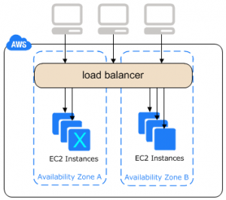](https://data-flair.training/blogs/wp-content/uploads/sites/2/2018/07/Classic-Load-balancers.png)

*Learn AWS ELB – Classic Load Balancers*

**Benefits of Load Balancers-**

* Provides Support to TCP and SSL listeners.
* Support to Sticky Session.
* Support to EC2- Classic.

## b. Application Load Balancers

After receiving the request Application Load Balancer analyzes the rules provide by the listener in priority order and determines the rule which has to apply. After that, it selects a target from the target group for the rule action.

An Application Load Balancer functions at the Open Systems Interconnection (OSI) model which is the **seventh layer of the OSI model.**

The User can analyze the rules of the listener and can modify it by sending it to different target groups based on the content of the application traffic even when the target is associated with multiple target groups.

Addition and removal of tags can do from the load balancers as per your needs. This can done without breaking the flow of your requests of the application.

[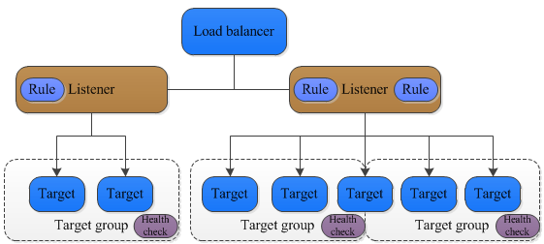](https://data-flair.training/blogs/wp-content/uploads/sites/2/2018/07/APplication-Load-Balancer.png)

*AWS ELB – Application Load Balancers*

### **Benefits of Application Load balancers-**

* Load Balancer’s performance improve in Application Load Balancer.
* Access logs containing information compress such that they may not require the additional space.
* Provides benefit for registering targets by IP address, including targets outside the VPC for the load balancer.

## c. Network Load Balancers

It is the **fourth layer of the Open System Interconnection Model.** After the load balancer receives a connection request, it selects a target from the group which targets for the default rule.

After enabling the availability zone Elastic Load Balancer creates the load balancer node in the availability zone. Each load balancer node automatically distributes traffic across the registered targets in its Availability Zone only.

Cross-zone Load Balancing enables to distribute traffic across the registered targets in all enabled Availability Zones.

Enabling Multiple Availability Zone can cause harm by increasing the fault tolerance of the applications and it will happen if each target group has at least one target in each enabled Availability Zone.

The problem can overcome in such a way that if one or more target groups do not have a healthy target in an Availability Zone, the IP address for the corresponding subnet from DNS is removed. If a person attempts again the request fails.

[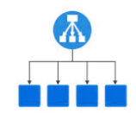](https://data-flair.training/blogs/wp-content/uploads/sites/2/2018/07/network-load-balancer.png)

*AWS ELB – NLB*

### **Benefits of Network Load Balancers-**

* NLB Provides the Support for static IP addresses for the load balancer.
* Provides support for registering targets by IP address which includes target outside the VPC for the Load Balancer.
* Provides support for monitoring the health of each service independently.

So, this was all about AWS ELB Tutorial. Hope you like our explanation.

## Conclusion

Hence, in AWS ELB tutorial, we studied the load balancer distributes traffic evenly across the Availability Zones that you enable for your load balancer. AWS Elastic Load Balance is one of the effective ways to manage and deploy the application as it is fast, reliable, and efficient.

Load Balancer simplifies and improves the security of your application and hence provides security which makes it a reliable function. Furthermore, if you have any doubt regarding AWS ELB, feel free to ask in the comment box.

# AWS ELB setup

## Application Load Balancer setup:

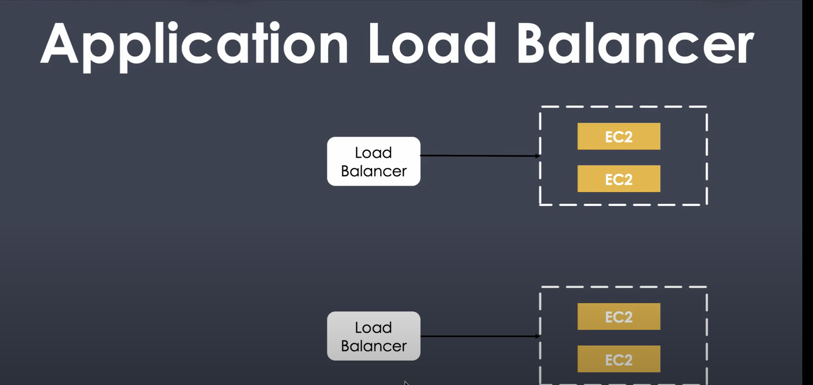

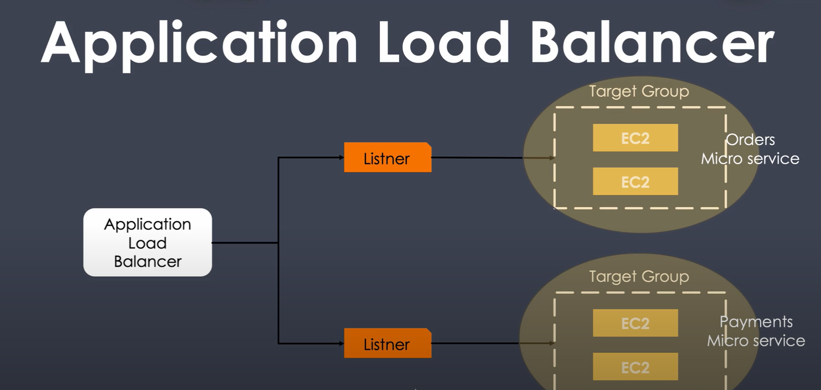

### 

Listener make routing decisions like when to route traffic to orders and when to route traffic to Payments.

Routing decisions are made based on the path or port (rules)

## Steps:

### Step1: Create Two instances: Orders & Payments

* Create an Ec2 instance with Linux image.
* Durind the instance creation, use the below code in the User instructions to create an html file in Advanced Settings🡪 User data for Orders.

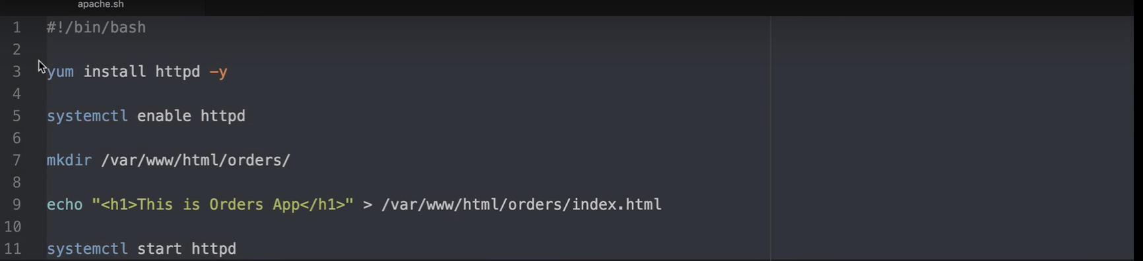

* Launch instance
* Similarly, launch instance for Payments application by giving the user data as shown below.

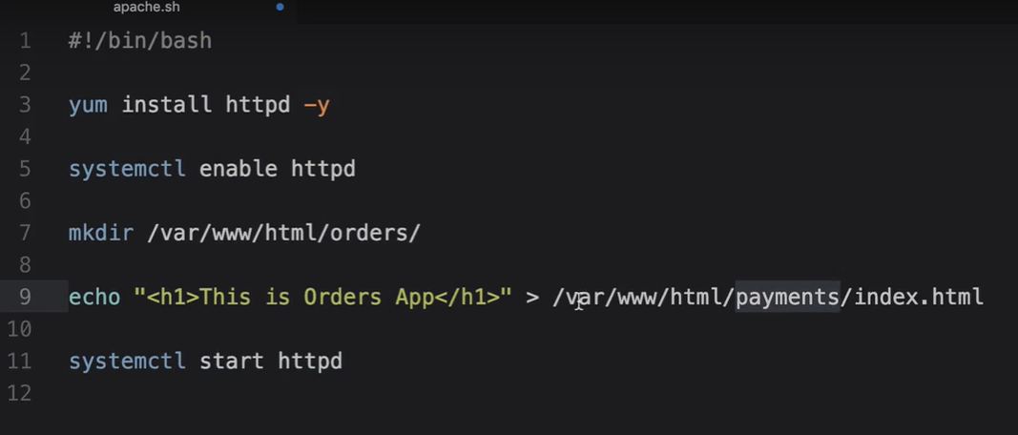

### Step2: Target Group creation

* Choose Load Balancing🡪 Target groups from AWS console Left Pane and **Create**
* Enter Details like Target group name as required, Target Type as **Instance**, Protocol as **HTTP,** port as **80,** VPC as required.
* Under Health check settings, update path as **“/orders/index.html**” path of the application and click **Create**

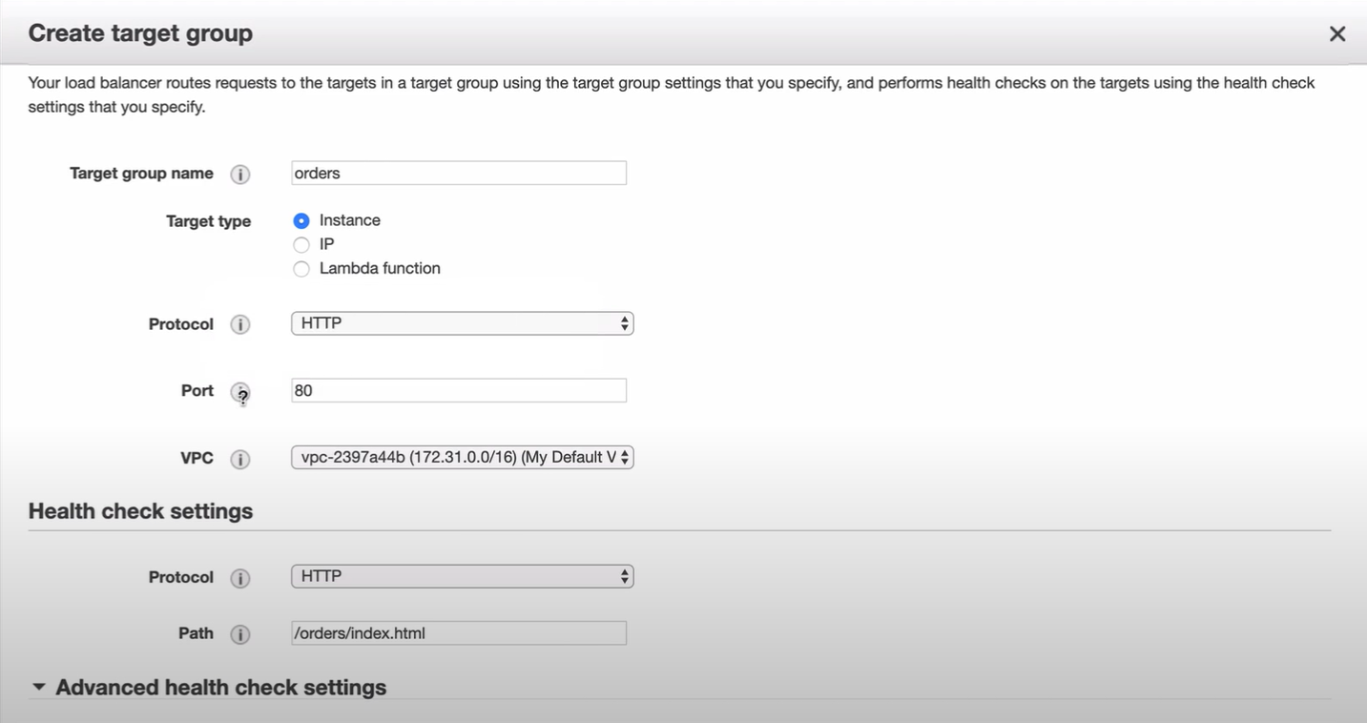

* Create another Target group for Payments Micro-service and update the Path as **“/payments/index.html”**
* Once the Target groups are created, associate the Targets for the Target group.

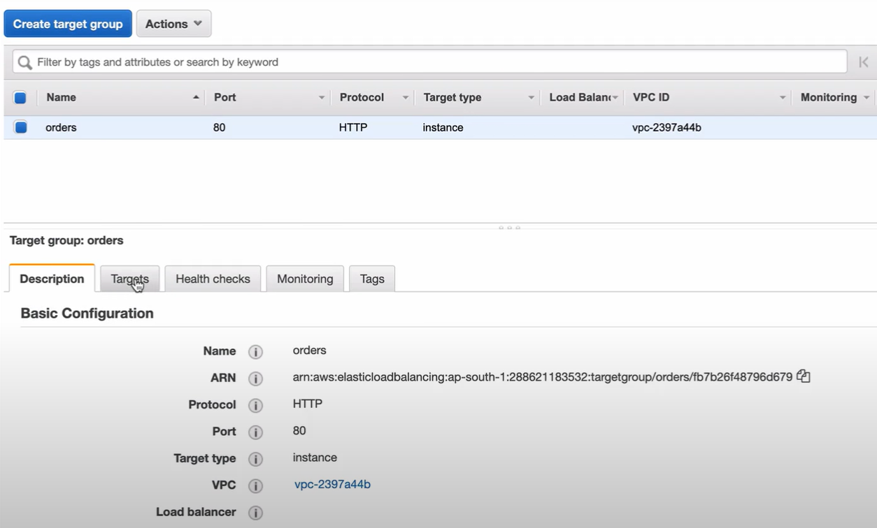

* Click **Edit** & register the instances as Target in the Target group & Save

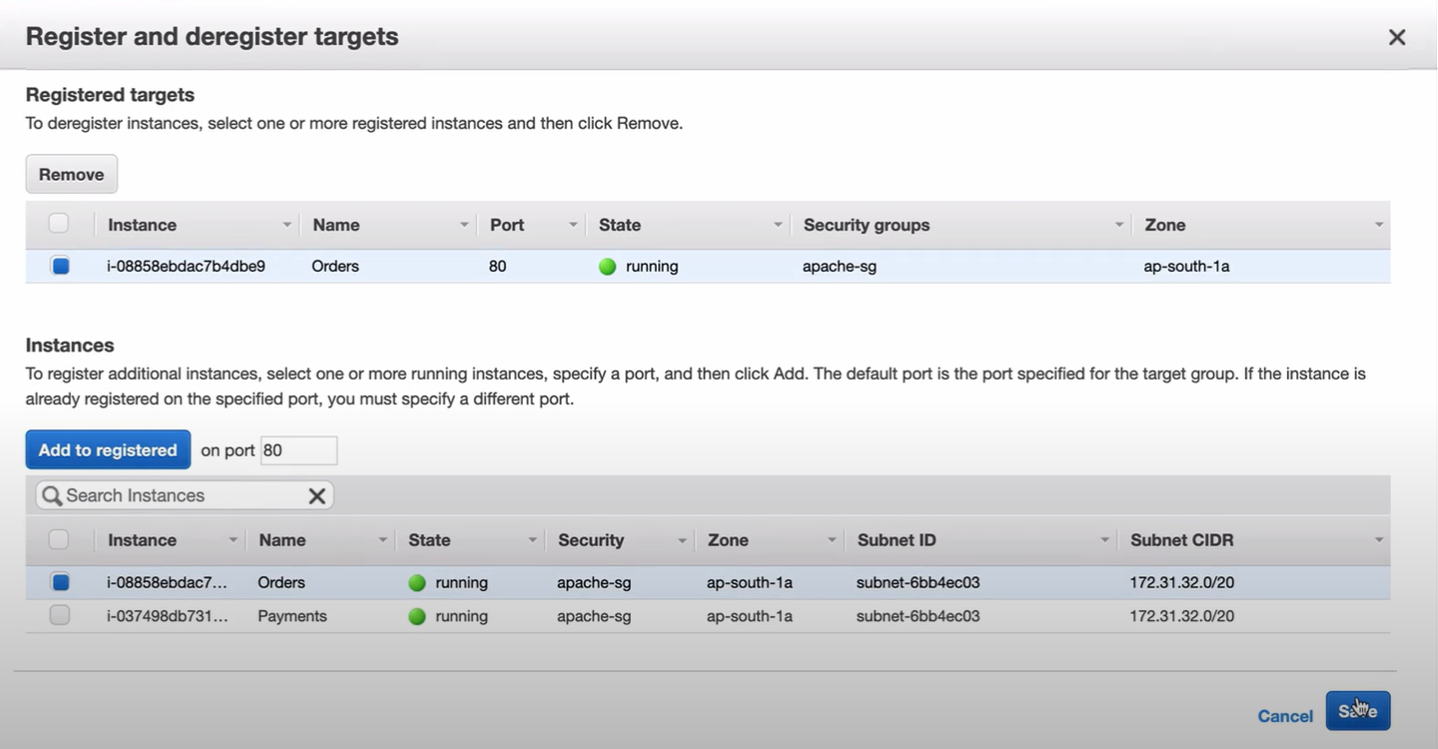

* Similarly, register the “Payments” instance as Target for “Payment” Target group
* You can check the status of Target groups

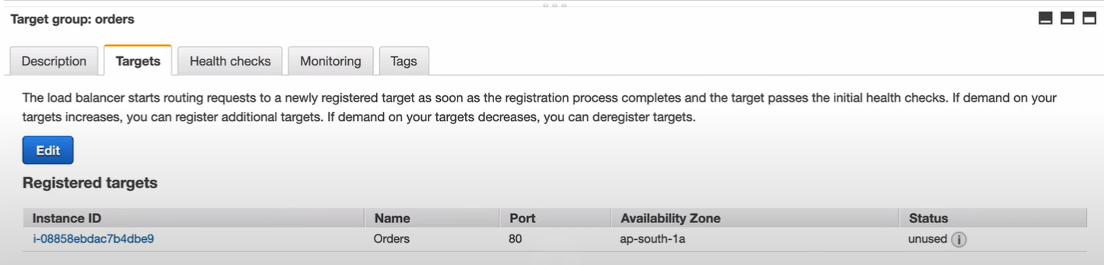

### Step3: Load Balancer Creation

* Select Load Balancing🡪 Load Balancer from AWS Console LP & **Create Load Balancer**

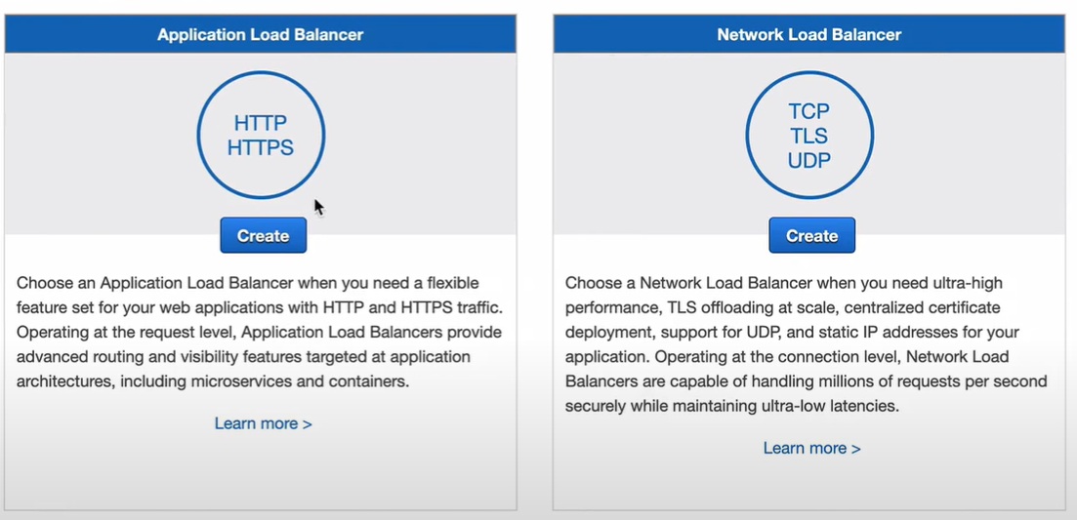

* In **Configure Load Balancer**, Enter as Required, Scheme as **Internet-facing,** IP address type as IPv4, Select default VPC from Availability zones and select the availability zones as required.

Note: The instances must reside on one of the availability zones listed.

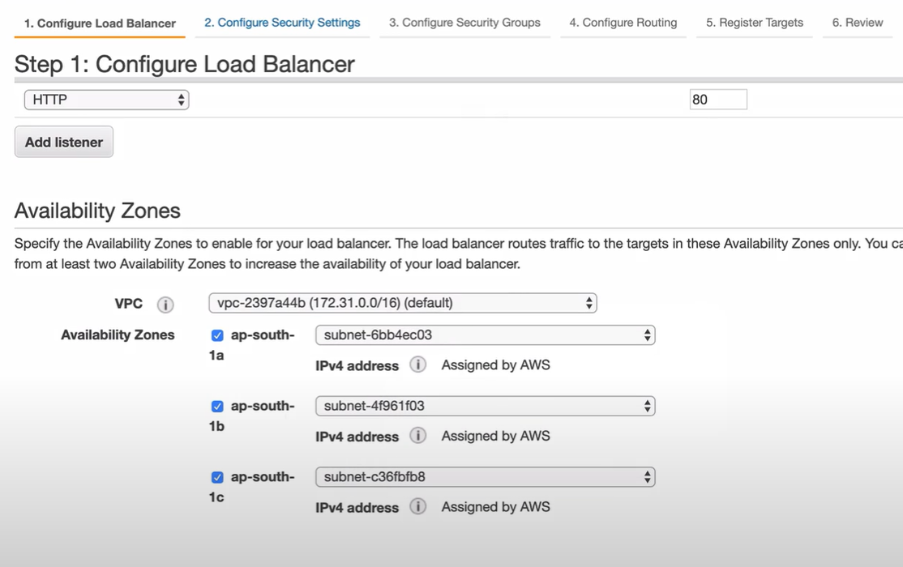

* **Configure Security group** as required

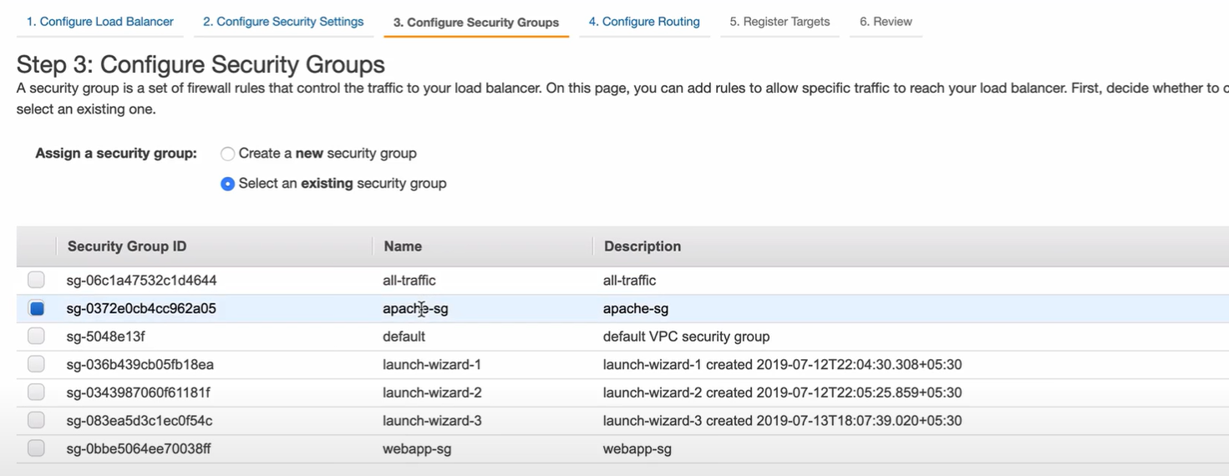

* **Configure Routing**, Select the Target group created for **Orders.**

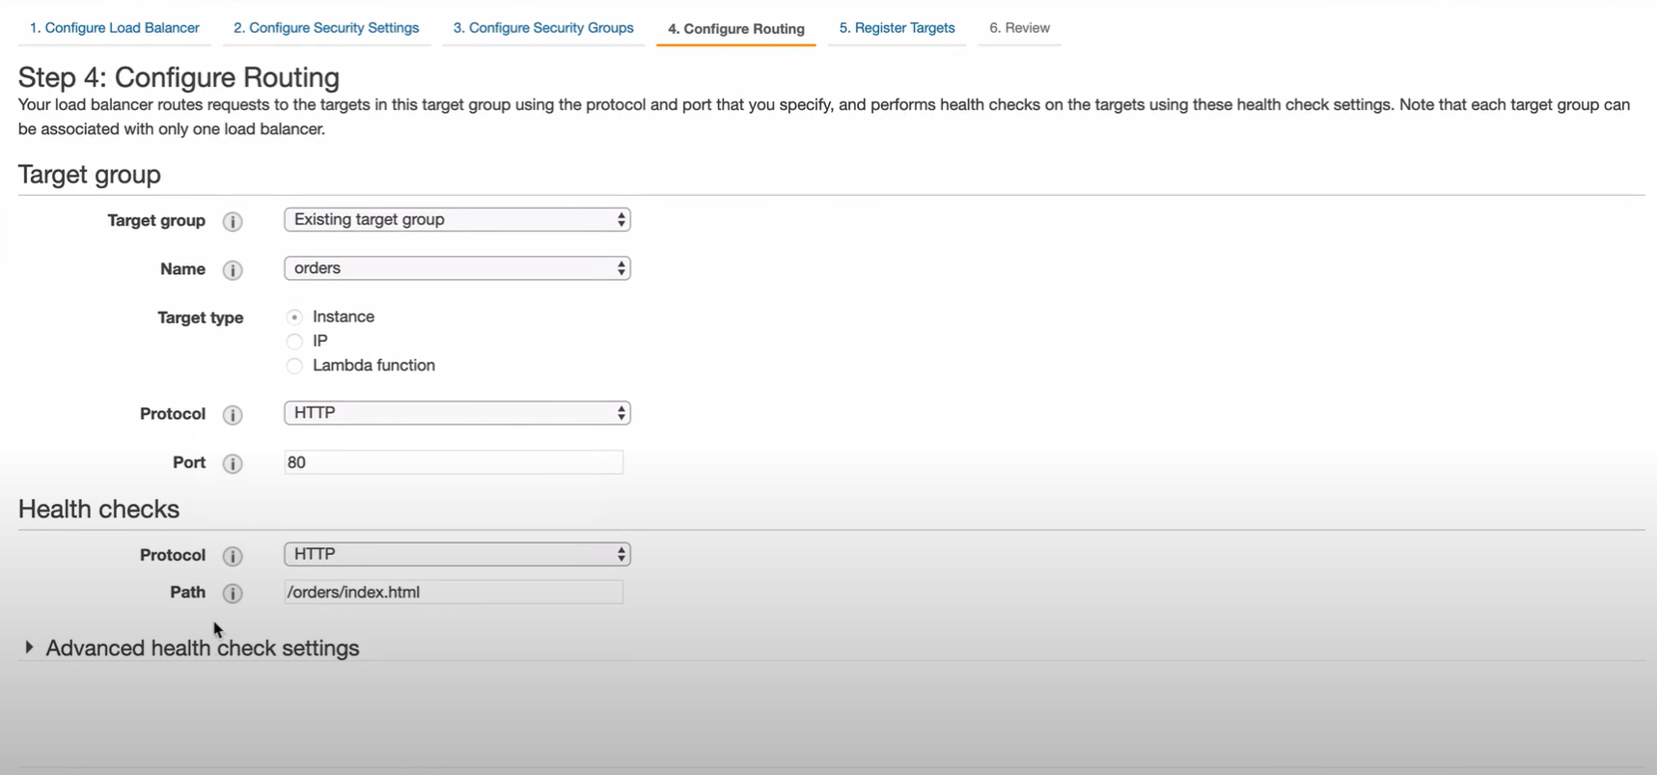

* **Register Targets**

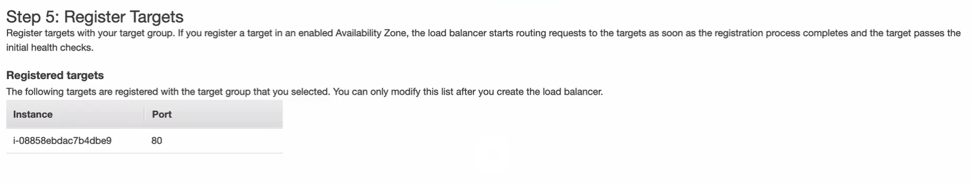

* **Review & Create**

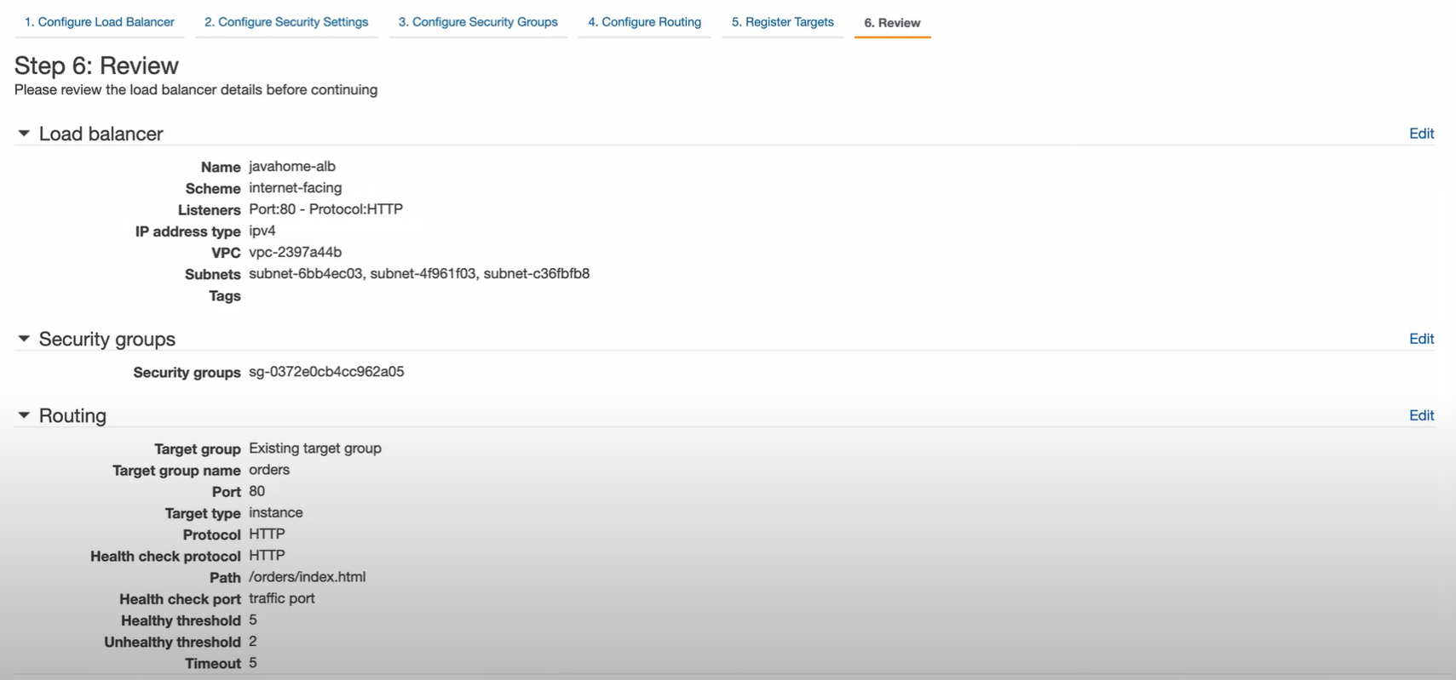

* Go to **Listeners**, it will have a default Listener and Rule

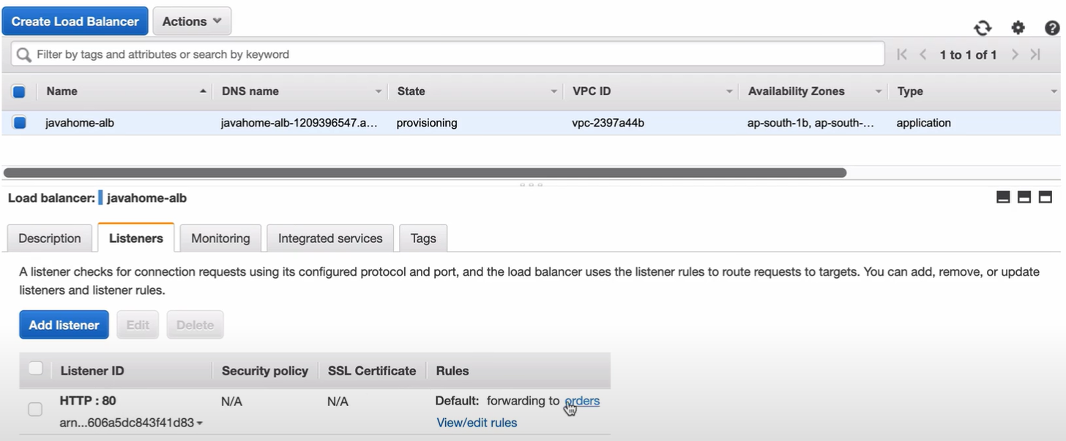

* Edit the rule to forward to Target group- Orders if path is **/orders/\***

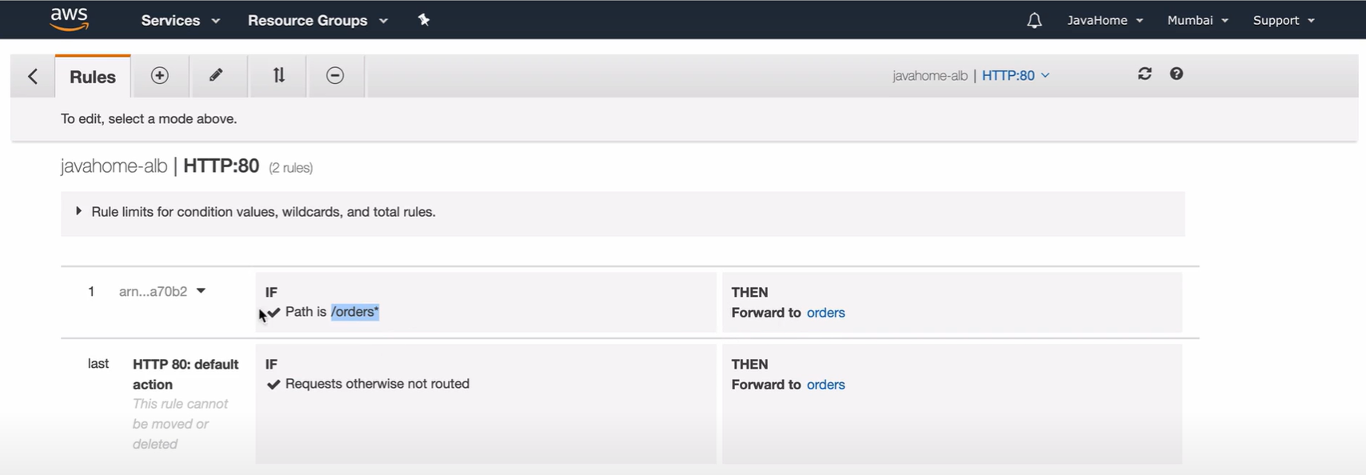

* Add another rule to forward to Target group- Payments if path is **/payments/\***

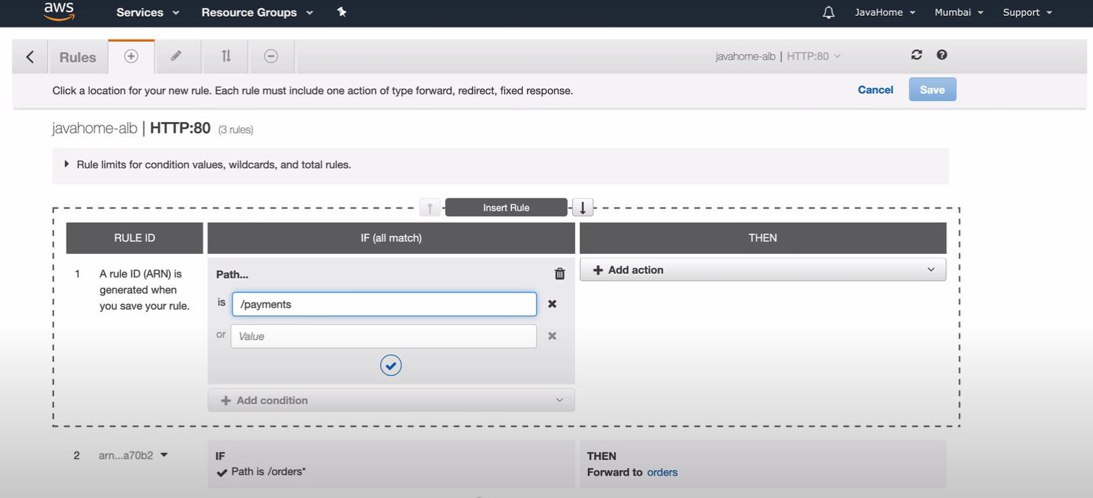

* Now,check the Target group status, it would be updated as Healthy

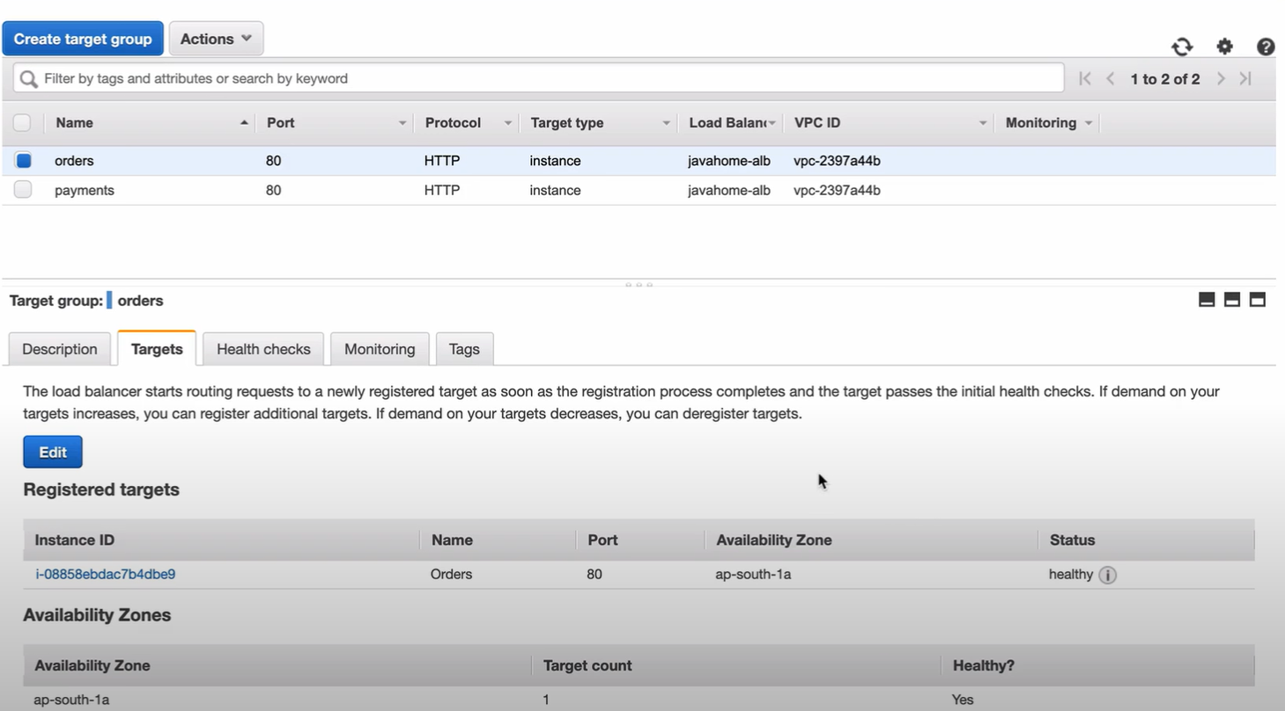

# AWS Scaling-group setup

## Working:

* Based on the Health checks

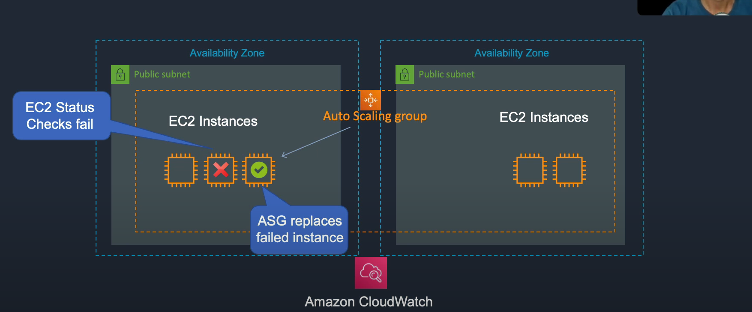

* Based on the Metrics using CloudWatch

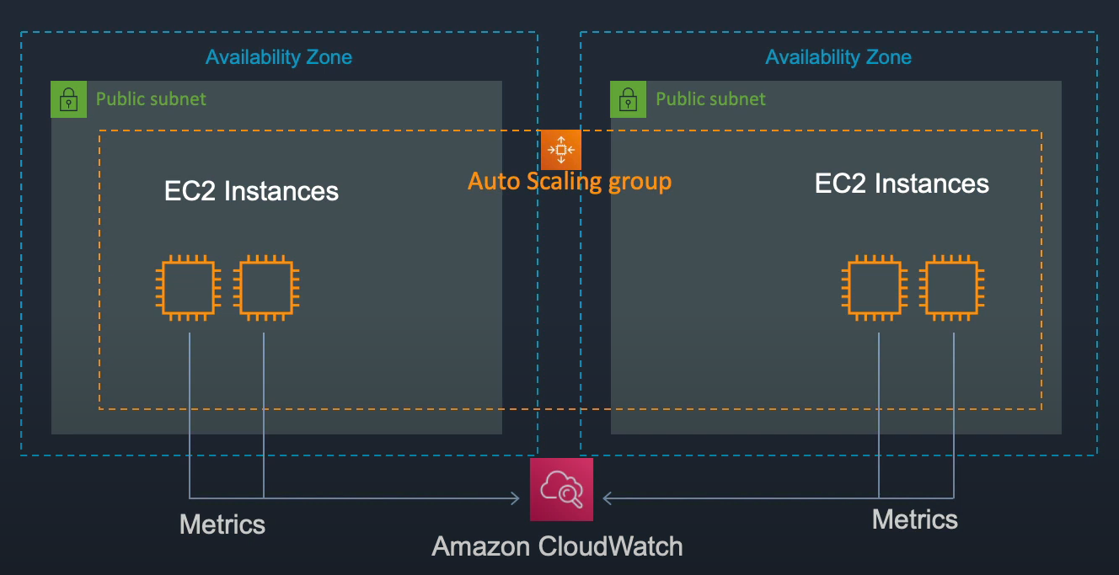

## Launch Templates:

* Features:

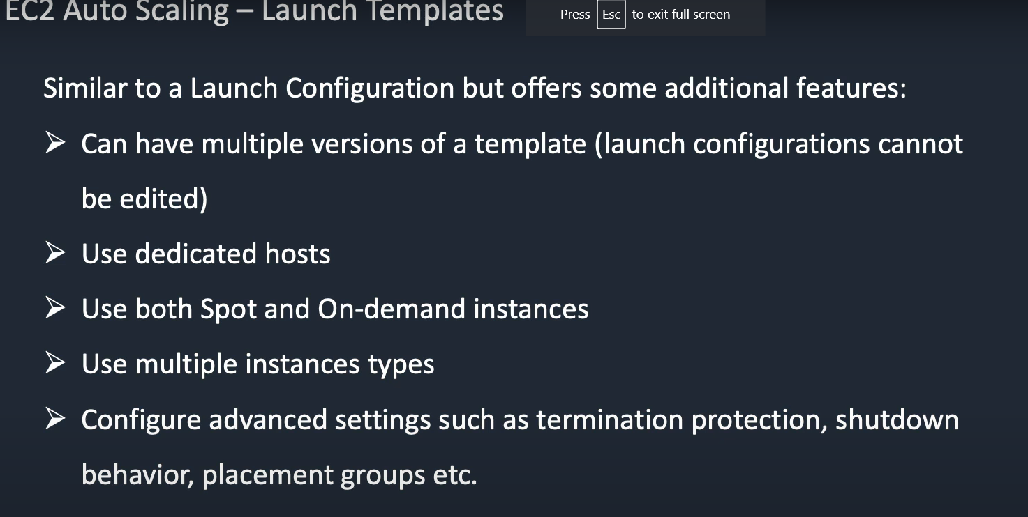

## Steps:

### Step1: Create Image of an instance

* Create an Image by selecting an EC2 instance, Actions🡪Image🡪 Create Image
* Then Select AMI from AWS LP to see the image being created.
* Create ELB with Target group but need not add any Targets in the Target group as it will be taken care as a part of Auto-scaling group
* The ELB should be pointing to Public subnets available in the different availability Zones

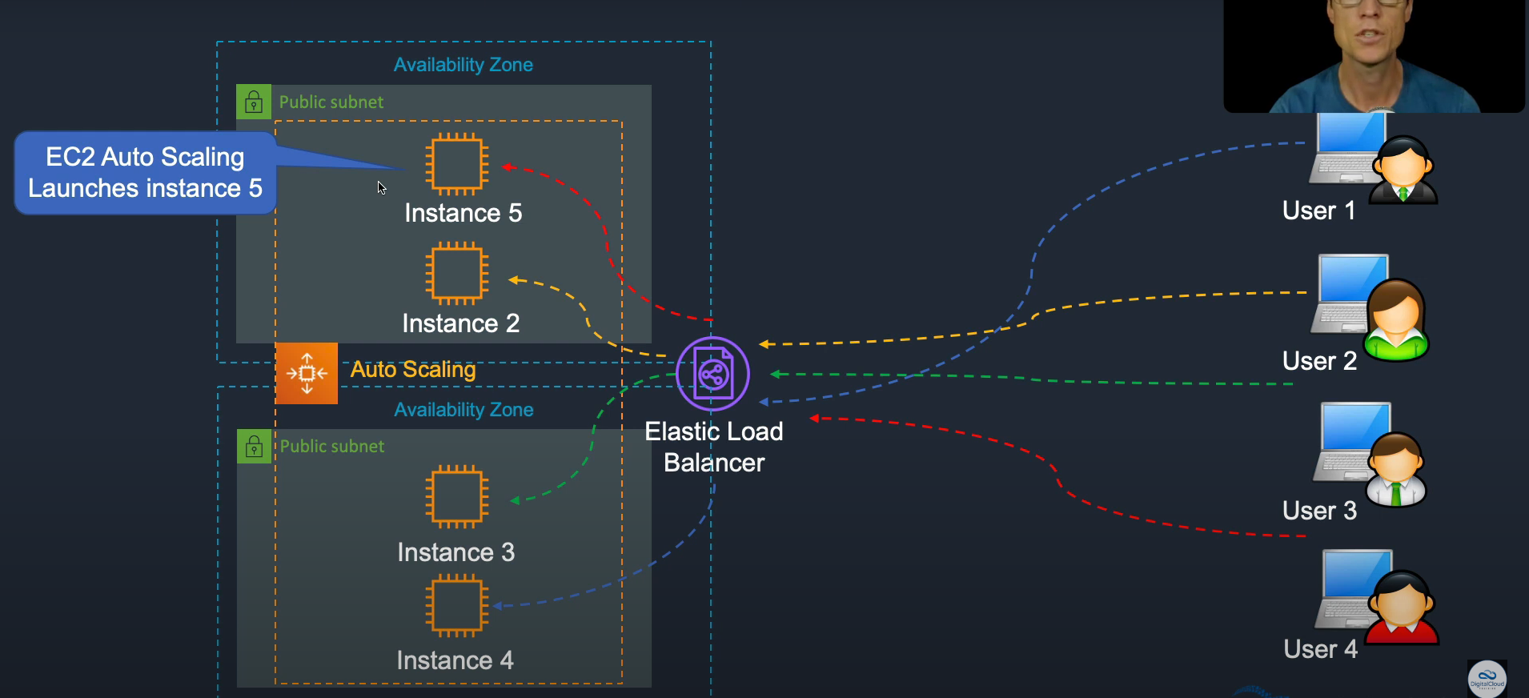

### Step2: Create Autoscaling group using Launch template

* Select the Auto Scaling🡪 Auto Scaling Group from AWS LP
* Click Create Auto-scaling group
* Enter Name of the ASG and click **Create a launch template**

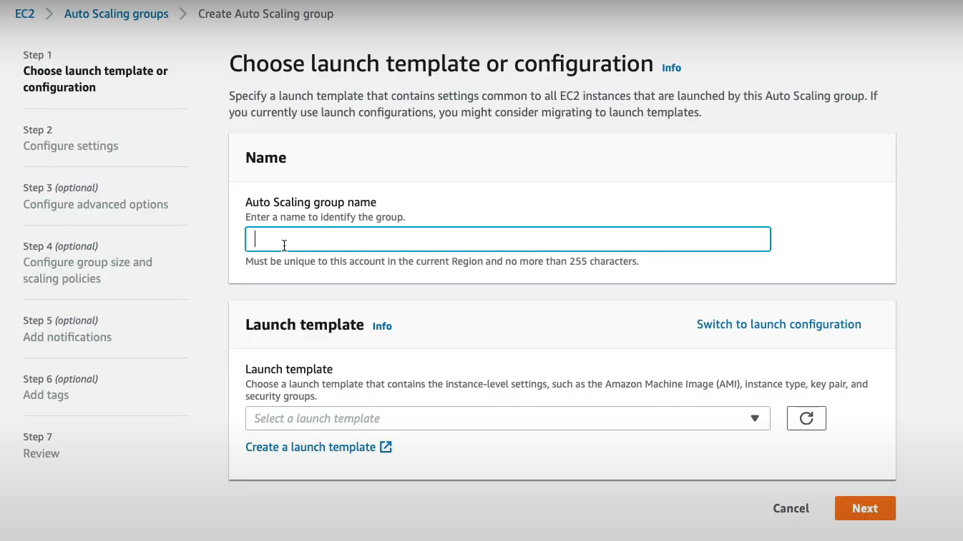

* Enter Launch template name as required, in select AMI🡪 Select the Image created from EC2 Instance, Instance Type, Key Pair, Select VPC, Security group, IAM Instance profile, and then click Launch Template.

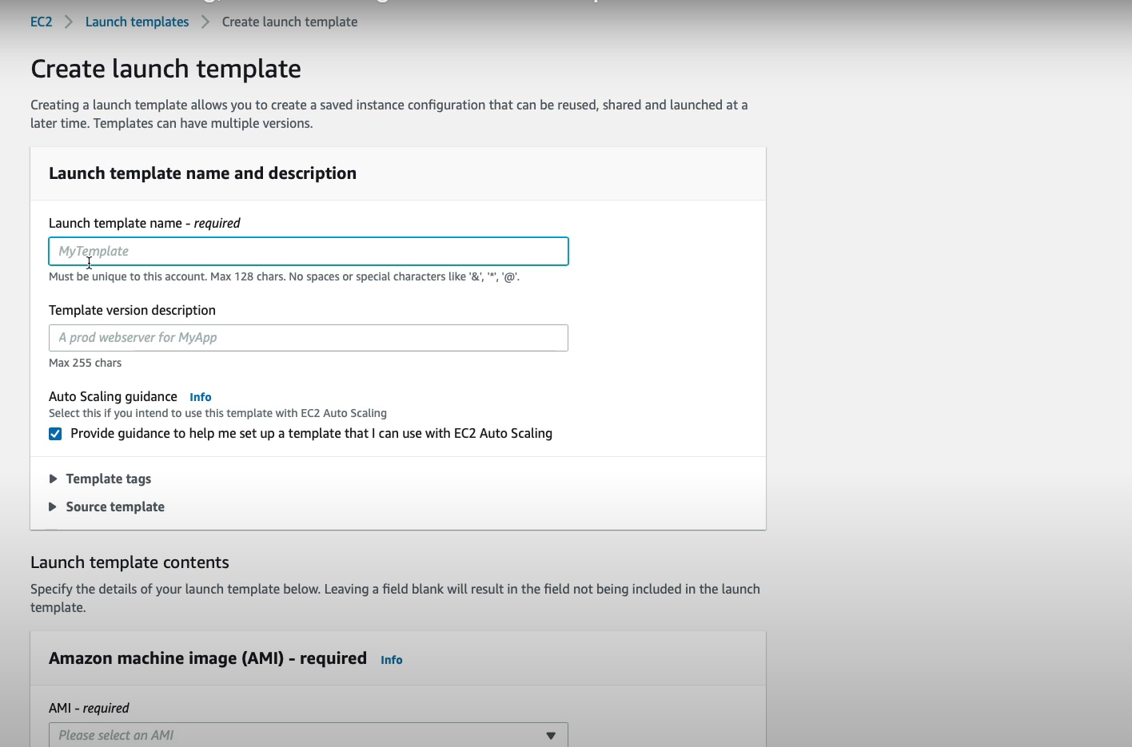

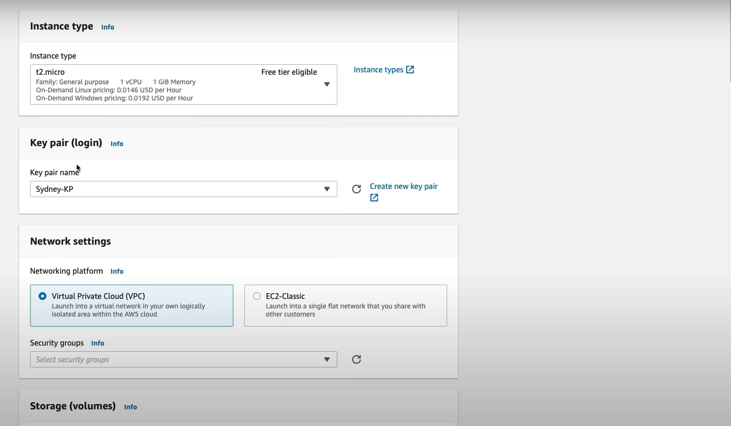

* Go back one step, choose the newly create Launch template and click Next

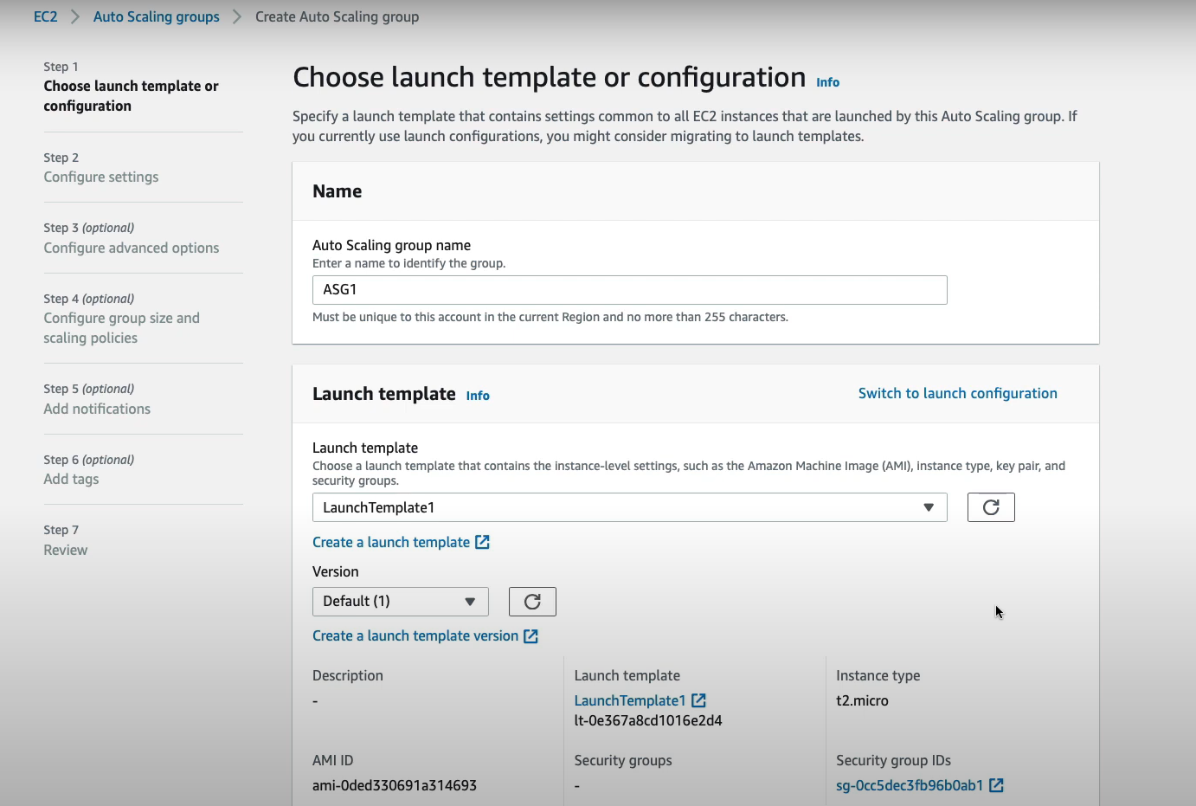

* You can choose Instances distribution in **Configure settings** & choose the Public subnets from different availability zones from the VPC

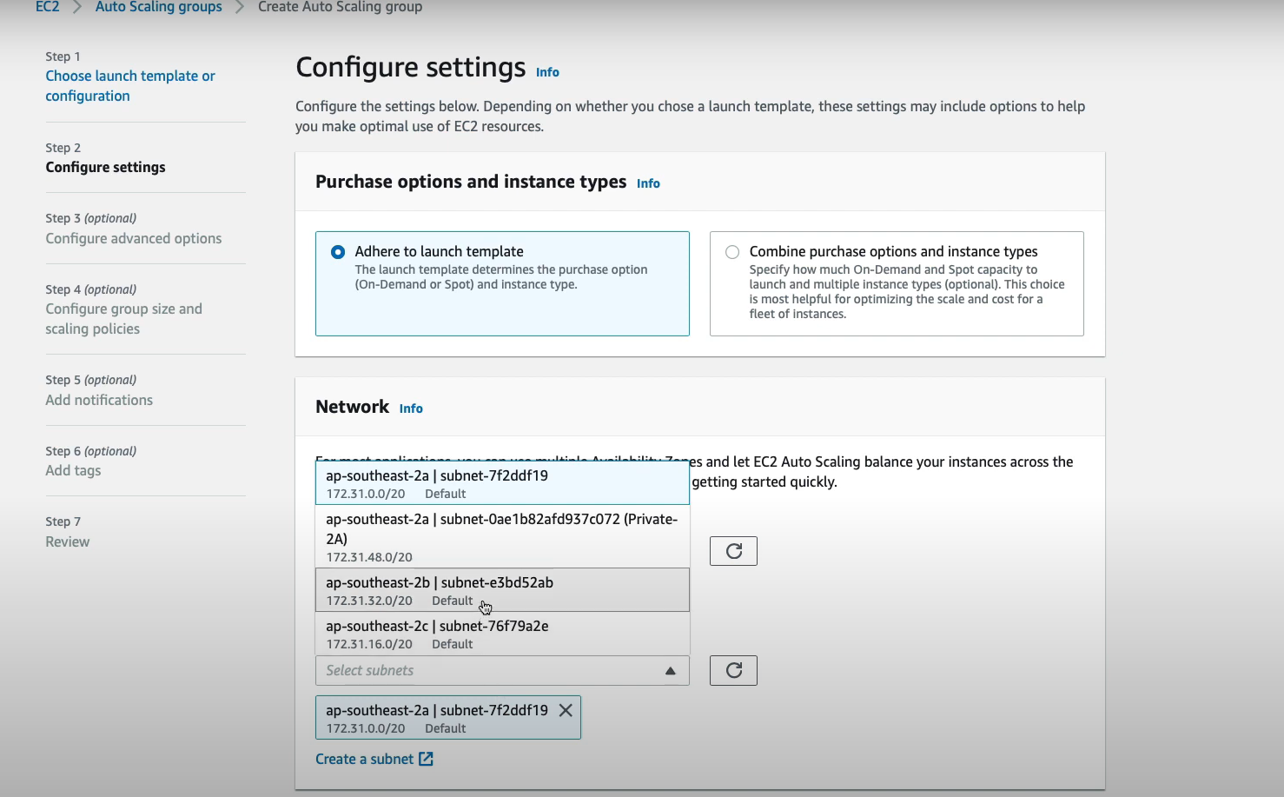

* Attach the Target group created in the **Configure Advanced** options.

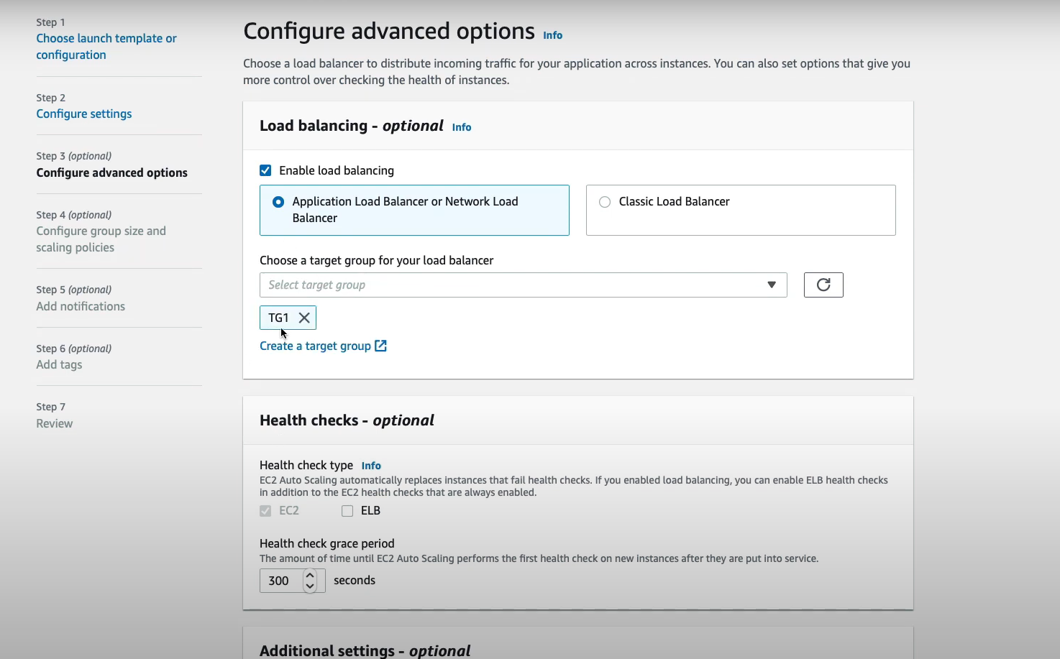

* You can enter the Desired, Minimum and Maximum scaling capacity for the Auto Scaling group.

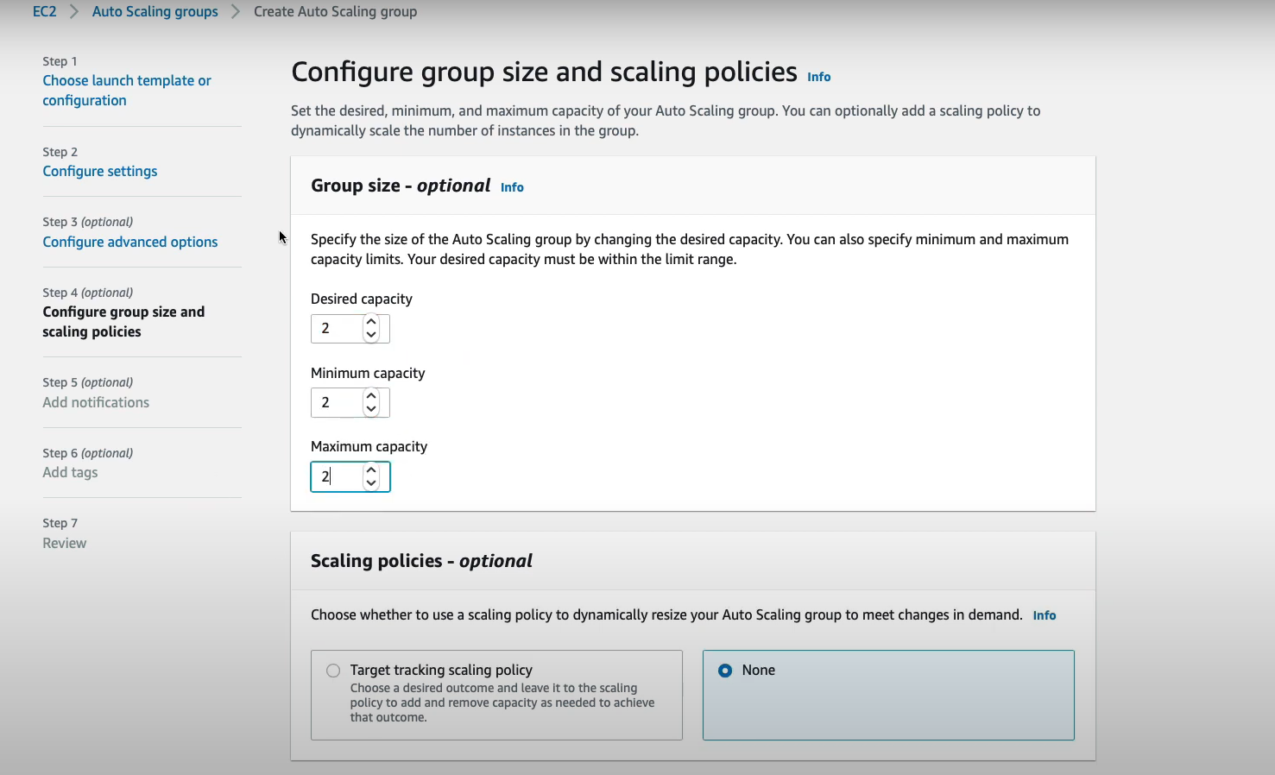

* You can add notifications, Tags if required else click Next until you get option to Create Autoscaling group.
* Once this is done, open the Auto-scaling group to view the details

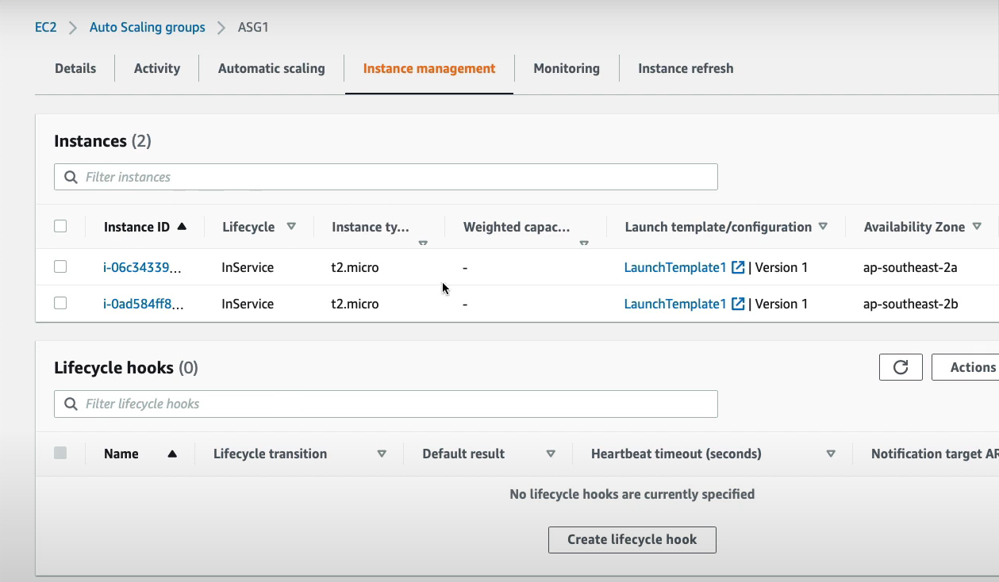

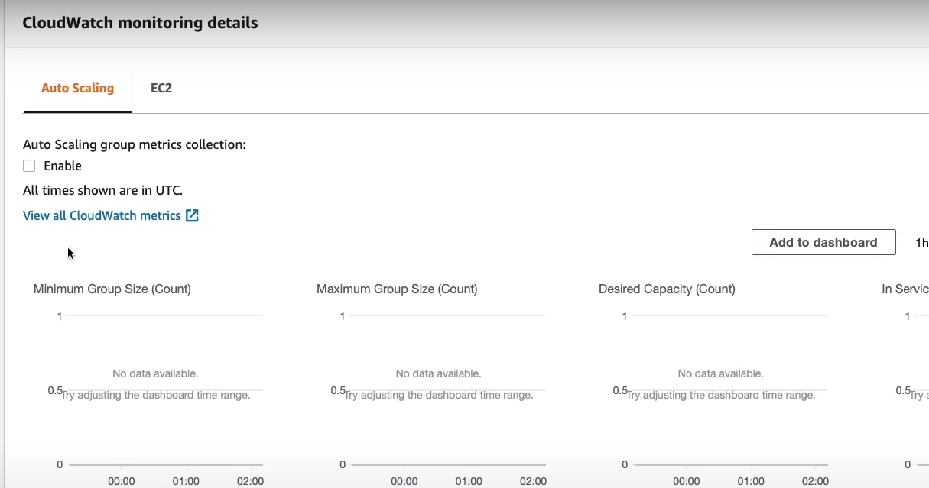

* If you go to Target groups, you can see the Targets created in the target group automatically.

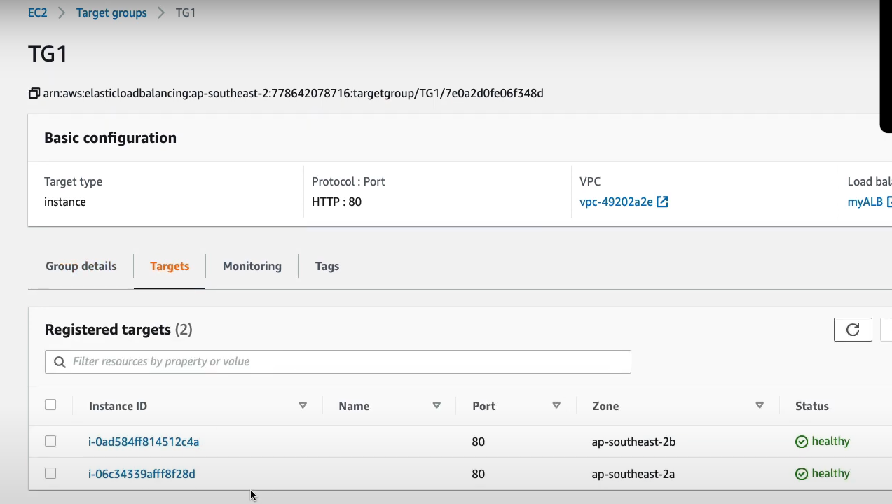

# AWS EKS Setup

* Setup kubectl  
  a. Download kubectl version 1.20  
  b. Grant execution permissions to kubectl executable  
  c. Move kubectl onto /usr/local/bin  
  d. Test that your kubectl installation was successful

curl -o kubectl <https://amazon-eks.s3.us-west-2.amazonaws.com/1.19.6/2021-01-05/bin/linux/amd64/kubectl>

chmod +x ./kubectl

mv ./kubectl /usr/local/bin

kubectl version --short --client

* Setup eksctl  
  a. Download and extract the latest release  
  b. Move the extracted binary to /usr/local/bin  
  c. Test that your eksclt installation was successful

curl --silent --location "https://github.com/weaveworks/eksctl/releases/latest/download/eksctl_$(uname -s)_amd64.tar.gz" | tar xz -C /tmp

sudo mv /tmp/eksctl /usr/local/bin

eksctl version

* Create an IAM Role and attache it to EC2 instance  
  Note: create IAM user with programmatic access if your bootstrap system is outside of AWS  
  IAM user should have access to  
  IAM  
  EC2  
  VPC  
  CloudFormation

## Create your cluster and nodes

eksctl create cluster --name cluster-name \

--region region-name \

--node-type instance-type \

--nodes-min 2 \

--nodes-max 2 \

--zones <AZ-1>,<AZ-2>

example:

eksctl create cluster --name valaxy-cluster \

--region ap-south-1 \

--node-type t2.small \

## To delete the EKS clsuter

eksctl delete cluster valaxy --region ap-south-1

## Validate your cluster using by creating by checking nodes and by creating a pod

kubectl get nodes

kubectl run pod tomcat --image=tomcat

# AWS ROUTE53 DNS Records

It’s a global service. You need to buy a domain in order to work with Route53, Go to Route53 Service & Click on register domain. Enter the domain name & check availability, Add to cart & click on continue.

Route53 can use basically:

Public domain names you own (or buy) or Private domain names that can be resolved by your instances in your VPCs.

Route53 has many features such as **Load balancing, Health checks, Routing policy like Simple, Failover, Geolocation, Latency, Weighted, Multi value.**

You pay $0.50 per month per hosted zone.

In AWS Route53, we have many types of records. Let’s talk about various records.

## **1- SOA (Start of Authority Records)**

Basic SOA stores information about below things.

Name of Server that supplied the data for zone.

The administrator of that zone & current version of data file.

Eg:

***ns-2048.awsdns-64.net. hostmaster.example.com. 1 7200 900 1209600 86400******Route53 Name server that create SOA record:***ns-2048.awsdns-64.net.***Email Address of Administrator:****hostmaster.example.com*

## **2- NS Record (Name Server Records)**

NS records is basically your name server records which are used by top level domain servers to direct traffic to content DNS server which contains the authoritative records.

*So whenever we create a hosted zone in Route53, Two types of records automatically created, one is SOA & second is NS.*

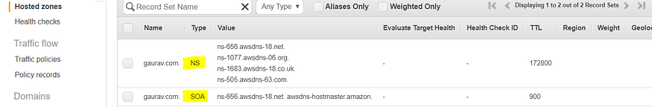

Hosted Zone(SOA & NS Records)

Before we head over to important type of records used in AWS, let’s talk about one important concept TTL(Time to Live)

**TTL (Time to Live):**

TTL is mandatory for each DNS record. So TTL is length that a DNS records is cached on either the resolving server or user own Laptop. The Lower the TTL, the faster changes to DNS records. Whenever you created record set, you need to define TTL for it.

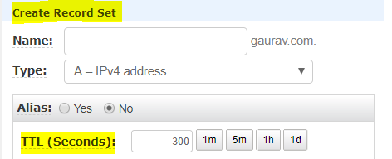

TTL(Time to Live)

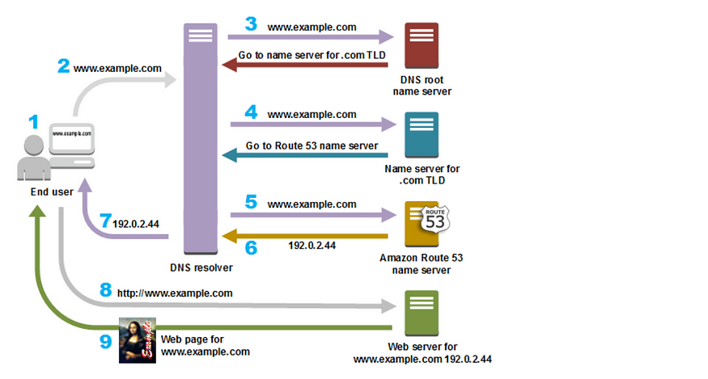

How Amazon Route 53 Routes Traffic for Your Domain (Source AWS Official)

Let’s talk about the most common records in AWS.

When you create basic records, you specify the following values.

Name

Type

Alias

TTL (Time to Live)

Value

Routing Policy

## **1- A Record ( URL to IPv4)**

The “A” record stands for Address record. The A record is used by computer to translate the name of the domain to an IP address.

Eg: (http://medium.com might point to http://126.78.98.90)

## **2- CNAME (Canonical Records- URL to URL)**

CNAME Points a URL to any other URL. (gaurav.gupta.com => gkg.example.com), We use it only for Non-Root Domain(aka. something.mydomain.com)

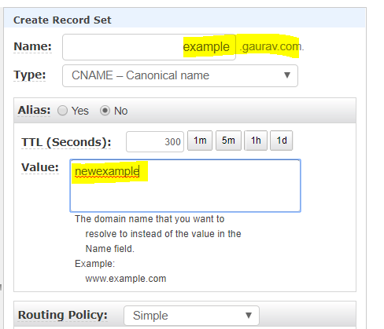

Resolving example.gaurav.com to newexample.gaurav.com

## **3- Alias Record:**

Alias record points a URL to an AWS Resource, Alias record are used to map resource record sets in your hosted zone to Elastic Load Balancer, CloudFront or S3 Buckets websites.

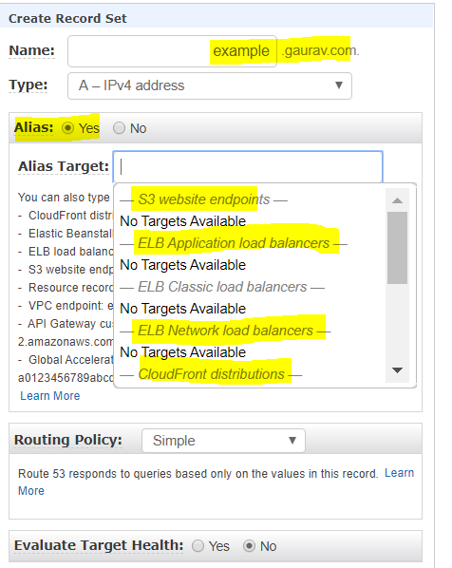

Alias Record

## **4- AAAA: (URL to IPv6)**

An **AAAA record** maps a domain name to the IP address (Version 6) of the computer hosting the domain. An **AAAA record** is used to find the IP address of a computer connected to the internet from a name.

## **5- MX Record (Main Exchange Record)**

A mail Exchanger **record** (**MX record**) specifies the mail server responsible for accepting email messages on behalf of a domain name. It is a resource **record** in the Domain Name System (**DNS**). It is possible to configure several **MX records**, typically pointing to an array of mail servers for load balancing and redundancy.

This is all about various type records, let’s talk about Routing policy. So what is routing policy.

***When you create a record, you choose a routing policy, which determines how Amazon Route 53 responds to queries.***

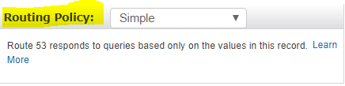

# Routing Policy

There is total 6 types of routing policy in Route53, let’s talk about one by one.

## **1- Simple Routing Policy:**

In case of simple routing policy, you can have only one record with multiple IP addresses. If you specify multiple values in record, Route53 returns all values in random order to the user.

Maps a domain to one URL, Use when you need to redirect to a single resource. You can’t attach health checks to simple routing policy. If multiple values are returned, a random one is chosen by the client.

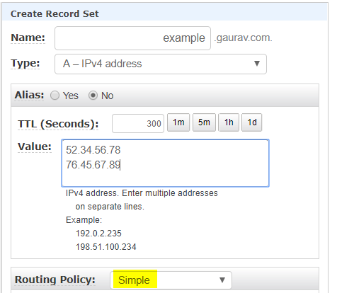

Simple Routing Policy

## **2- Weighted Routing Policy**

Weighted Routing Policy controls the what percentage % of the requests that go to specific endpoint. It’s helpful to test 1% of traffic on new app version. It is also helpful to split traffic between two regions. We can associate Health checks with it.

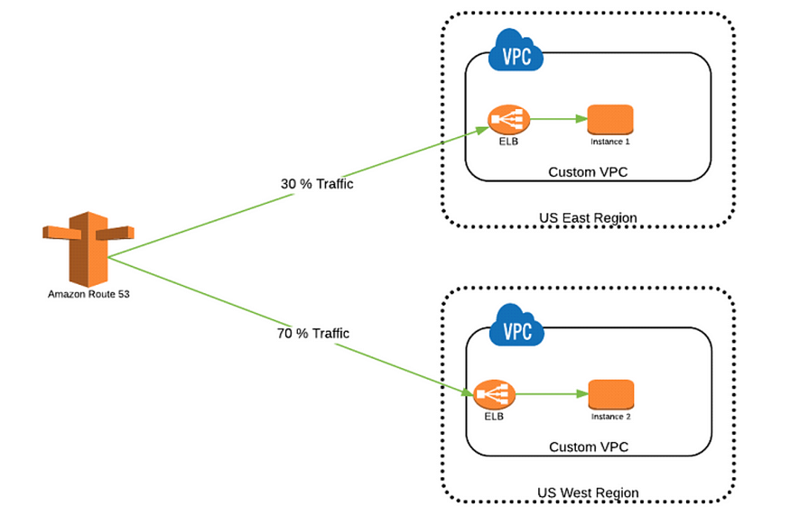

Weighted Policy

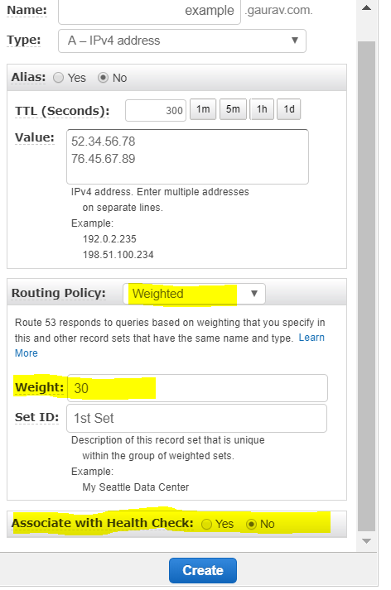

## **3- Latency Routing Policy**

It allows you to route your traffic based on lowest network latency for your end user. It redirects to the server that has the least latency close to us also helpful when latency of users is a priority. Latency is evaluated in terms of user to designated AWS Region. For example: Germany may be directed to the US (if that’s the lowest latency)

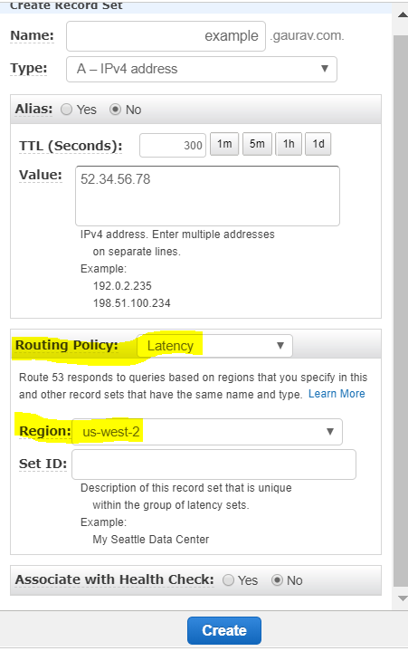

## **4- Failover Routing Policy**

**Failover routing** lets you **route** traffic to a resource when the resource is healthy or to a different resource when the first resource is unhealthy. The primary and secondary records can **route** traffic to anything from an Amazon S3 bucket that is configured as a website to a complex tree of records.

You can associate health check with this type of policy.

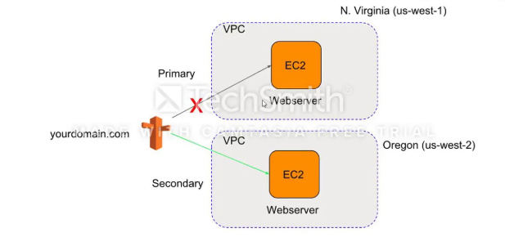

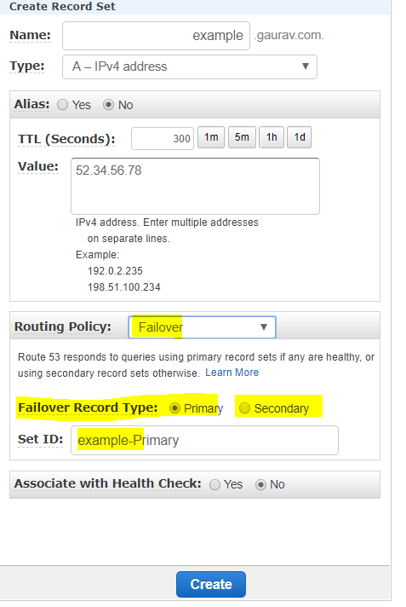

Failover Routing Policy

## **5- Geo Location Routing Policy**

**Geolocation routing** lets you choose the resources that serve your traffic based on the geographic location of your users, meaning the location that DNS queries originate from. For example, you might want all queries from Europe to be **routed** to an ELB load balancer in the Frankfurt region.

This is routing based on user location. Health check associated.

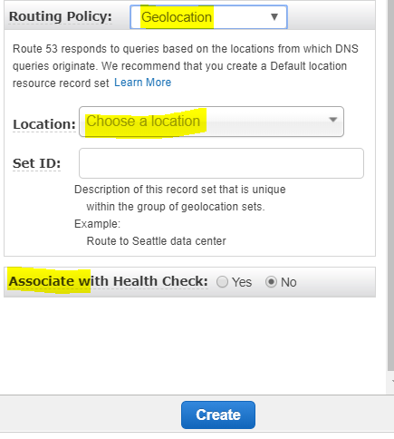

Geolocation Policy

## **6- Multi Value Routing Policy**

It helps distribute DNS responses across **multiple** resources. For example, use **multivalue** answer **routing** when you want to associate your **routing** records with a **Route** 53 health check.

Use multivalue answer routing when you need to return multiple values for a DNS query and route traffic to multiple IP addresses. Up to 8 healthy records are returned for each Multi Value query. Multi Value is not a substitute for having an ELB.

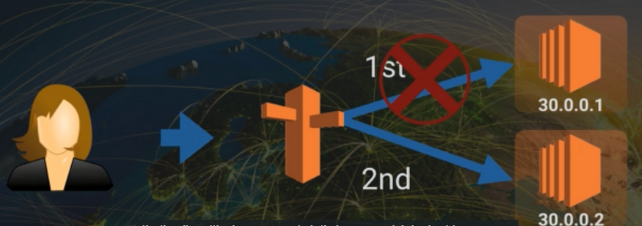

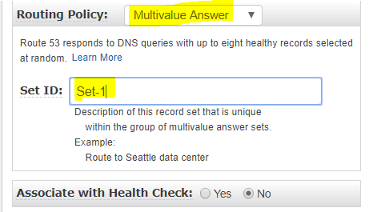

MultiValue Routing

# Amazon Elastic Disaster Recovery

## Definition:

Minimizes downtime, data loss with fast reliable recovery of on-premises & cloud-based applications using affordable storages, minimal compute & point-in-time recovery

## Recovery-why?

* Disaster happened at one Availability zone, at that point of time, we have to point/route all the requests to the recovery environment where data is already replicated at the backend.
  + Users will not get impacted & the new data will get routed to the new server whichever we consider it as recover server called as **Failover(**to launch recovery instances having previous data & new requests will be routed to new server)
* Disaster is over, **failback** from recovery server to the original source server.

### Process:

* Create an replication agent which acts as a media b/w source server & DR environment & tries to replicate(in time interval) . In the backend, it takes the snapshot of the source environment if any disaster happens.
* During Failover, the latest sanpshot can be taken for recovering our instances & source environment if any disaster happens.
* Available for Region-to-region; within a region; on-premises system

### Architecture:

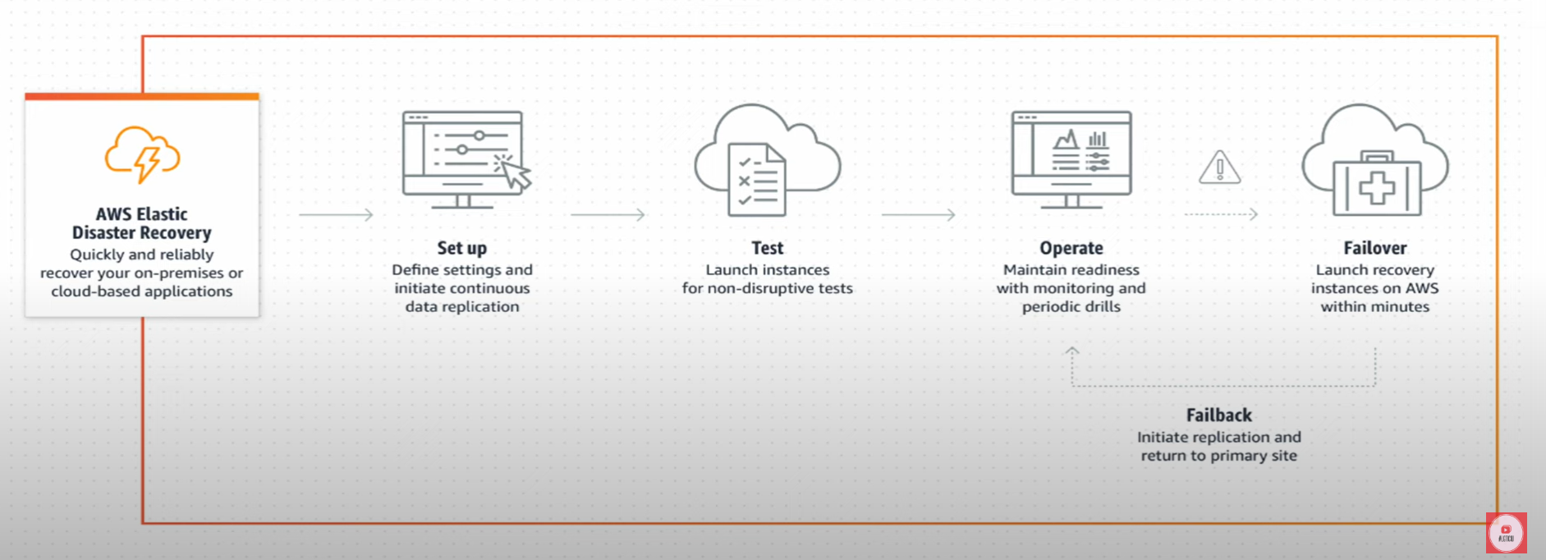

### How it works?

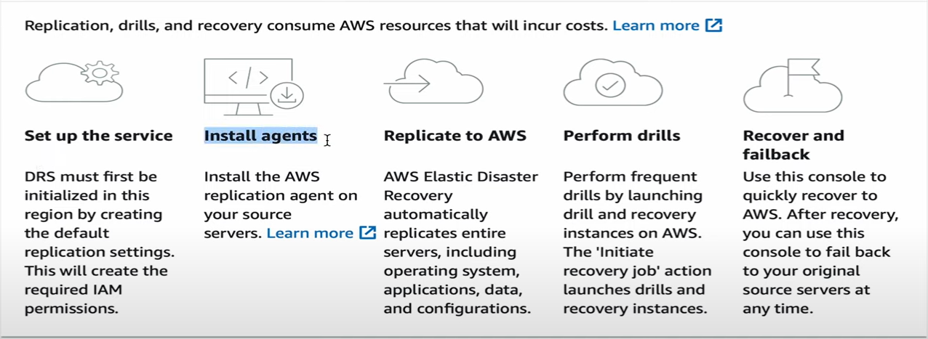

### EDR Dashboard:

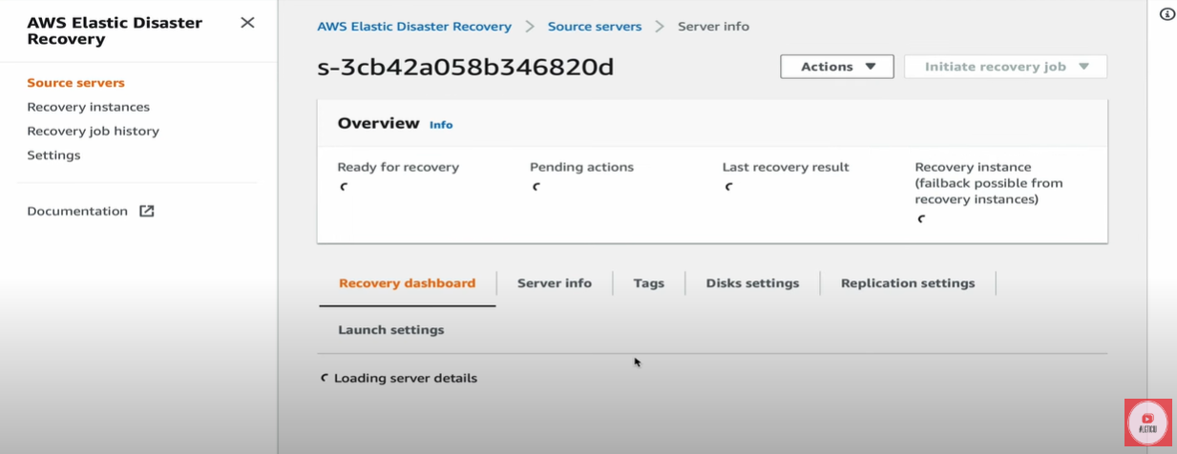

* Server Info🡪 RAM, Recommended Instance type, Hardware
* Tag🡪 Name
* Disk settings🡪 Disk name & storage
* Replication settings🡪
* Launch settings🡪 Ec2 Launch Template
  + Create template
    - Size/Tier
    - Key pair
    - SG
    - Subnet
    - Storage🡪gp3
  + Template version🡪 Set as “default version”

### Steps:

## Step1: Settings

* Go to AWS🡪 Services🡪 Storage🡪 Amazon Elastic Disaster Recovery🡪Settings🡪Edit default Application settings
* Subnet🡪 Public/Private
* Replication server instance type🡪 t3.micro
* Volume🡪 SSD gp3 cheaper than gp2
* EBS Encryption🡪 Default
* Security Group🡪 Custom SG
* Data Routing:
  + VPN, Direct Connect, VPC peering
  + Public IP creation
* Point in Time🡪 Snapshot retention(1-365)

### Step2: IAM Role setup

* Role setup🡪 IAM🡪 Role🡪 Add or Create Role
  + Entity🡪EC2
  + Tag🡪 <name>
* Policy/Permission: AWSElasticDisasterRecoveryRecoveryInstancePolicy
* Attach the role to your user
* Assign the role to the running instances🡪 Actions🡪 Security🡪 Modify IAM Role🡪 Enter Role & Save it

### Step3: Install Agent

* Install Agent🡪 Pull the code/file to CLI using wget (refer Amazon documentation)
* Execute the file as root user
  + Enter AWS region
  + Enter Access Key & Secret Key [IAM🡪Users🡪Security credentials]
  + Choose the disks to replicate🡪 Enter to replicate all
  + Once this is done, replication agent will be downloaded & installed, then in AWS EDR dashboard, we can see the hostname with source servers Private IP
  + Data replication will be initiated
  + We will have one new instance as **“AWS Disaster Recovery Replication Server”** along with source instance.

### Step4: Recovery Job

* Once replication is done & snapshot is created(Source server is ready for recover) and the same can be viewed in EDR Dashboard

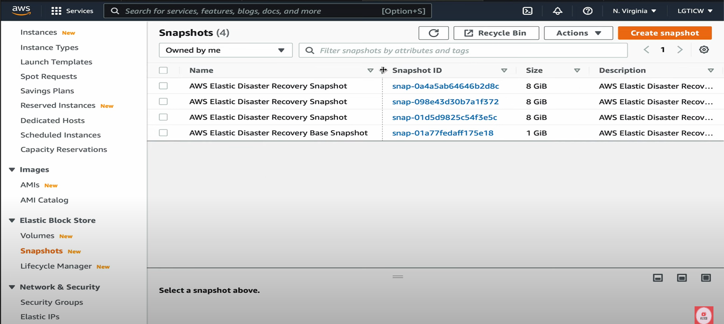

* Select Hostname🡪Initiate Recovery job🡪Initiate recovery



* + Select the required PIT
  + Initiate recovery
* This will create a conversion server in EC2 instances as “**AWS Disaster Recovery Conversion Server”**
  + This is not the replicates server
  + This will stop & terminated once the replicated server instance is created/initiated

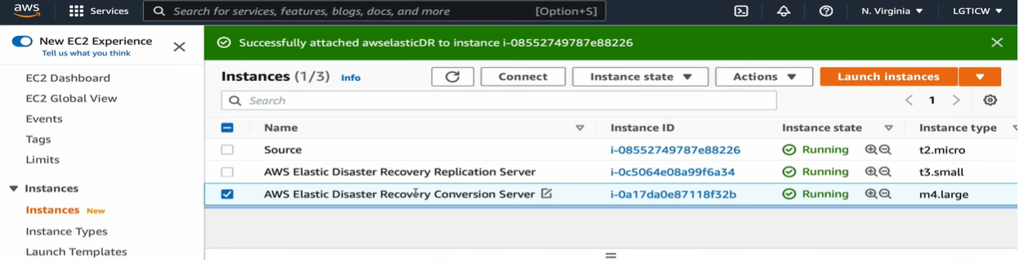

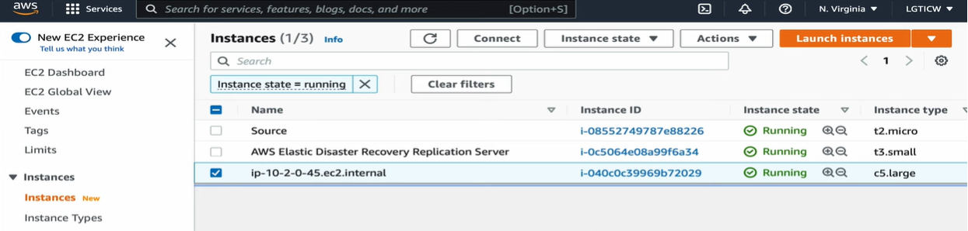

### Step5: Failback

* Install agents in the replicated server
* Go to Recovery instances🡪 Select 🡪 Failback

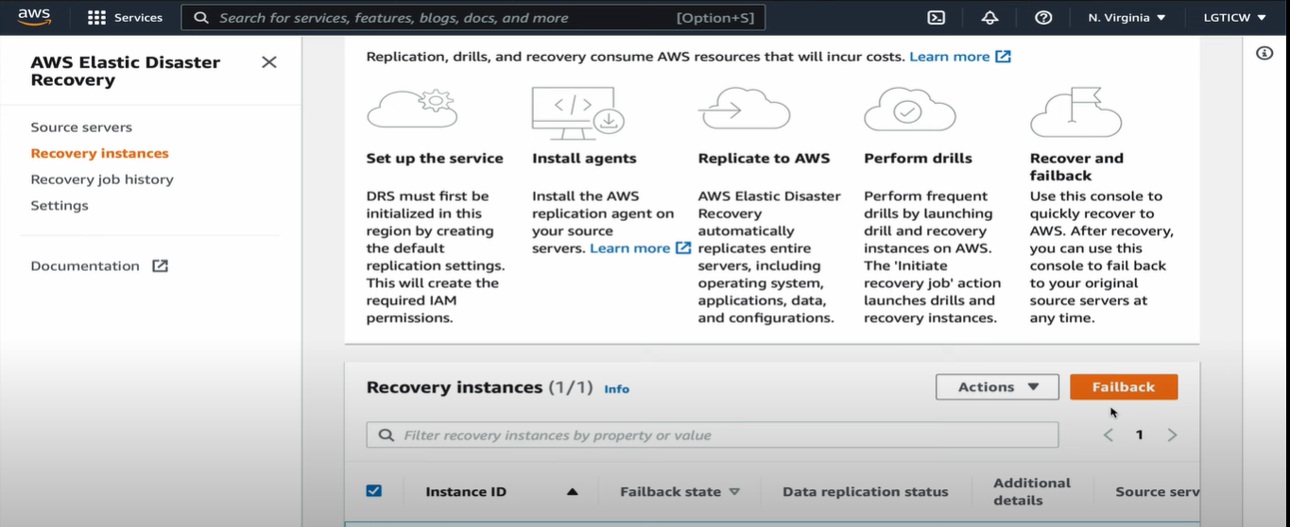

# VPC

## Architecture:

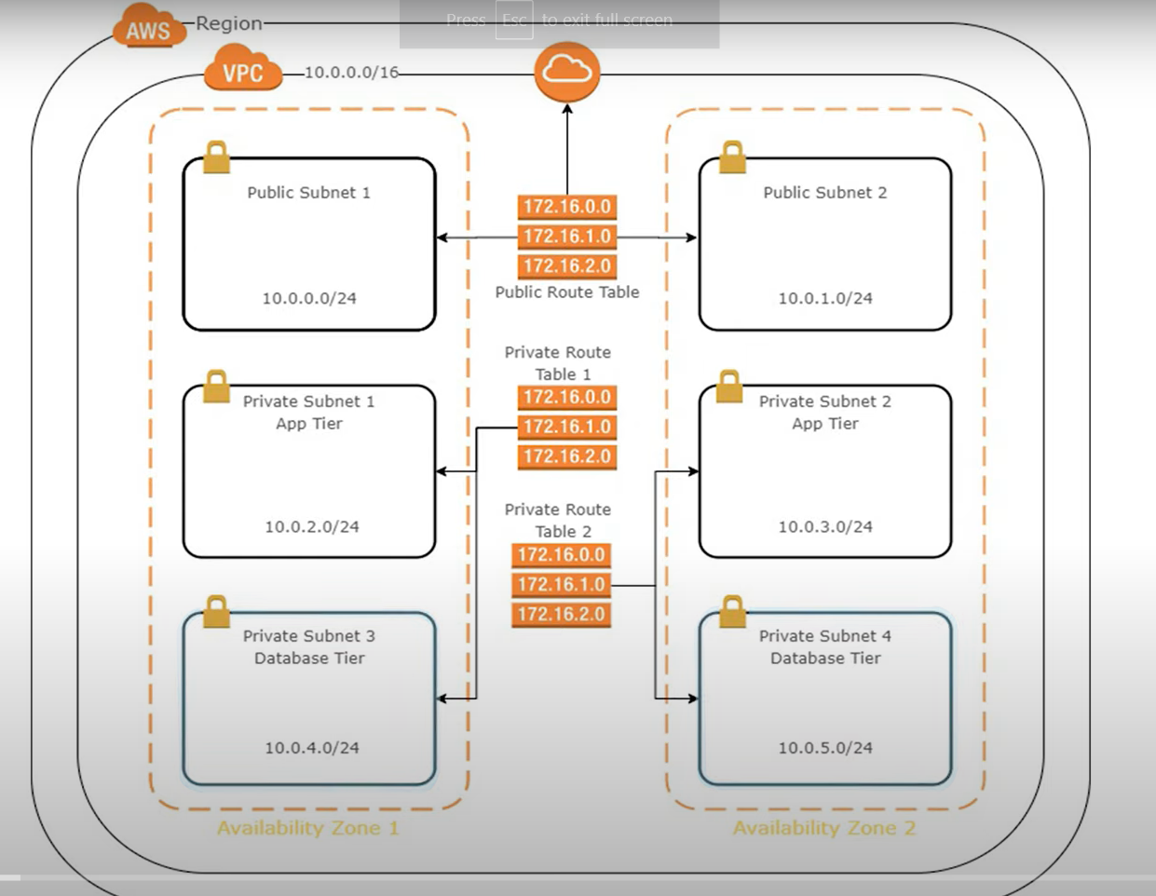

## Process:

### Steps:

### Step1: Create VPC

* Select region
* Services🡪 Networking & Content delivery🡪 VPC
* Create VPC
* Enter CIDR block

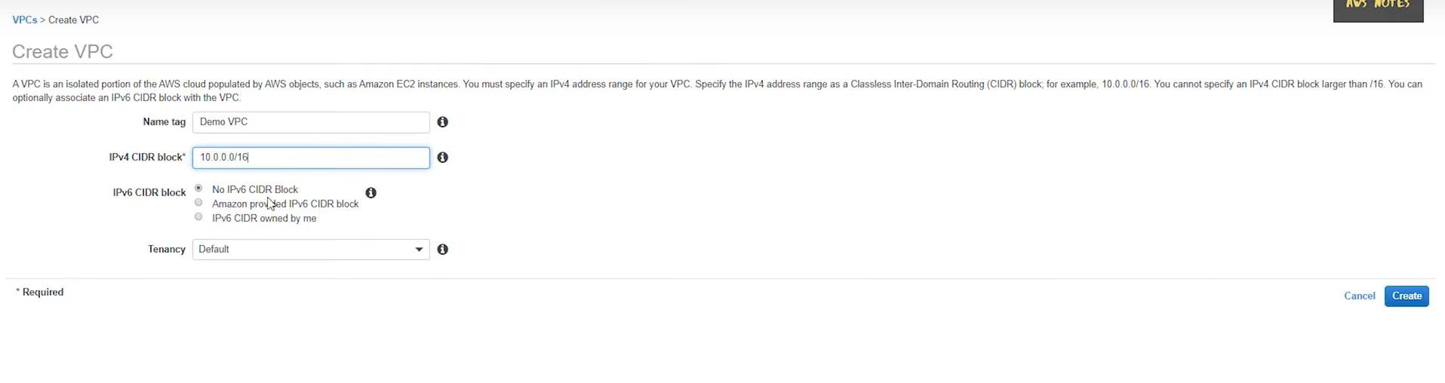

* Create
* The system will automatically create Route table which is private

### Step2: Create Internet Gateway and attach it to VPC

* Select Internet Gateway🡪Create
* Give name “Demo IGW”
* Close
* Then Select created gateway🡪Actions🡪Attach to VPC
* Enter the VPC
* Click “Attach”

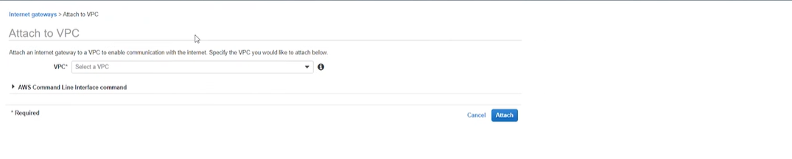

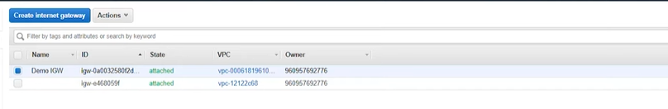

### Step3: Create Subnets in Different Availability Zones

* Click on “Subnets” in Left Pane
* Fill the details like required VPC, Availability zone, Name of subnet(Public subnet1), CIDR block

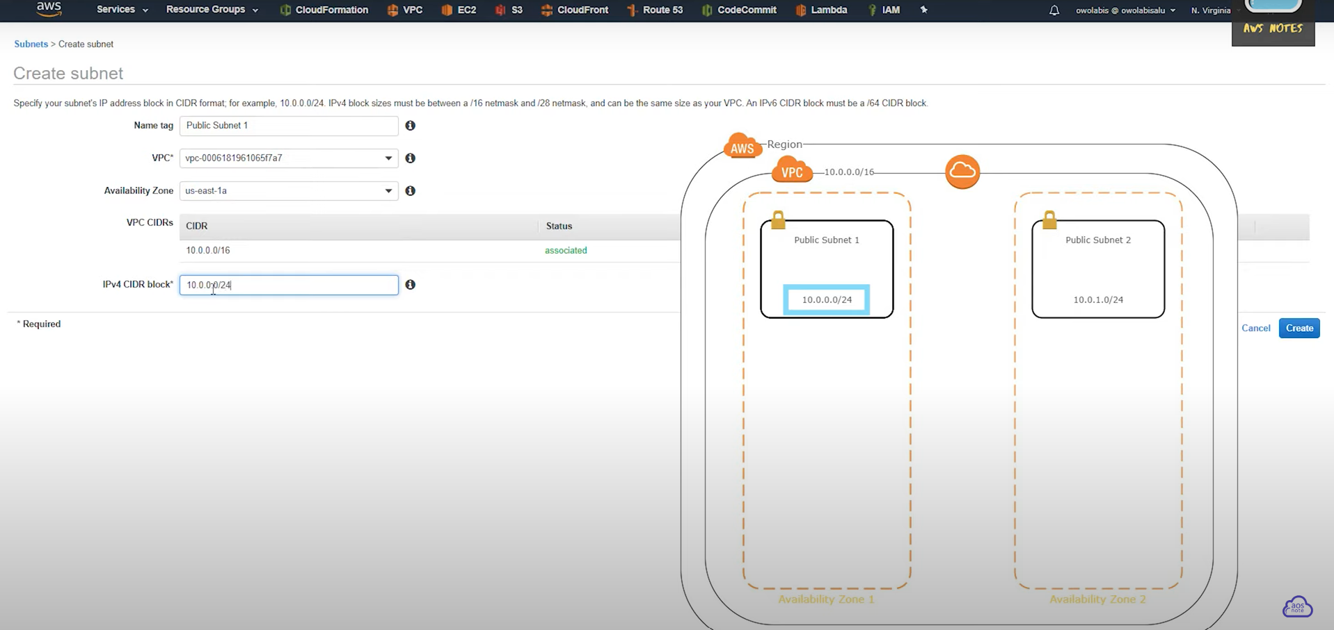

* Repeat the previous step to create another subnet(“Public subnet2”) and change the Availability Zone alone.

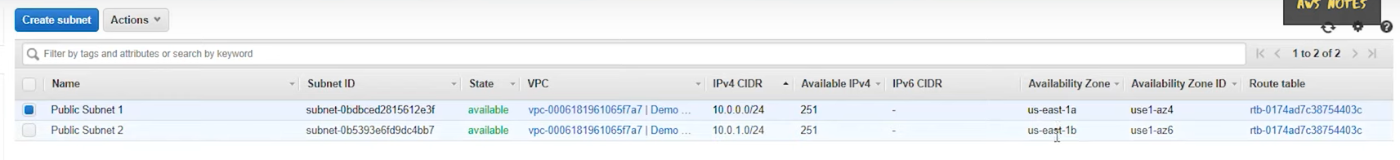

* To assign IP automatically to this subnet, select the Subnet🡪Action🡪Modify auto-assign IP settings & check-in **Enable** IpV4

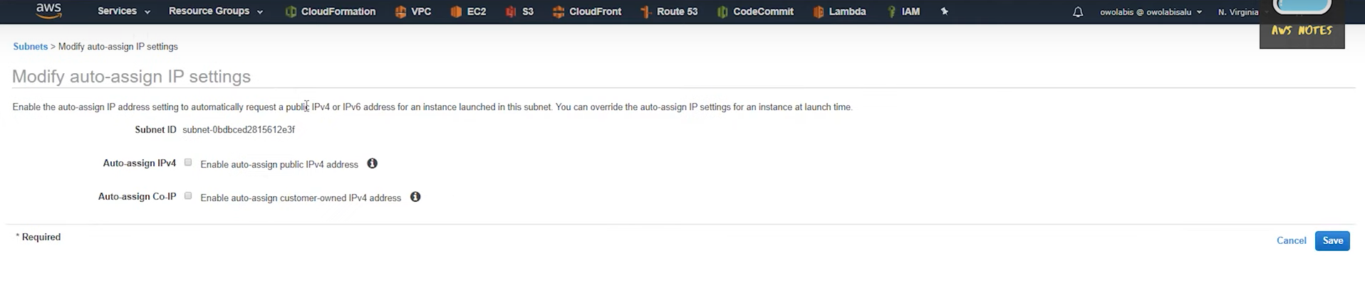

### Step4: Create and Assign public route table to public subnet 1 & 2

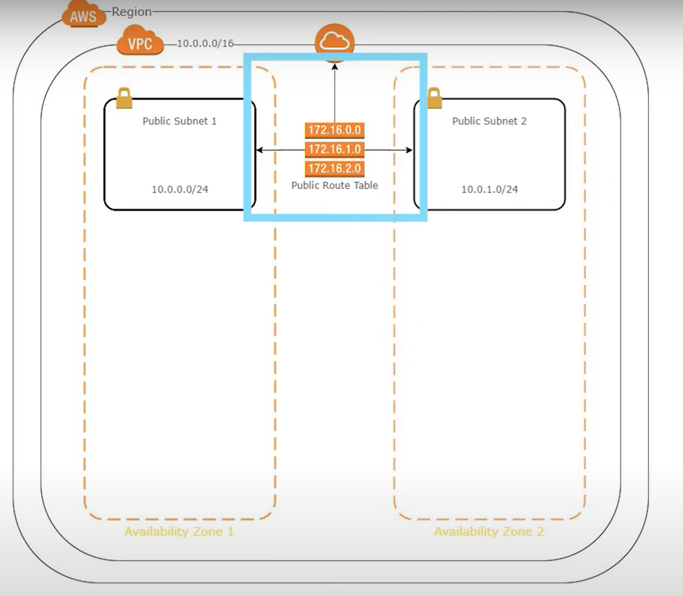

* Select “Route table” in the Left pane of AWS console and select Create
* Enter details like Name & Enter VPC “Demo VPC” & **Create**

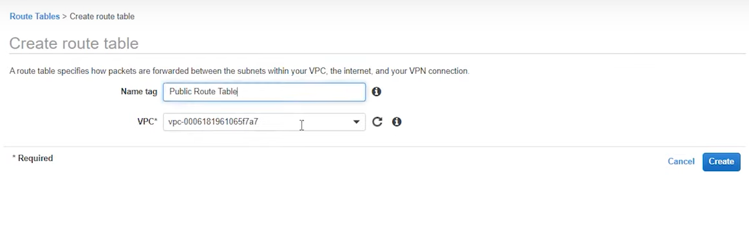

* Select created Route Table🡪 Routes
* Enter Route as “0.0.0.0/16” and Target as “Internet Gateway” and **Save Routes**

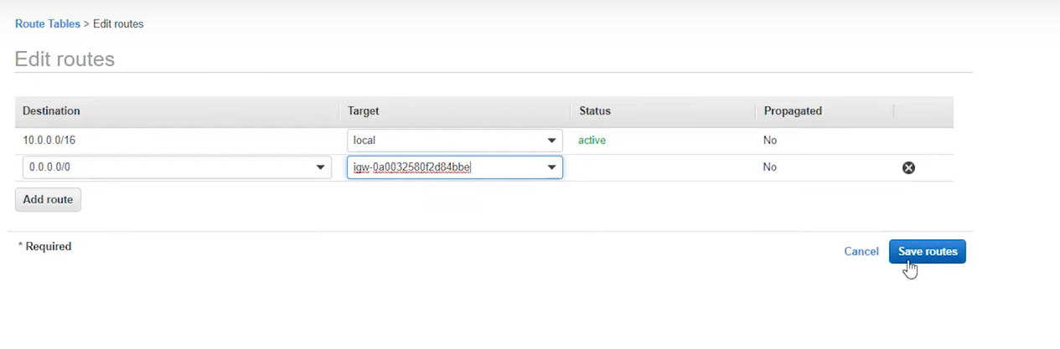

* To associate the subnets, Select Route table 🡪 Subnet Associations 🡪 Edit

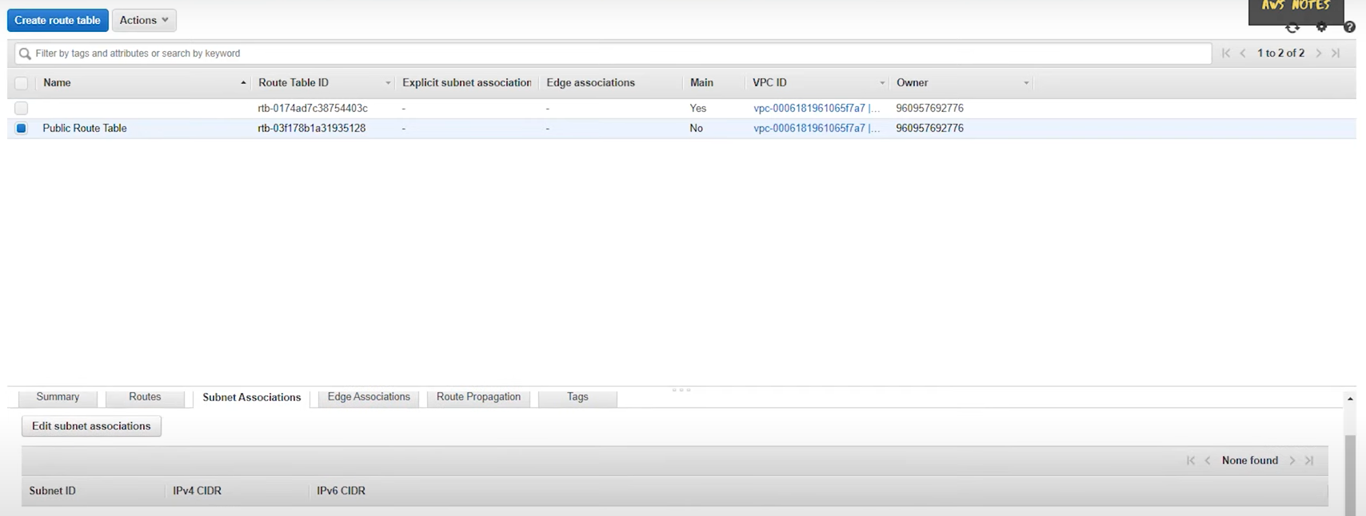

* Check-in the created Subnets and click **Save**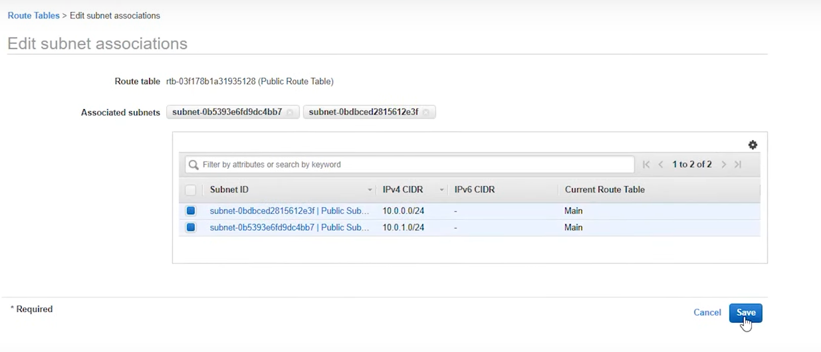
* Create the two private subnets by following the same steps, but it doesn’t have any Internet gateway associated with it

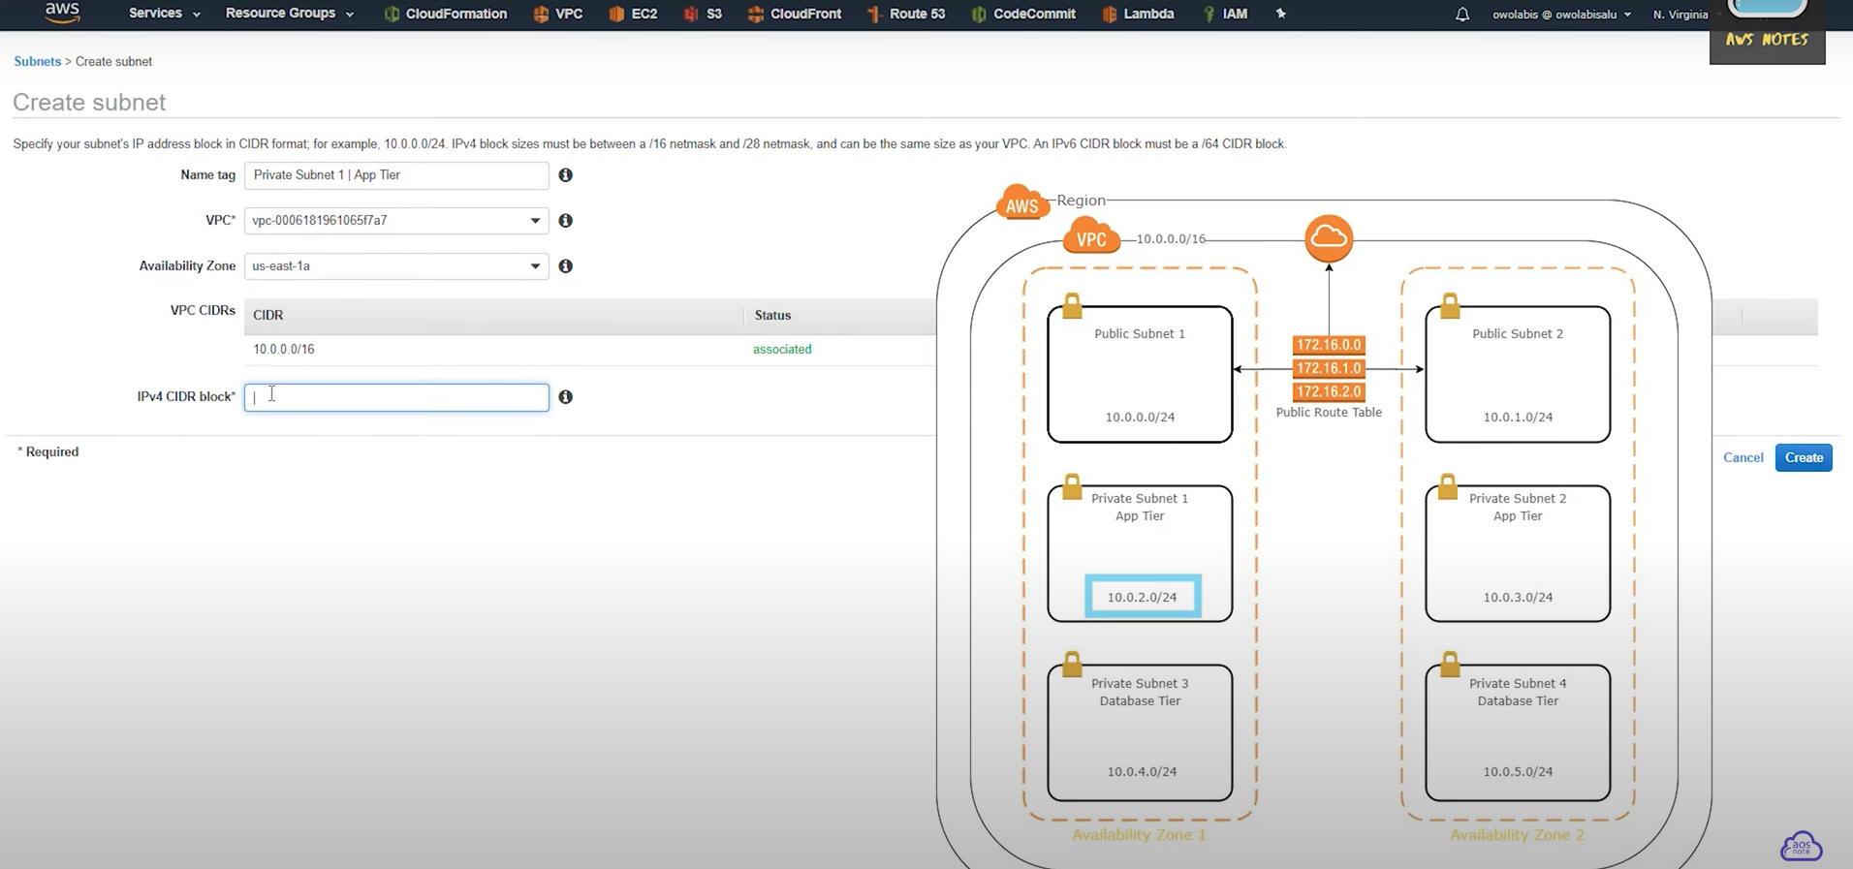

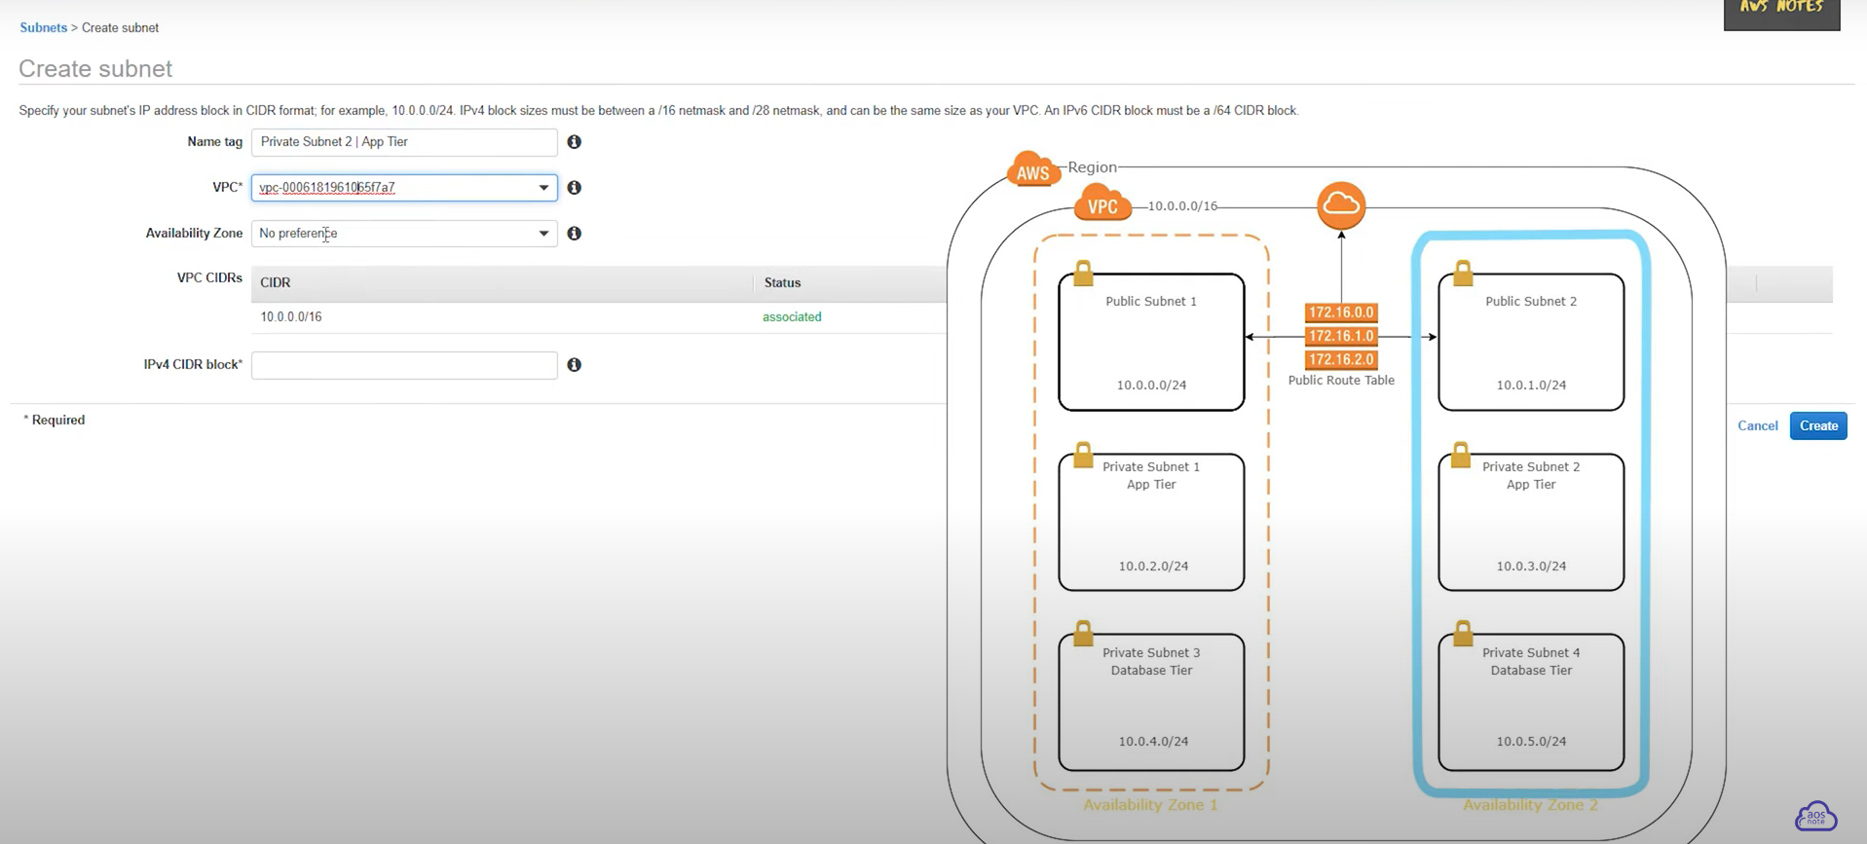

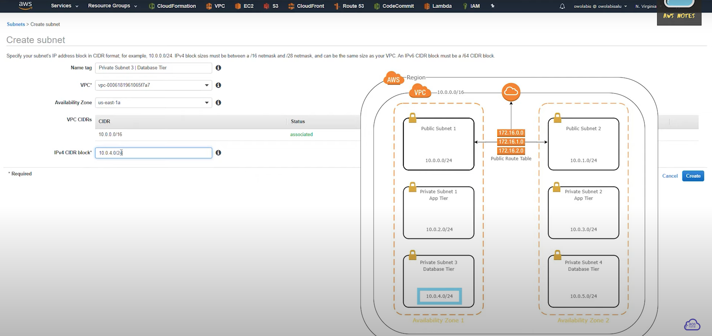

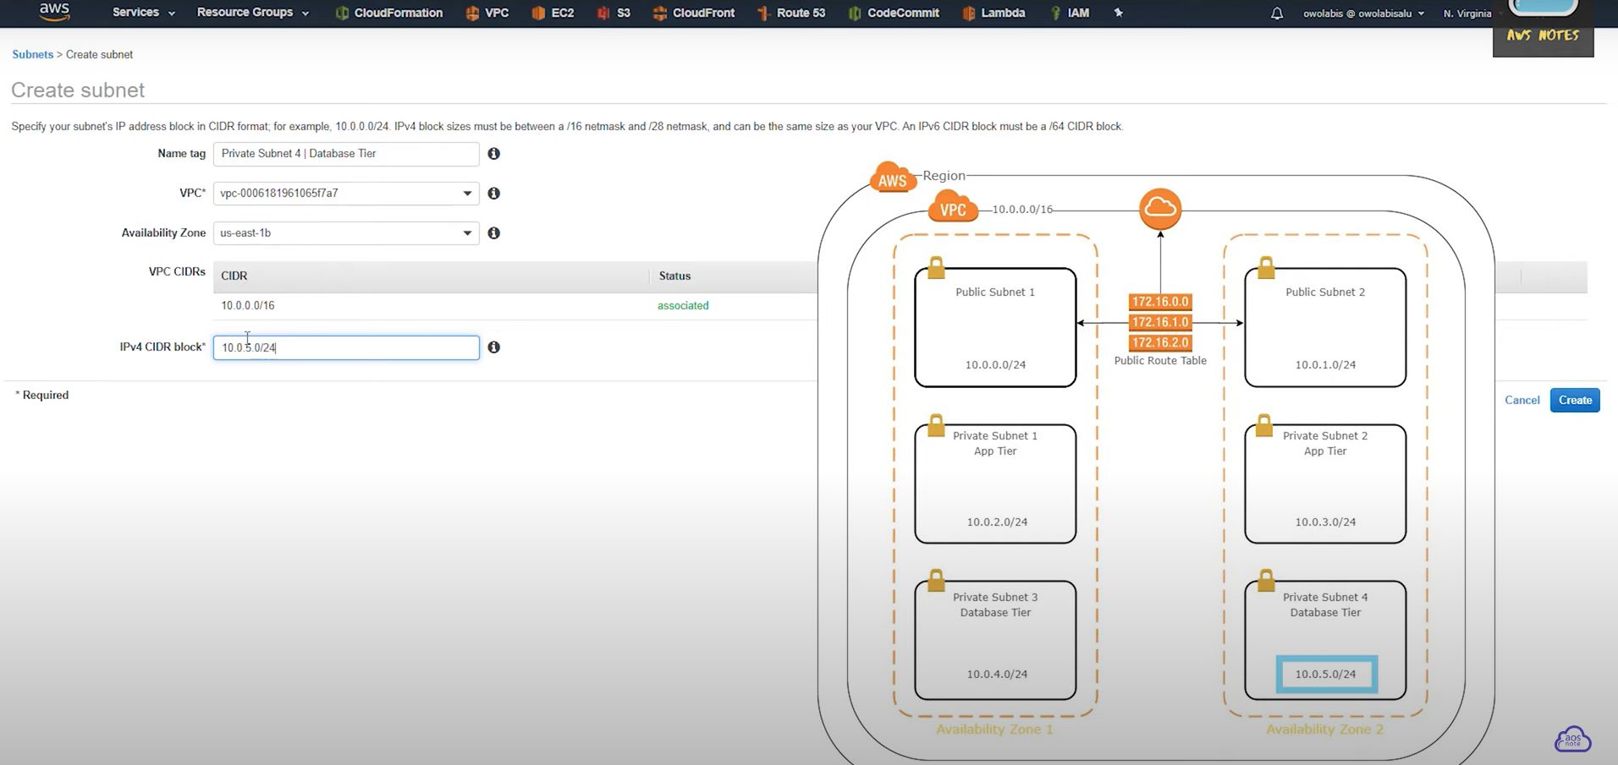

After Subnet creation:

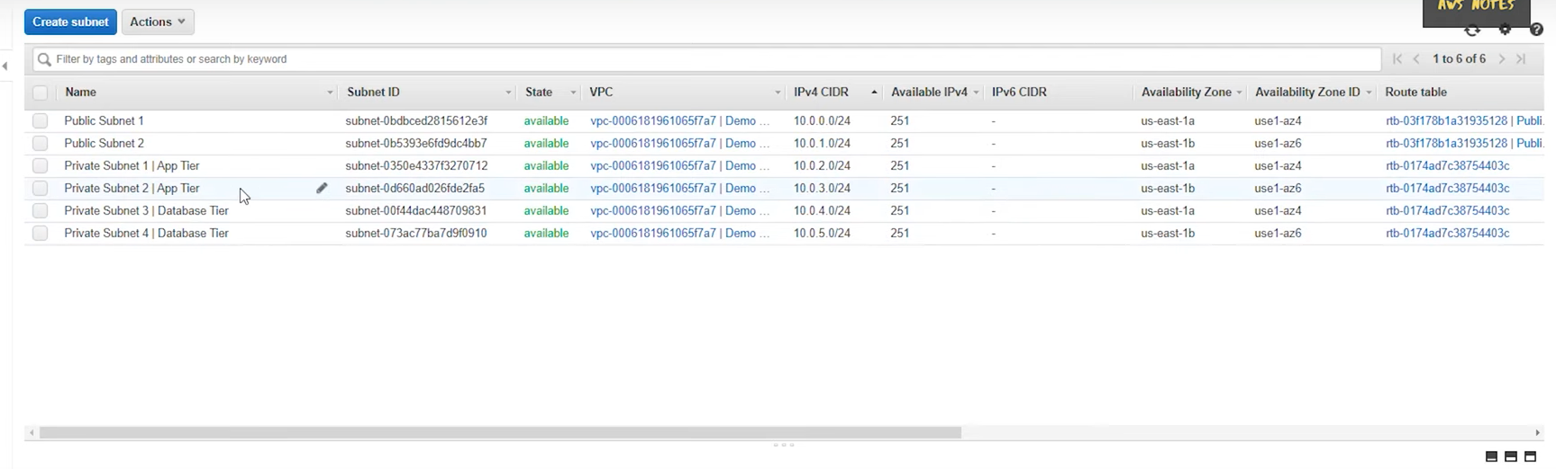

### Step5: Create Two Private Route tables and attach it to 4 subnets

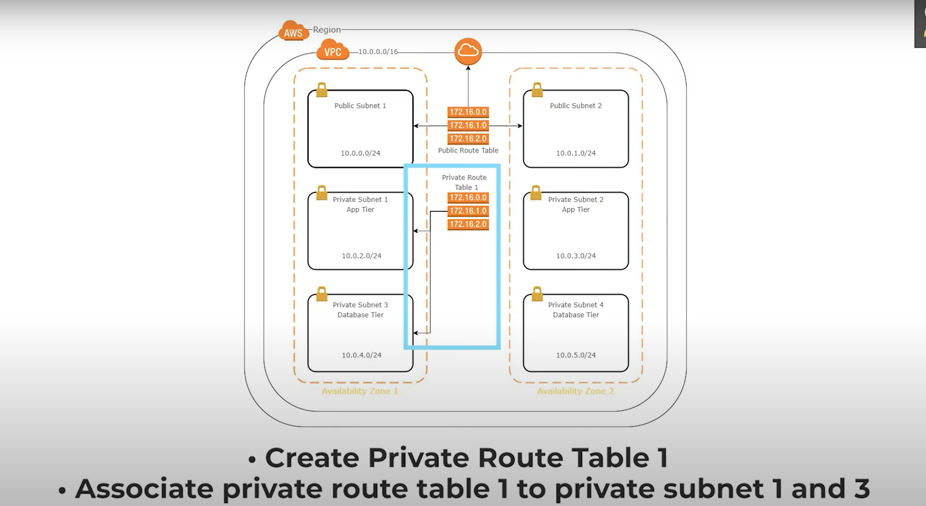

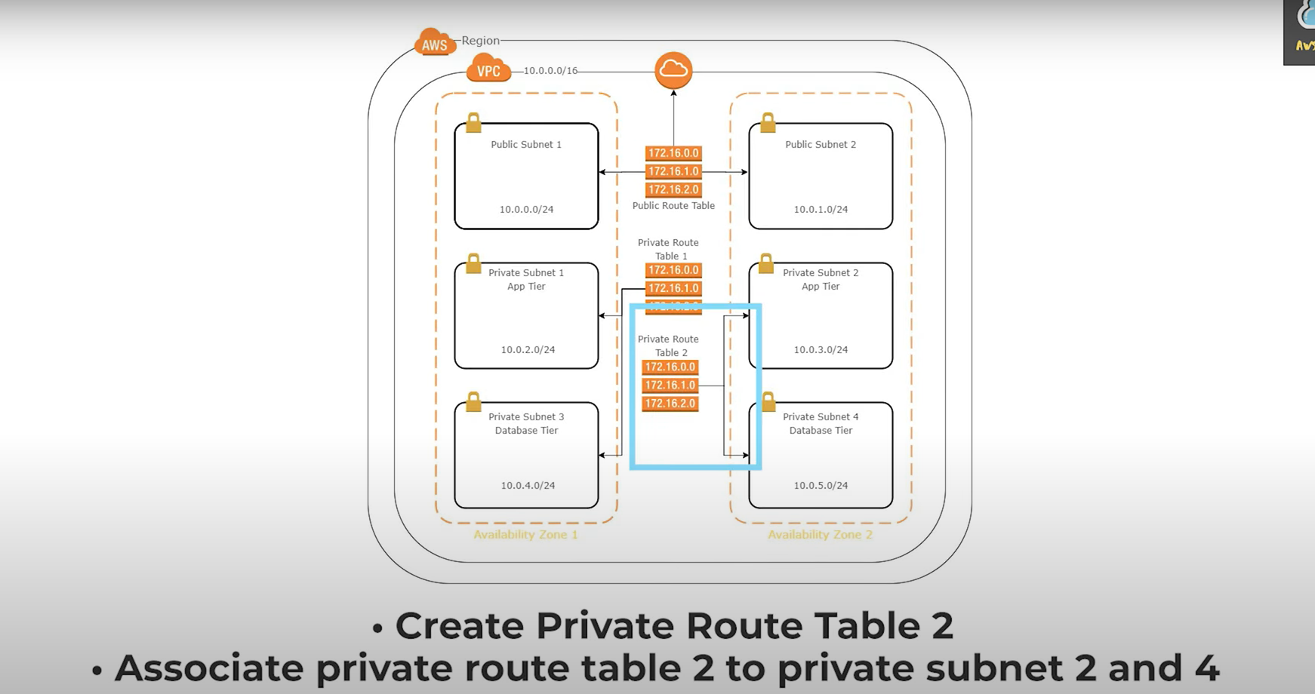

* Follow the step 4 till the Subnet Associations

### Step6: Create two Elastic IP’s

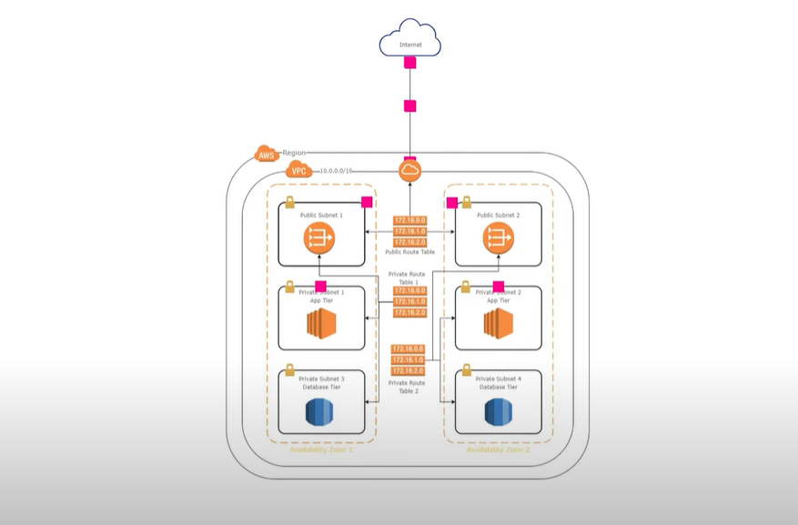

* Select Services🡪Networking & Content Delivery🡪 VPC
* Click on “Elastic IP’s” in the Left pane of AWS dashboard
* Click “Allocate Elastic IP address”

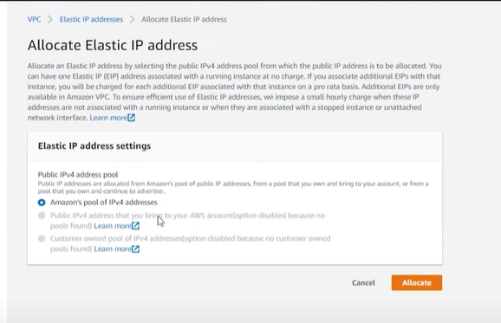

* Click “Allocate”
* Repeat the same step to create another Elastic IP

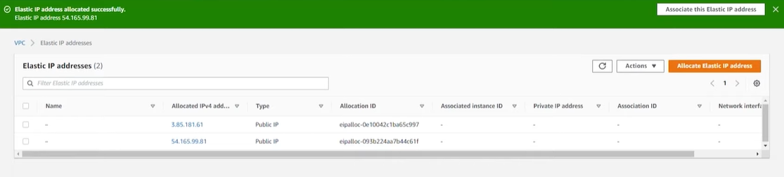

### Step7: Create NAT Gateway

* Select “NAT Gateway” from LP and click **Create**
* Enter the details like Public subnet tag and Elastic IP for NAT gateway & click **Create**

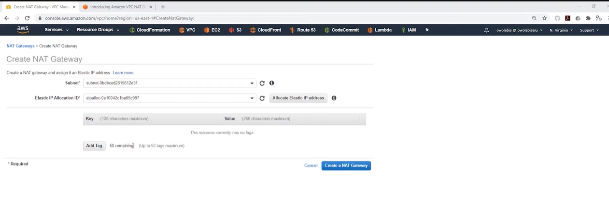

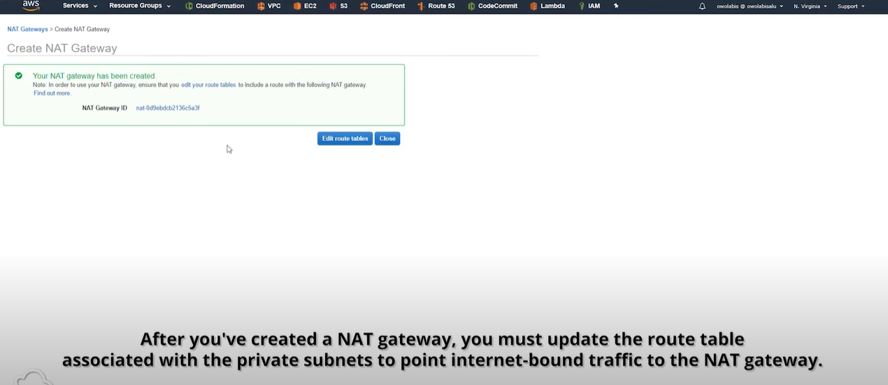

* Click “Edit Routes”
* Select the Private Route table 1 and click “Routes” & Edit
* Enter the Open IPv4 and Target as “NAT Gateway” and click Save

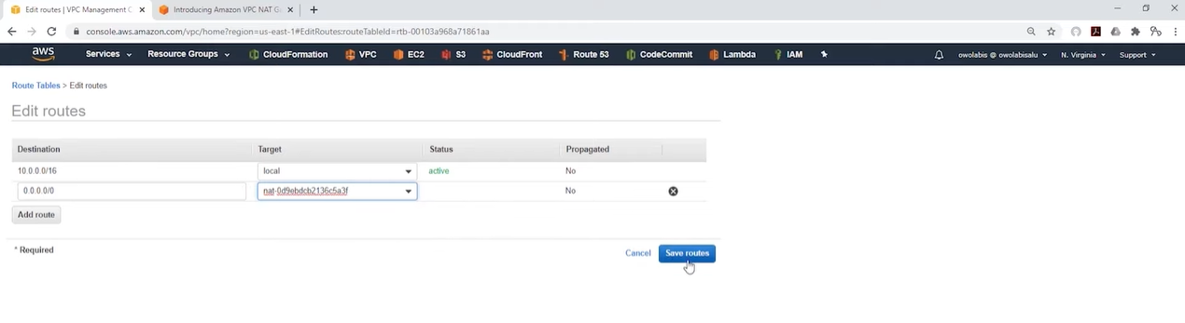

* Repeat the same steps to create another NAT gateway and assign it to Private Route Table 2.

# AWS 3-Tier Architecture with VPC, RDS, ELB:

AWS 3-Tier architecture consists of 3 Tiers namely Presentation Layer, Application Layer & Database Layer.

**Presentation layer** is the layer where the application is running. Eg: Amazon Web Portal

**Application Layer** is the layer where the business logic for computation is present. Eg: Java code, Springboot, Python, NodeJS

**Database layer** is the layer where the data is stored/maintained.

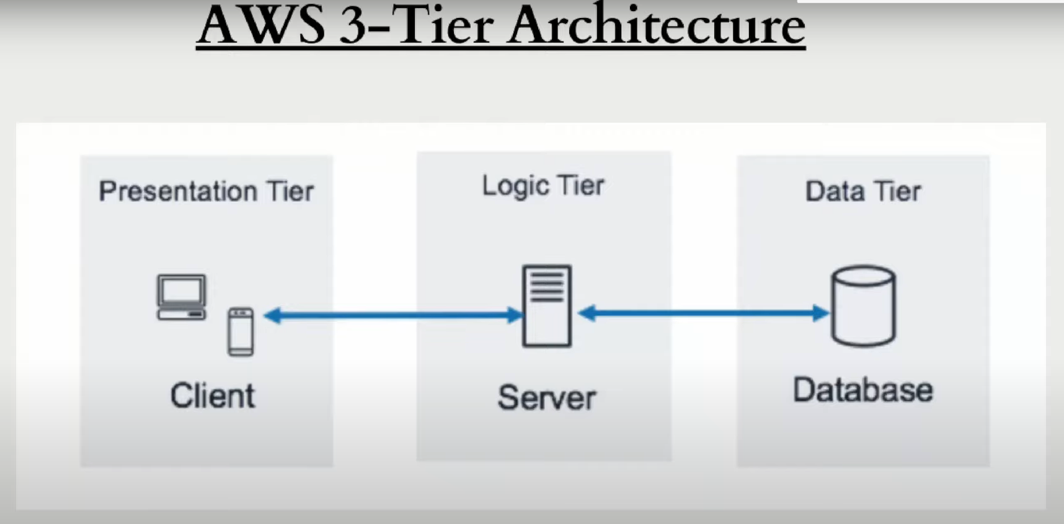

## Steps required for the 3-tier Setup

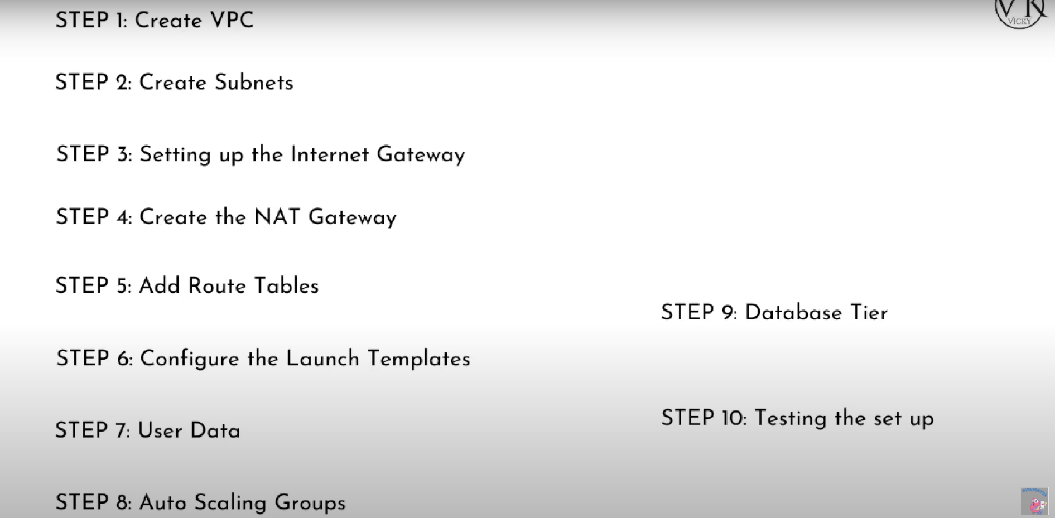

## Steps:

### Step1: Create VPC

* Select region
* Services🡪 Networking & Content delivery🡪 VPC
* Create VPC
* Enter CIDR block
* Create
* The system will automatically create Route table which is private

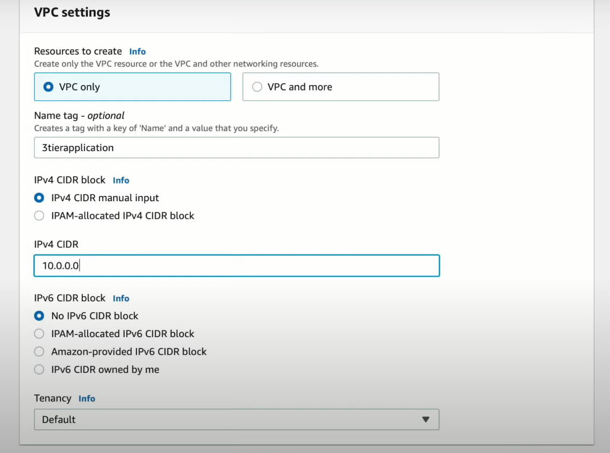

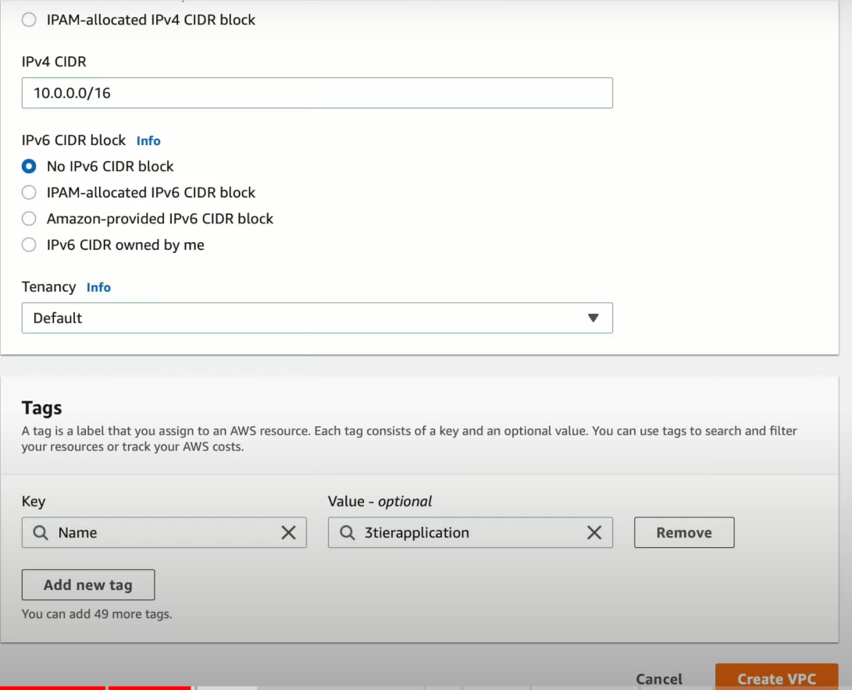

### Step2: Create Subnets

* Click on “Subnets” in Left Pane
* Fill the details like required VPC, Availability zone, Name of subnet(Public subnet1), CIDR block



* Repeat the previous step to create another subnet(“Public subnet2”) and change the Availability Zone alone. Likewise, create two Private subnets for Application Tier in two different availability zones & two private subnets for Database tier in two different availability zones as like Presentation & Application Tier



* To assign IP automatically to this subnet, select the Subnet🡪Action🡪Modify auto-assign IP settings & check-in **Enable** IpV4



### Step3: Setting up the Internet Gateway

* Select Internet Gateway🡪Create
* Give name “Demo IGW”
* Close
* Then Select created gateway🡪Actions🡪Attach to VPC
* Enter the VPC
* Click “Attach”





### Step4: Create Route Table & Subnet Associations



* Select “Route table” in the Left pane of AWS console and select Create
* Enter details like Name & Enter VPC “Demo VPC” & **Create**



* Select created Route Table🡪 Routes
* Enter Route as “0.0.0.0/16” and Target as “Internet Gateway” and **Save Routes**



* To associate the subnets, Select Route table 🡪 Subnet Associations 🡪 Edit



* Check-in the created Subnets and click **Save**
* Create the two private subnets by following the same steps, but it doesn’t have any Internet gateway associated with it









After Subnet creation:



### Step4.1: Create Two Private Route tables and attach it to 4 subnets





Follow the step 4 till the Subnet Associations

### Step5: Create the Elastic IP’s



* Select Services🡪Networking & Content Delivery🡪 VPC
* Click on “Elastic IP’s” in the Left pane of AWS dashboard
* Click “Allocate Elastic IP address”



* Click “Allocate”
* Repeat the same step to create another Elastic IP



### Step5.1: Create NAT Gateway

* Select “NAT Gateway” from LP and click **Create**
* Enter the details like Public subnet tag and Elastic IP for NAT gateway & click **Create**





* Click “Edit Routes”
* Select the Private Route table 1 and click “Routes” & Edit
* Enter the Open IPv4 and Target as “NAT Gateway” and click Save



* Repeat the same steps to create another NAT gateway and assign it to Private Route Table 2.

### Step6: Launch Template

* Go to AWS🡪EC2🡪Launch Template🡪 Create Launch Template
* Give Template Name, Version(optional), Check-in Provide Guidance, **Amazon linux** as AMI, **t2.micro** as Instance Type, Keypair.
* Create new Security group
  + Give name for SG as Web-Tier SG
  + Give our VPC value
  + Enter new Inbound Security group rule for SSH
    - Type-SSH; Protocol- TCP; Port range-22
    - Source- Custom; Source- 0.0.0.0/0
  + Enter new Inbound Security group rule for SSH
    - Type-HTTP; Protocol- TCP; Port range-80
    - Source- Custom; Source- 0.0.0.0/0
* Enter the script in the user-data

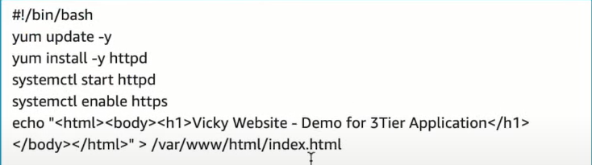

* Go to Auto Scaling🡪 Auto- Scaling Group
  + Enter the name of the Auto-Scaling Group as LT3tierApplication
  + Template as the one which we created.

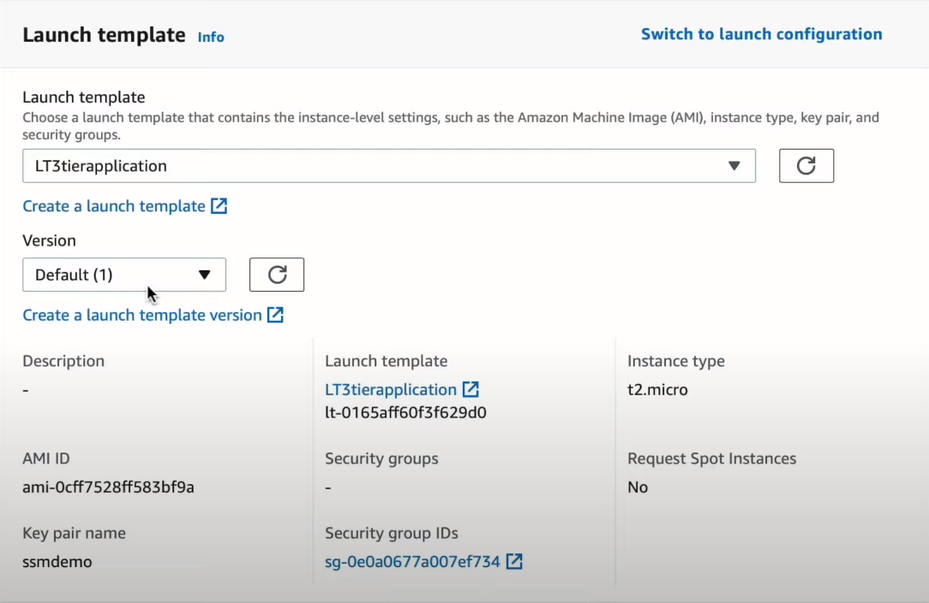

* + Select our VPC

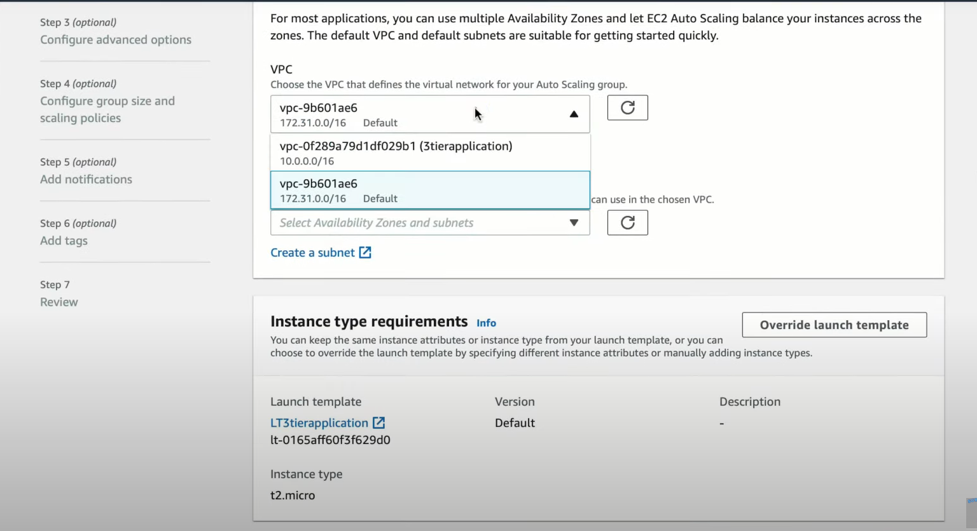

* + Availability zones as our two public subnets

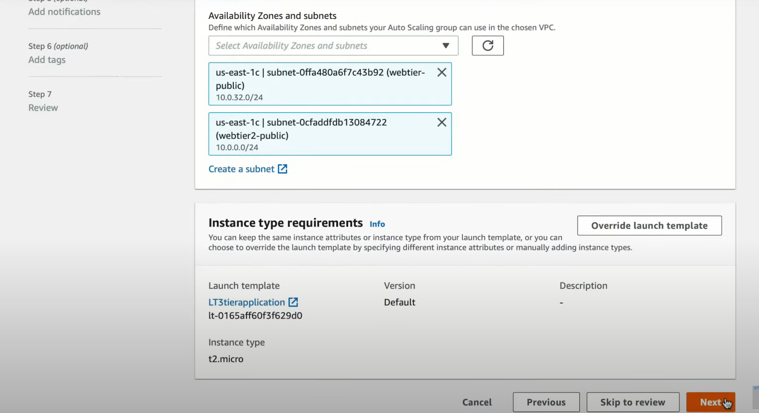

* + No ELB as of now, give the size as Minimum capacity, Desired Capacity, Maximum capacity as 1.
  + Give the Tag as **Web-Tier Machine**

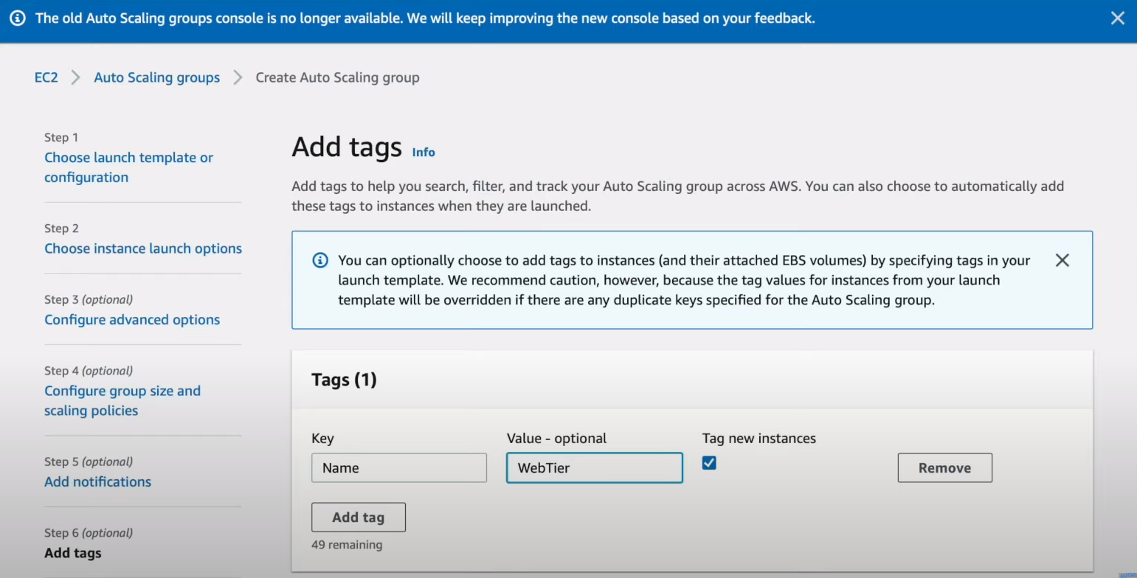

* + Then click create
  + This will create the Auto-scaling group for the Web-Tier
* Similarily, create Auto-scaling group for Application tier with new Launch template for Application-Tier with VPC as our VPC, SG with Following Inbound rules
  + Enter new Inbound Security group rule for MySQL/Aurora
    - Type-MySQL/Aurora; Protocol- TCP; Port range-3306
    - Source- Custom; Source- 0.0.0.0/0 or **SG of Database** tier
  + Enter new Inbound Security group rule for **SSH**
    - Type-SSH; Protocol- TCP; Port range-22
    - Source- Custom; Source- 0.0.0.0/0 or **SG of Web-tier**
  + Enter new Inbound Security group rule for HTTP
    - Type-HTTP; Protocol- TCP; Port range-80
    - Source- Custom; Source- 0.0.0.0/0

### Step7: Create Database

* Create RDS by choosing RDS🡪 Create Database
* Enter details like **Standard** as Creation method, **Free tier** as Template, **MySQL** as Engine & version, Give credentials details in **Credentials settings**, **Burstable classes &** change tier as **t2.micro** in Instance configurations.
* Select our VPC in the connectivity.
  + Create Subnet group🡪New subnet group
  + Set Public access as **‘No’**
  + VPC Security group🡪 Create New
    - We can give ***availability zone preference***
    - Db port as **3306**
* Database Authentication
  + Enable Password authentication
* Then click Create Database

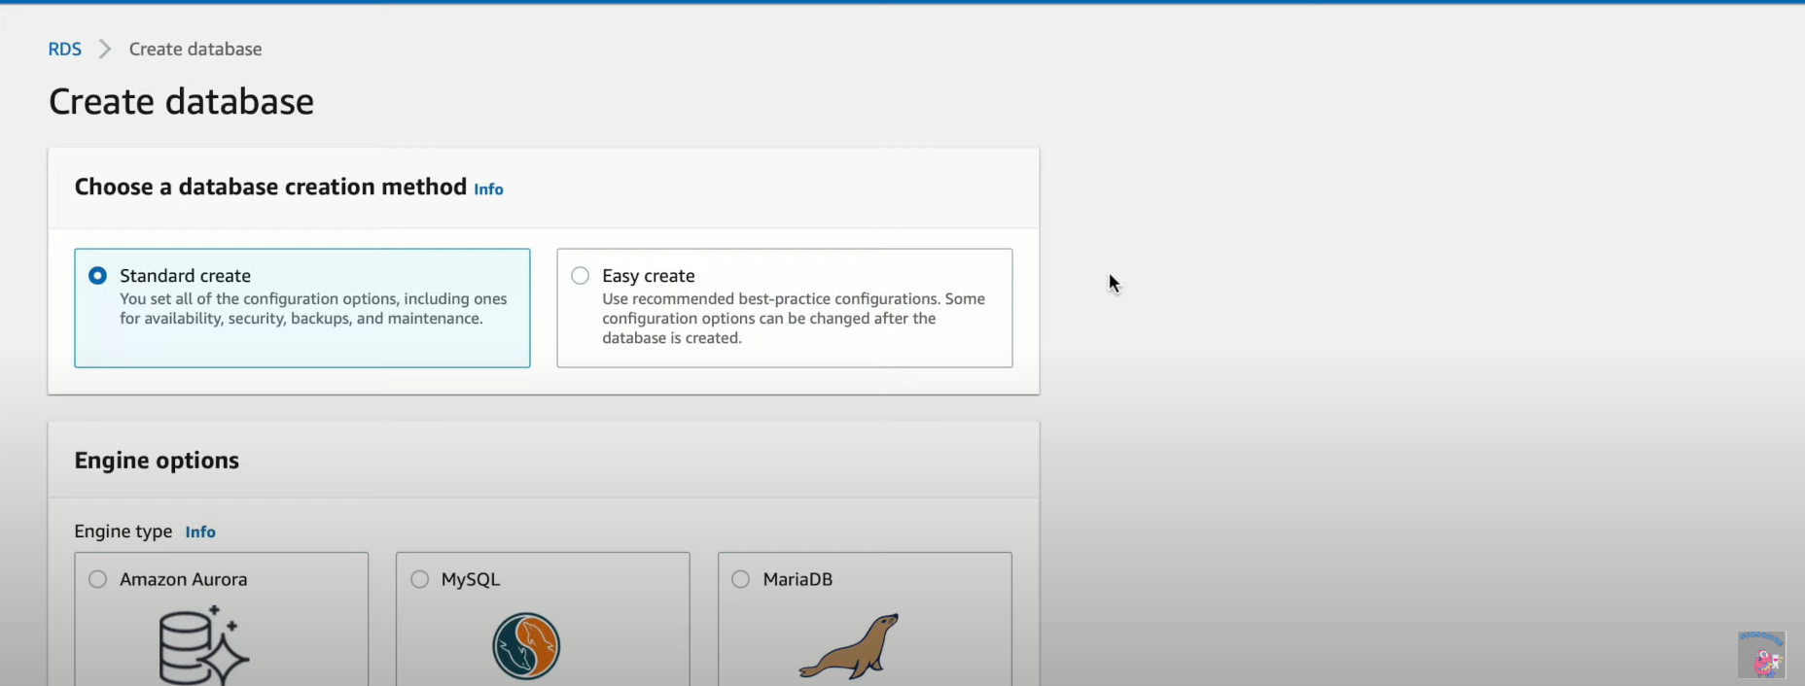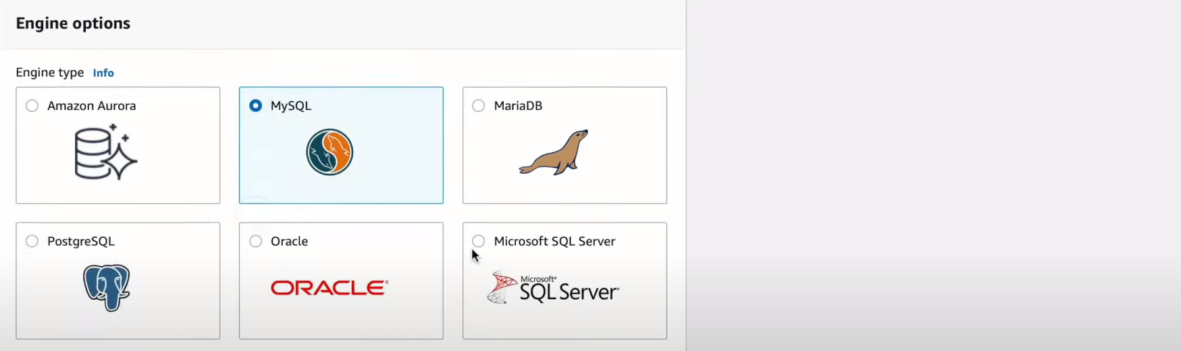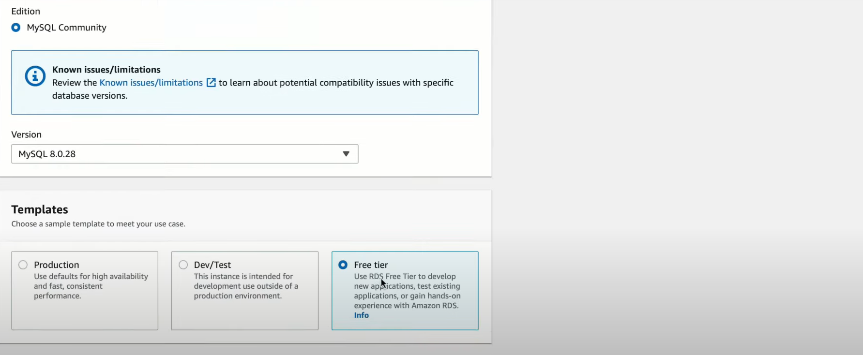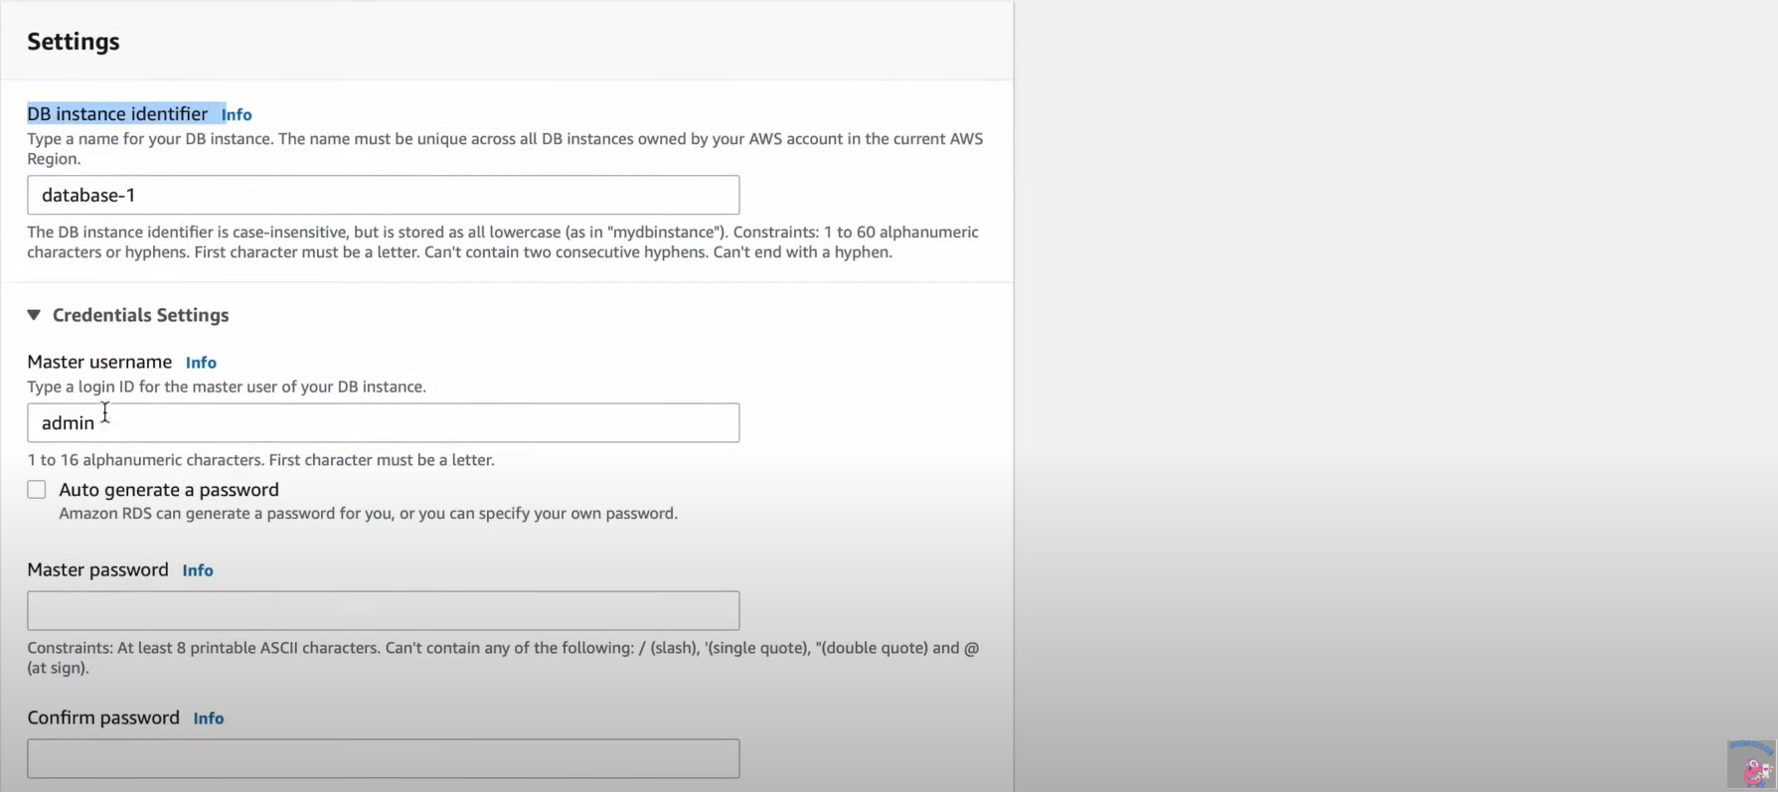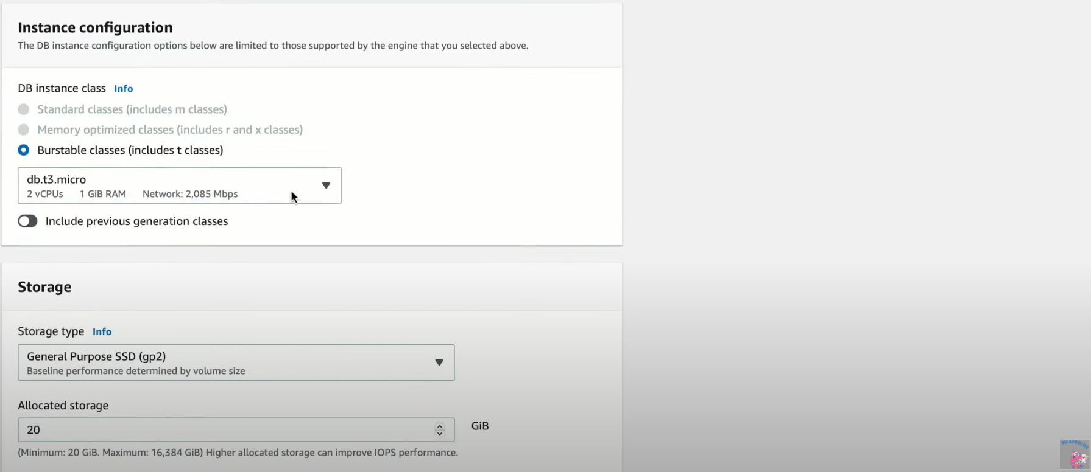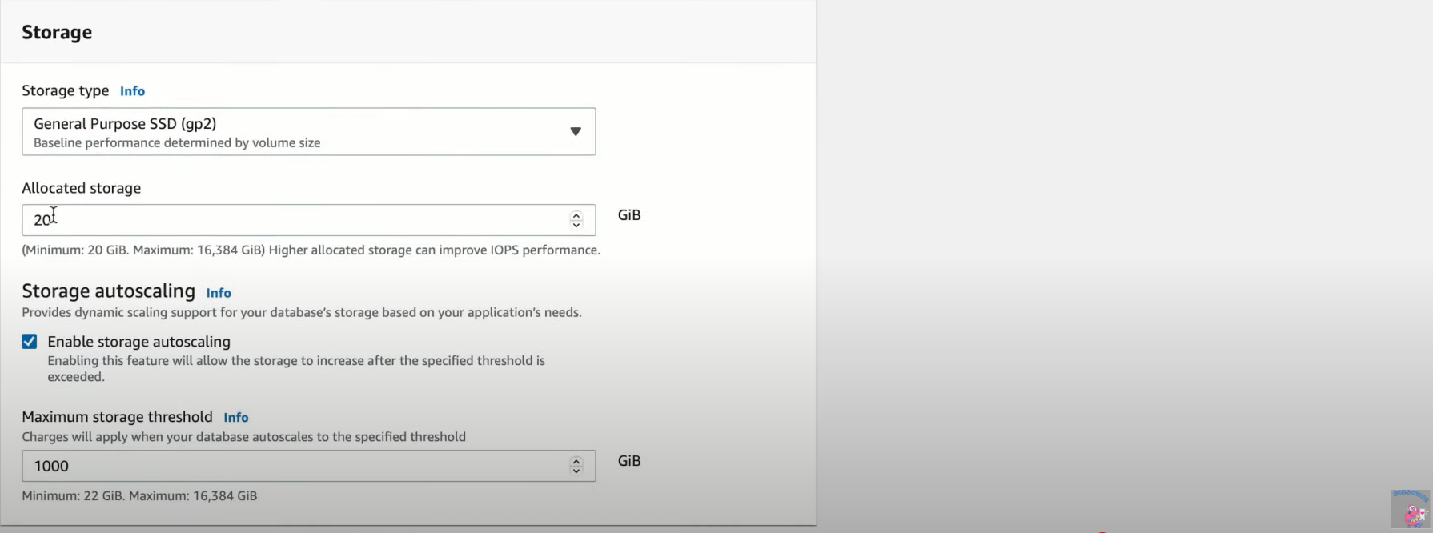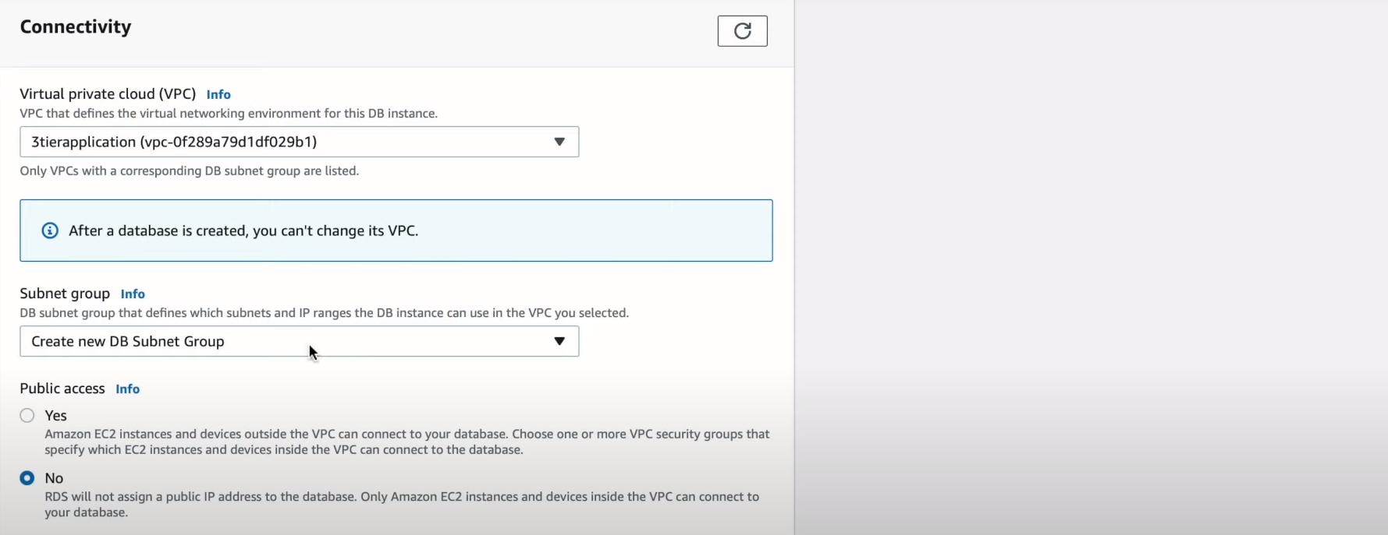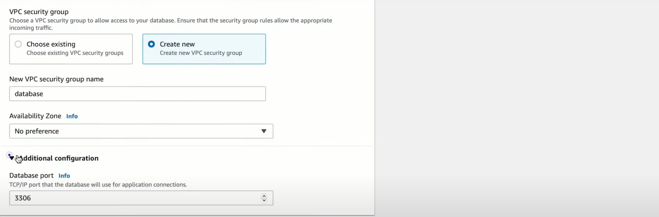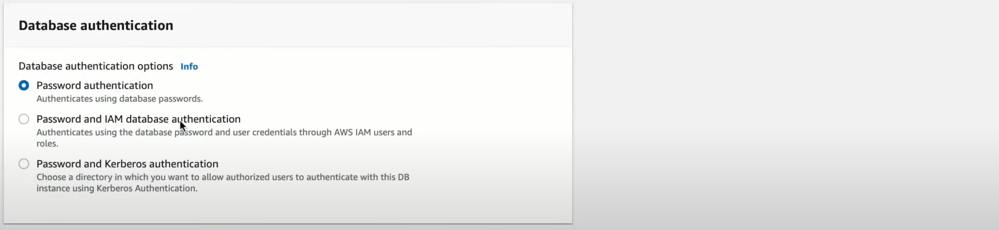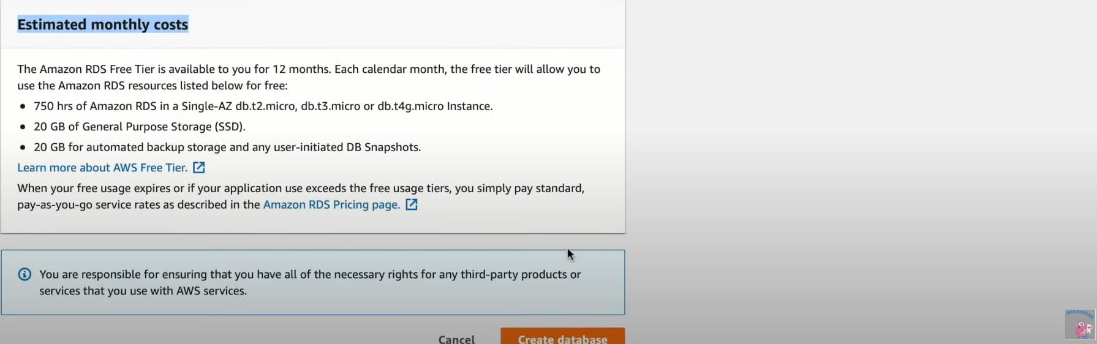

* This will create the database.
* Once the database is created, take the **SG of this database and paste it in the inbound traffic of the Application Tier**

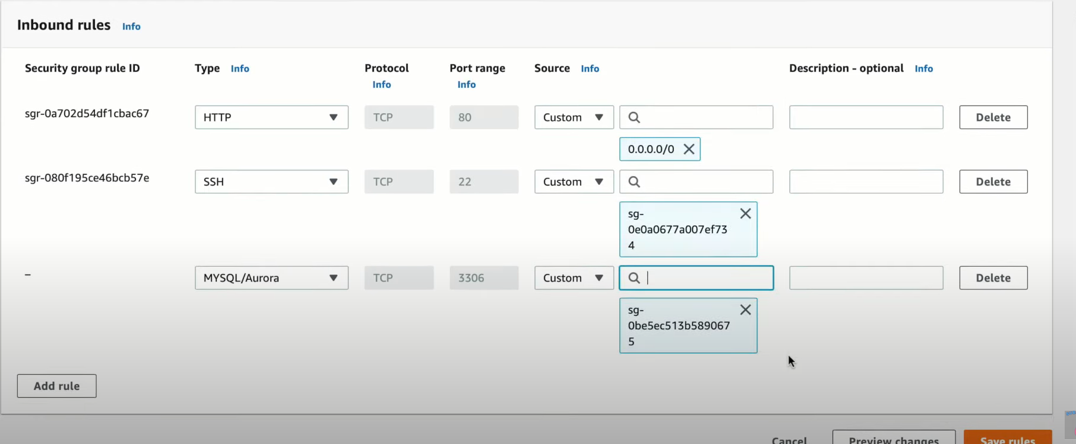

### Step8: Enable connection between the 3 Tiers

* Login to Web-tier instance, copy the ssh key file and paste it into Application-tier instance or use cmd: ssh-copy-id ec2-user@<pvt Ip of application tier>
* To check connection, cmd: ping ec2-user@<pvt Ip of application tier>
* To connect Database & Application tier
  + Copy the endpoint of Database from Console
  + Install MySql in Application-tier console:
    - Cmd: sudo yum install mysql -y
  + Command to establish connection for database:
    - Cmd: mysql -h <end-point> -P 3306 -u <username of db> -p <password of db>

# AWS CloudWatch Setup

AWS CloudWatch is the feature provided by the AWS to Collect, Monitor, Act, Analyze the resources which are part of our AWS project. We can visualize the logs colleted by CloudWatch by using the dashboards provided by the AWS.

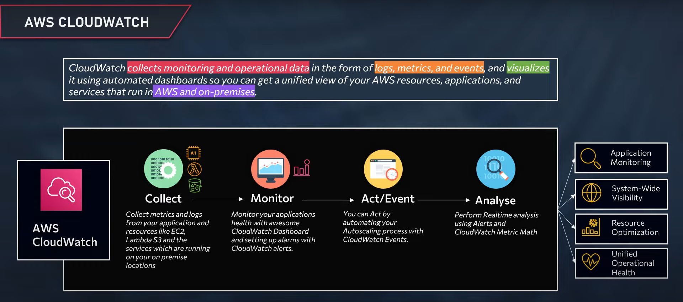

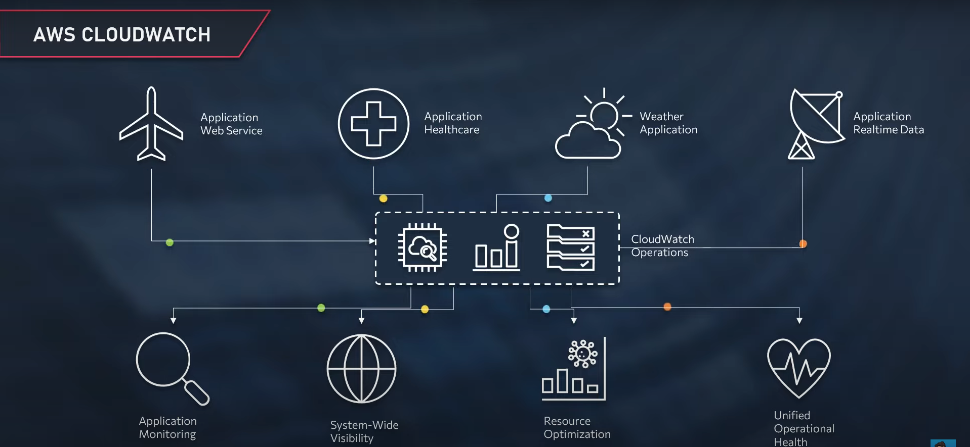

## Four Pillars:

* Collect
* Monitor
* Act
* Analyze

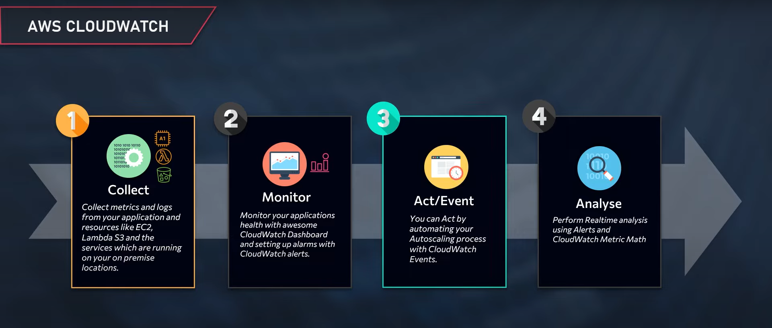

## How CloudWatch Works?

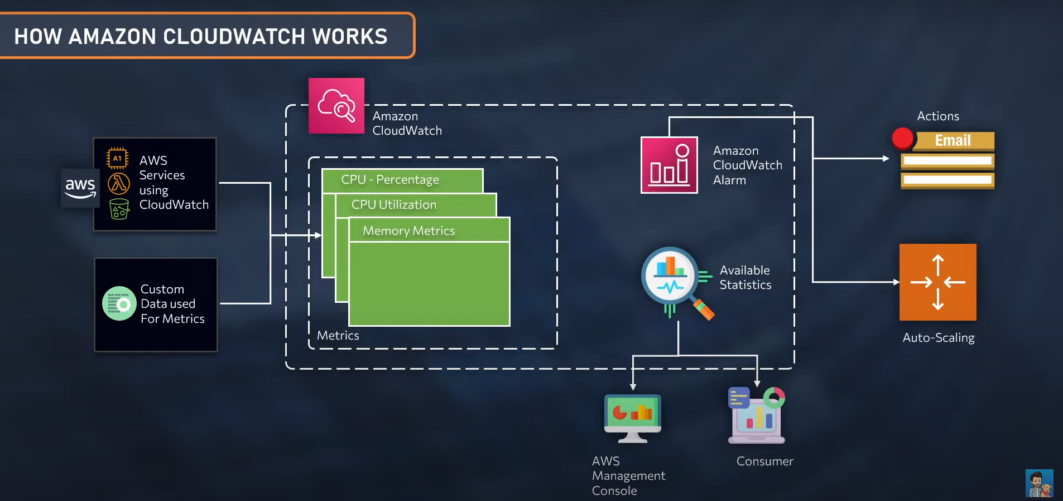

## Implementation of Four Pillars:

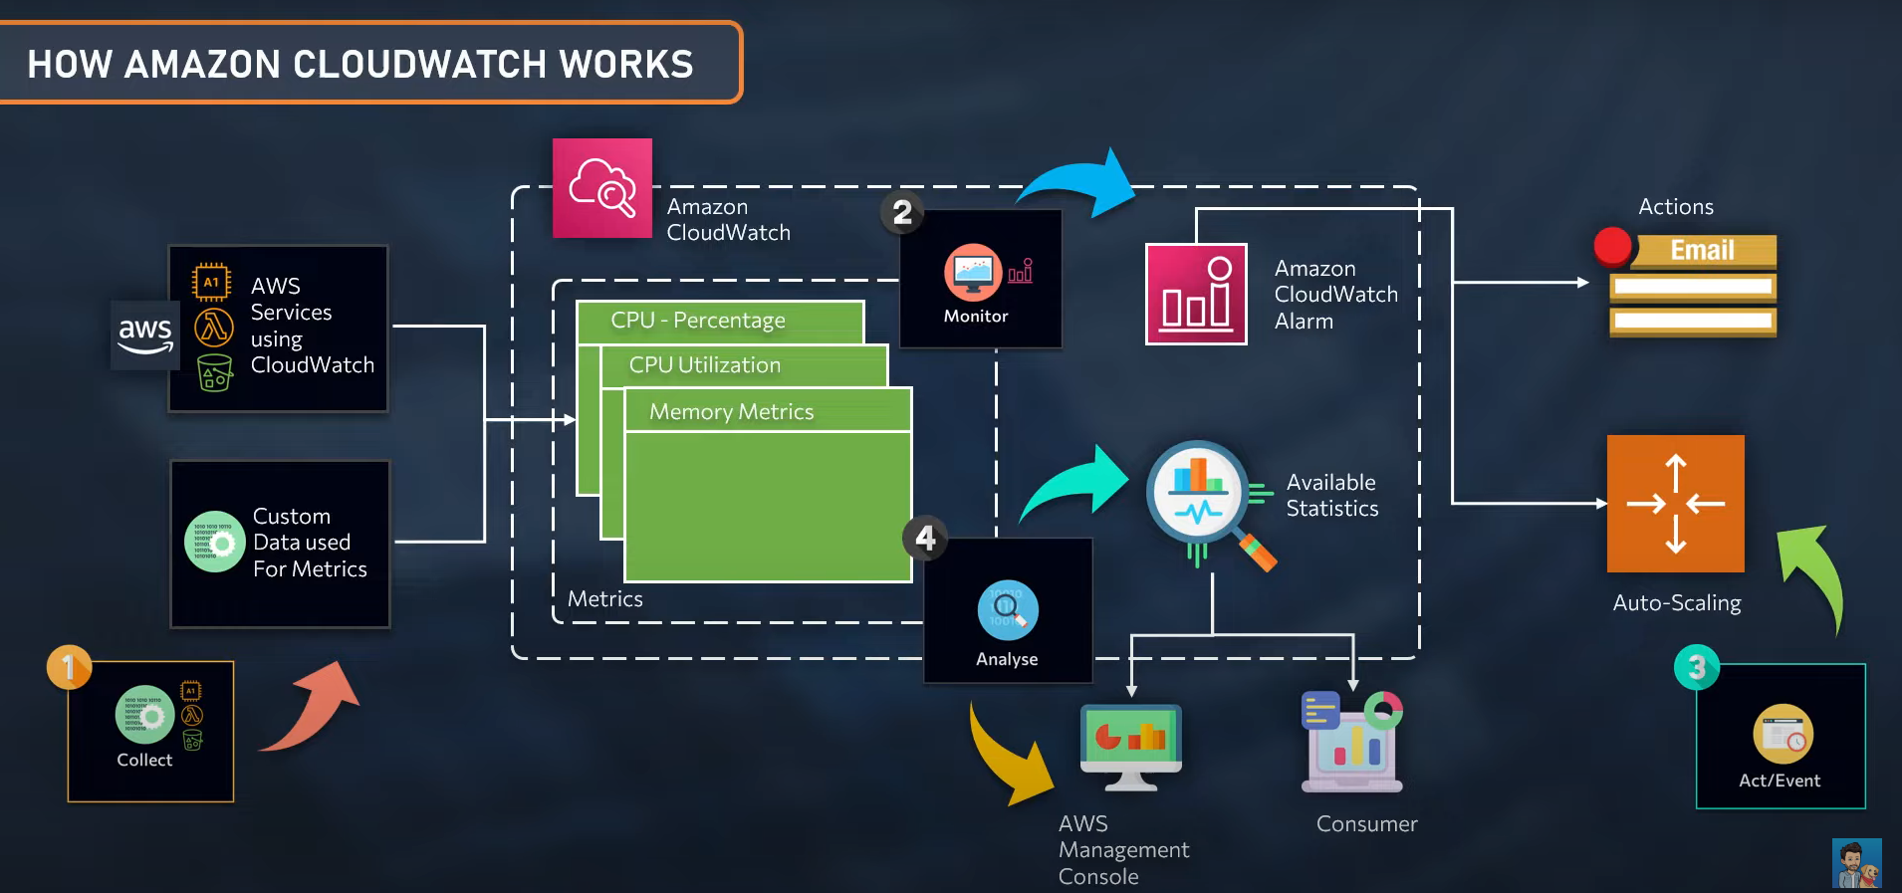

CloudWatch events:  
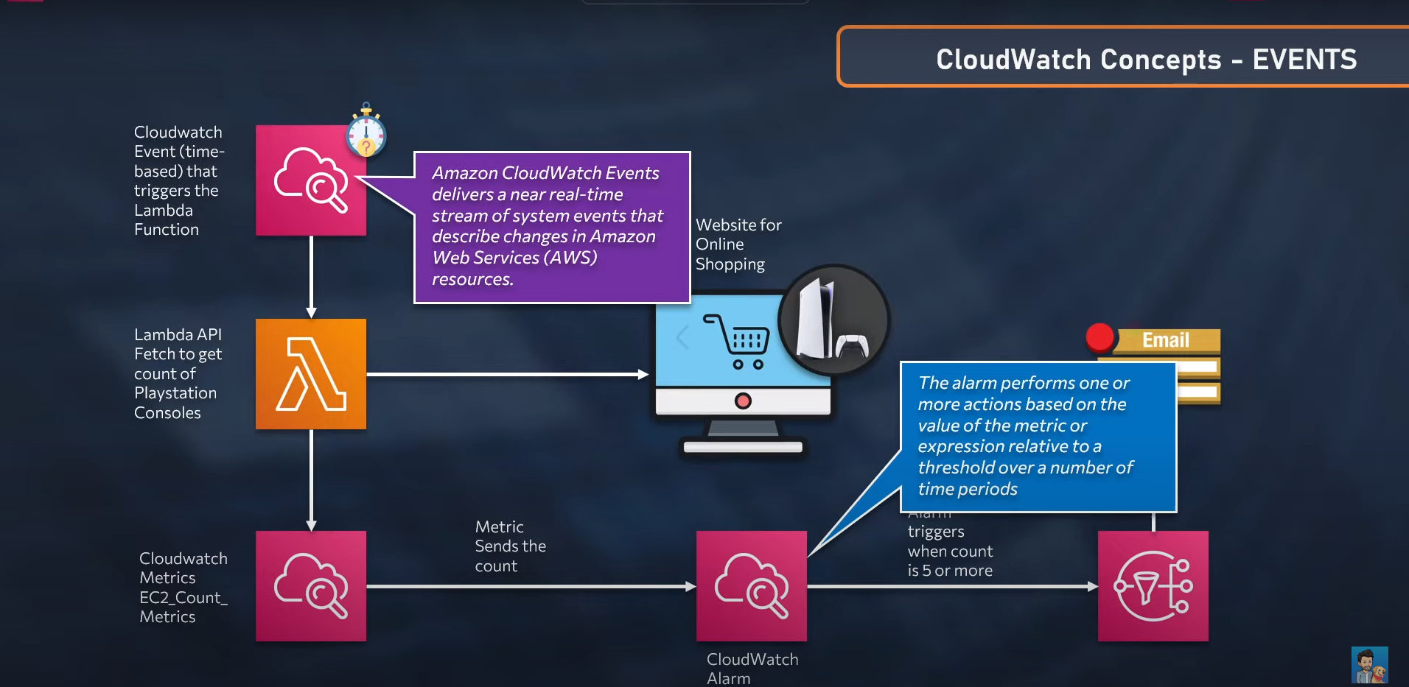

* Suppose we wish to be notified whenever there is a stock for PS5 consoles, we can write a Lambda API fetch to get the count of PS5 consoles(not to try this as this is unethical, mentioned here just for an example). We can setup an event to trigger the Lambda API fetch to trigger once in every minute.
* Data fetched through Lambda API fetch is sent across Cloudwatch Metrics.
* We can setup an cloudWatch Alarm which is based on the count delivered from the metrics, when the count is more than 5 or so, then CloudWatch will notify us that PS5 is available via Mail through SNS.

## CloudWatch Alarms:

* You can use an alarm to automatically initiate actions on your behalf.
* Alarms keeps on focussing over a single metric over a period of time.
* Action: Notify to SNS topic or to an Auto Scaling group
* Measures a change of state over a set number of time & a period of time.

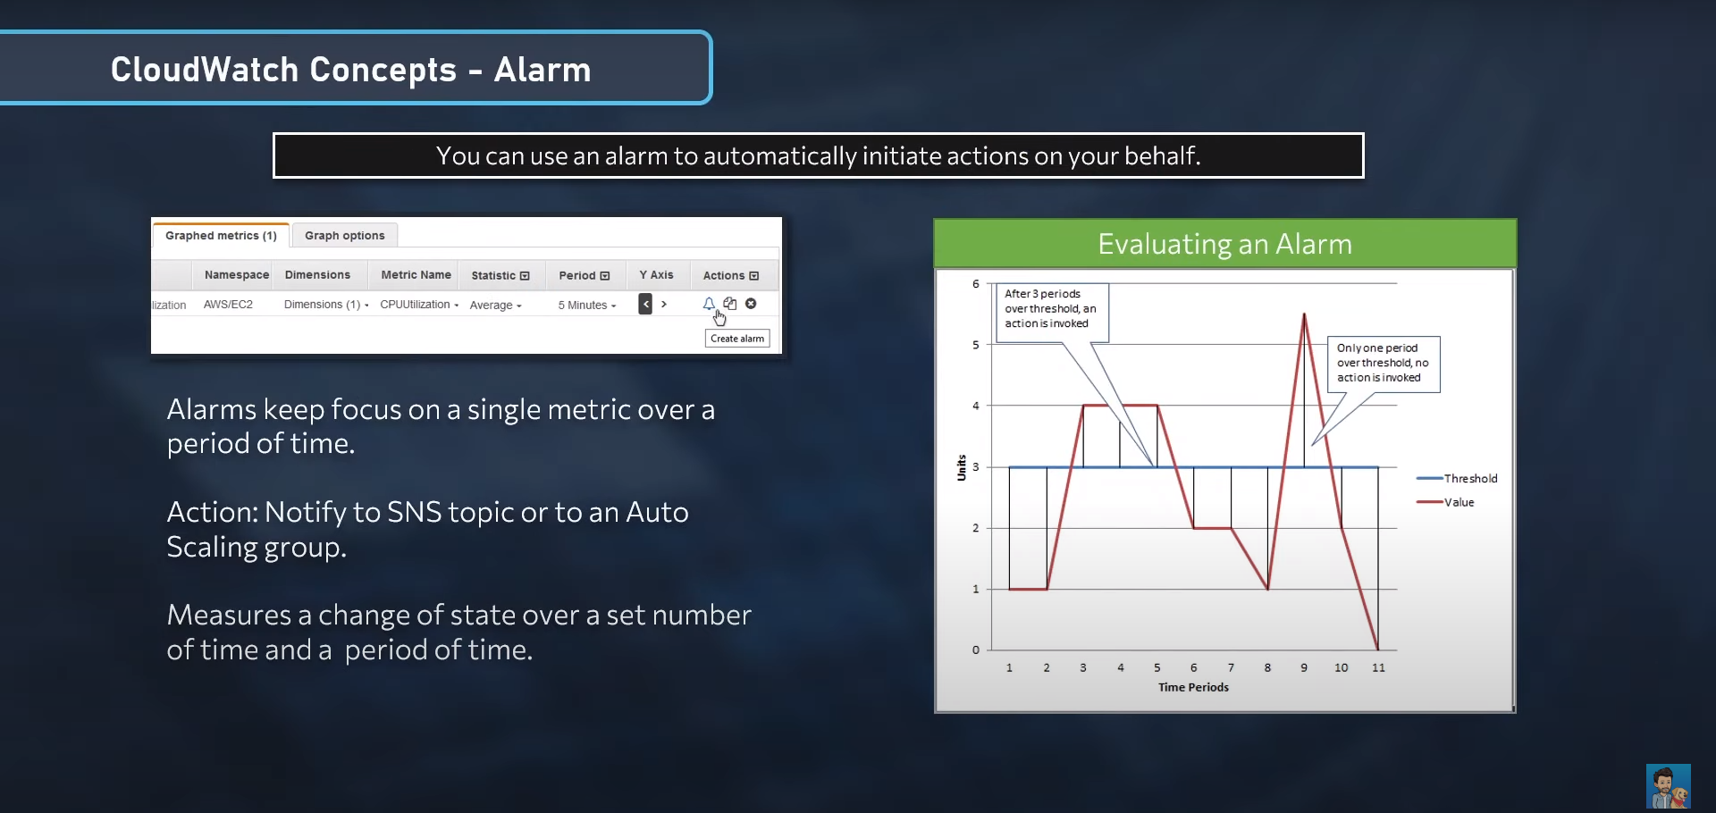

* When you create an alarm, there are 3 settings to be set.
  + Period: The length of time to evaluate the metric or expression to create each individual data point for an alarm.
  + Evaluation periods: The number of the most recent periods, or data points, to evaluate when determining the alarm state.
  + Datapoints to Alarm: The number of data points within the evaluation periods that must be breaching to cause the alarm to go to the ALARM state.

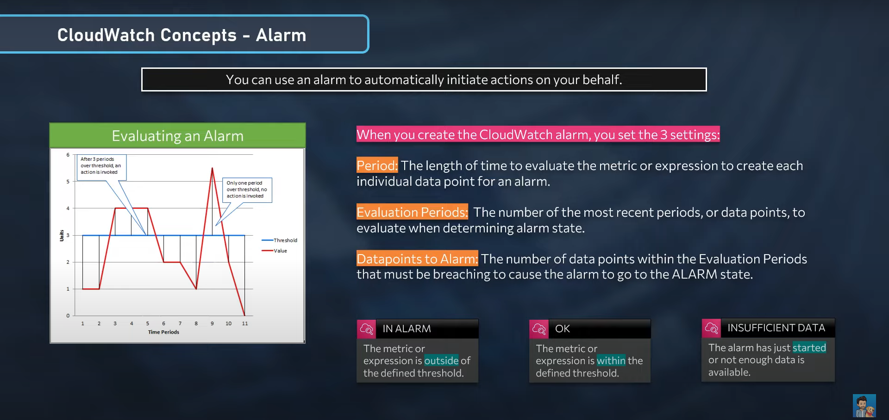

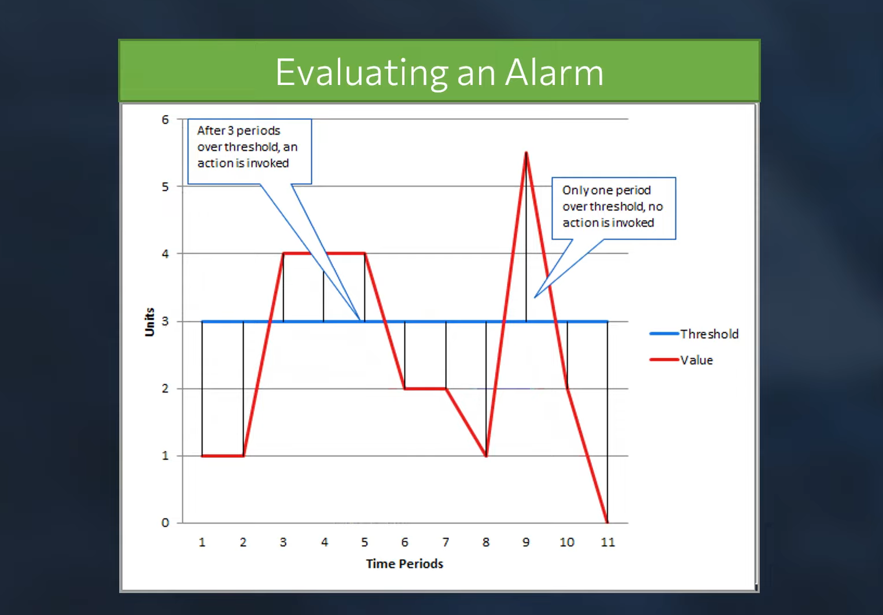

## Design- Autoscaling with CloudWatch Alarms:

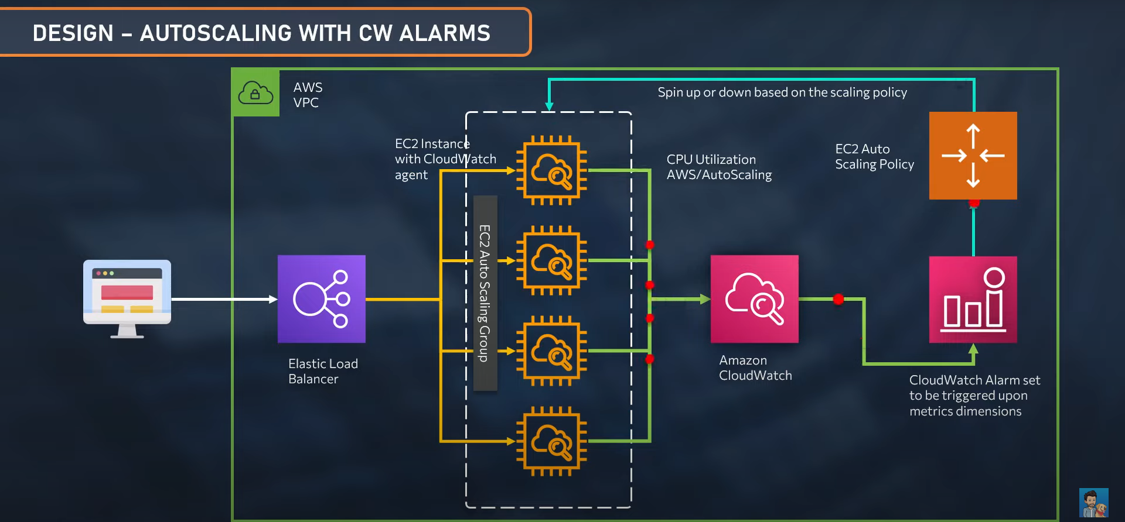

## Create Alarm with SNS notification for CPU utilization:

### Steps:

* Go to AWS🡪Cloudwatch🡪Metrics

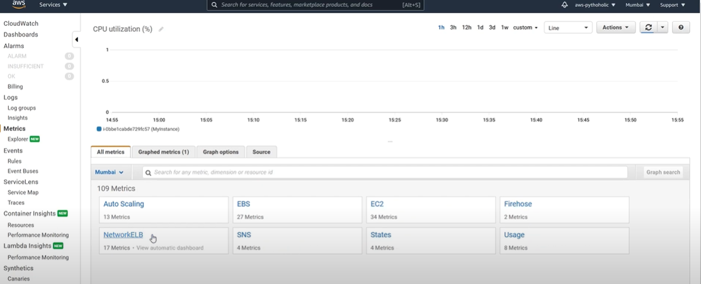

* Select the **required instance** from All Metrics and click ‘Alarm’ icon in the instance line.

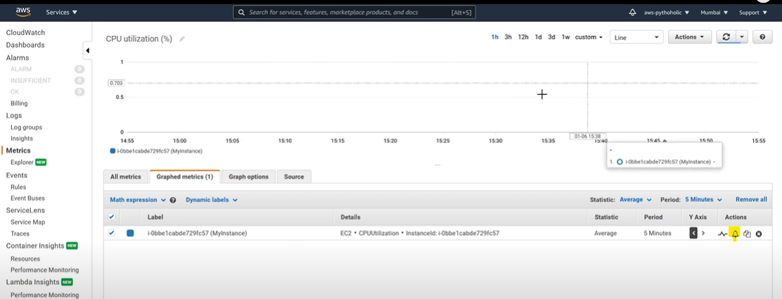

* Enter Metric name, Instance Id, Statistics, Period as **1 minute**, Threshold type as **Static**, Whenever CPUutilization is **greater than 0.6** & Click **Next**

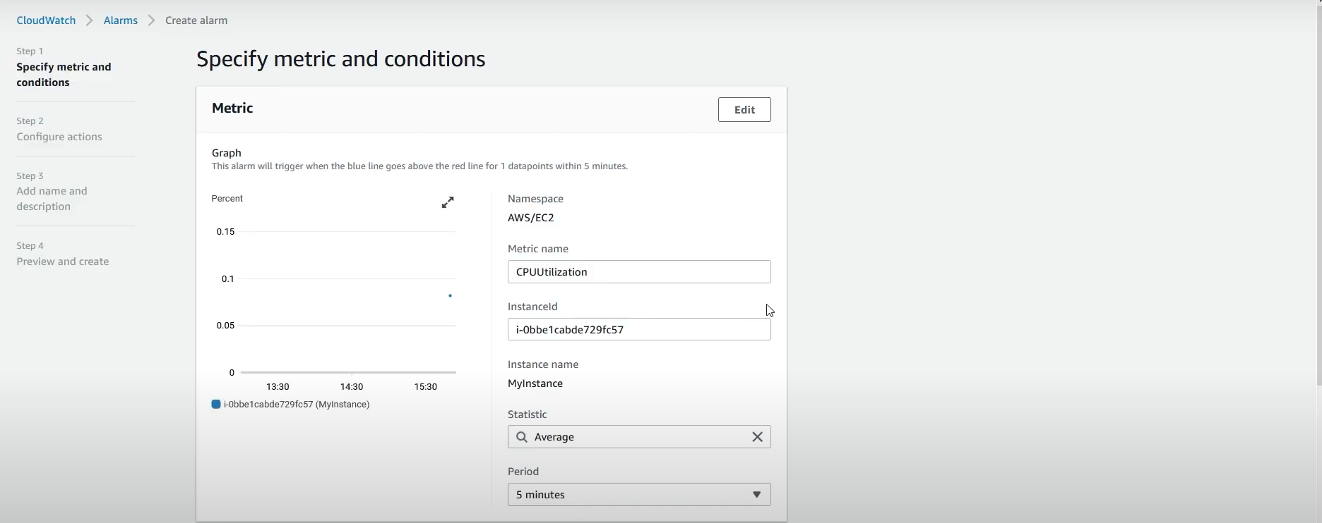

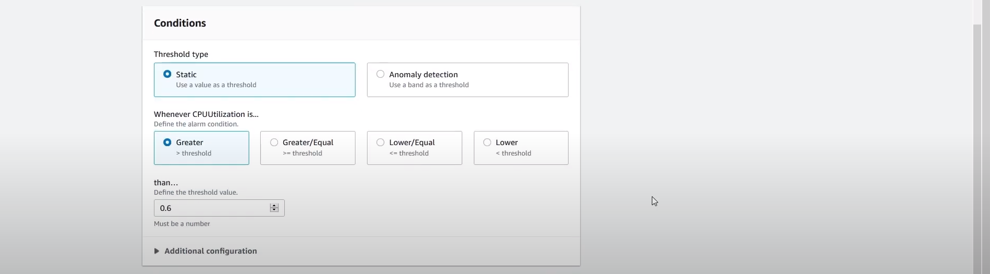

* In Configure actions, Alarm state as **In Alarm**, Select an SNS topic as **Create new topic,** Email endpoint as **Mail Id** & click Create Topic.

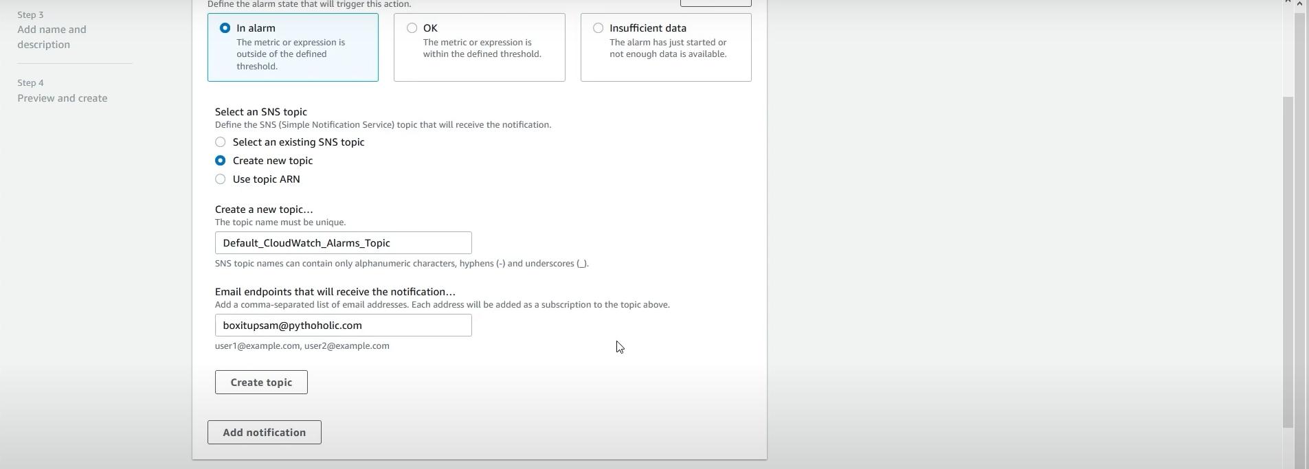

* Enter name for Alarm and click **Create Alarm**
* The Alarm will be created with state as “Insufficient Data”.

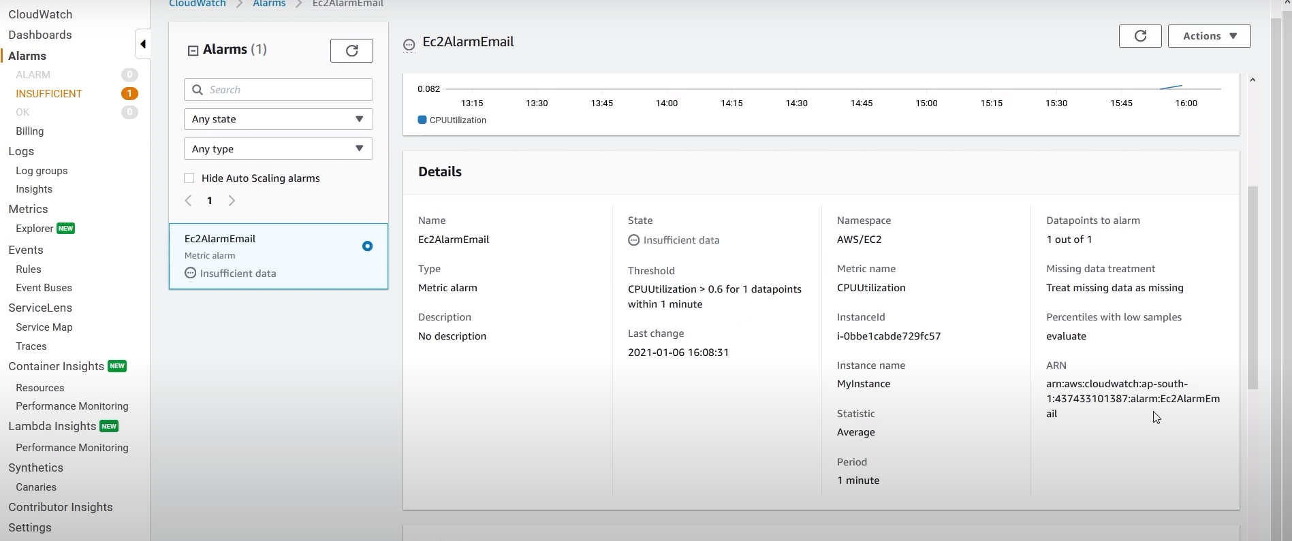

* You can select & create this view as Dashboard.

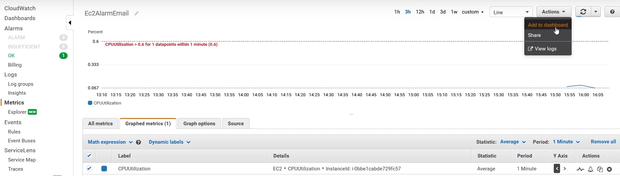

* To test this, install stress application in the Ec2 instance.

Cmd: Sudo amazon-linux-extras install epel -y

Sudo yum install stress -y

Stress –help

Stress –cpu 4 –timeout 180

## Create Alarm with Autoscaling Group for CPU Utilization

To create a CloudWatch Alarm to trigger auto-scaling group to create new instance if the CPU utilization is above mentioned threshold limit.

## Steps:

### Step1: Update Dynamic scaling policy in Auto-scaling group

* Go to EC2🡪Auto-scaling group🡪 Select created Auto-scaling group
* In **Automatic scaling** section, click **Create Dynamic Scaling Policy**

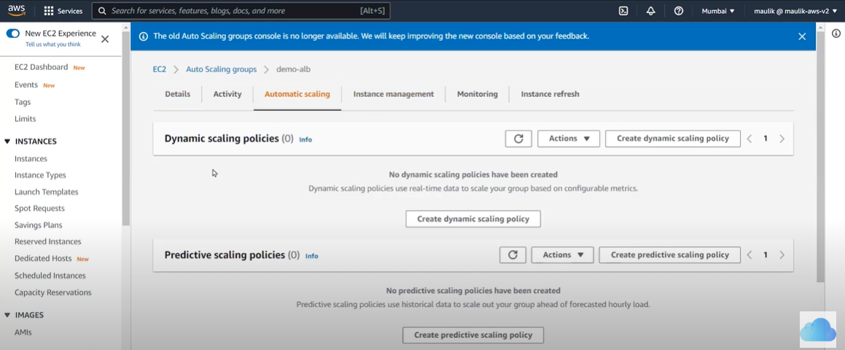

* Enter Policy type as **Simple Scaling,** Policy name as **Policy-1**, Take the action as **Add,** Quantity as **1,** And Then Wait as **60** seconds.

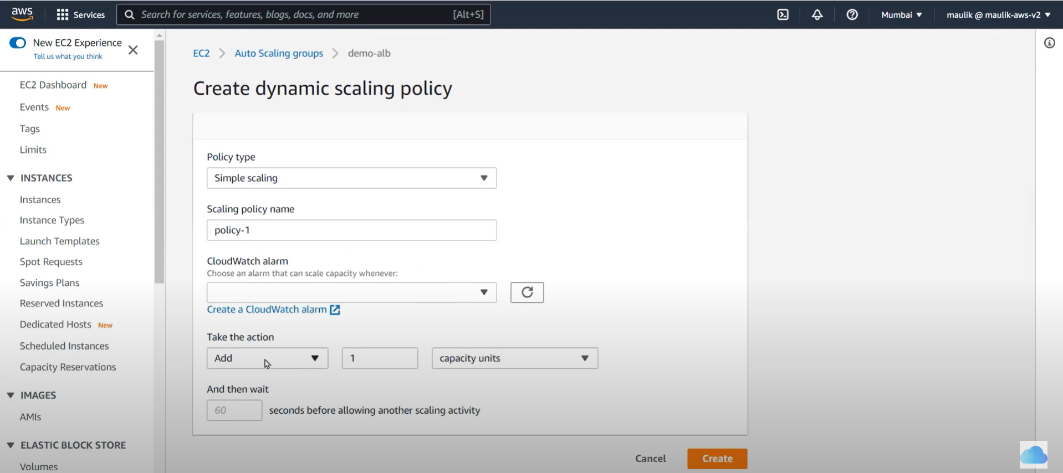

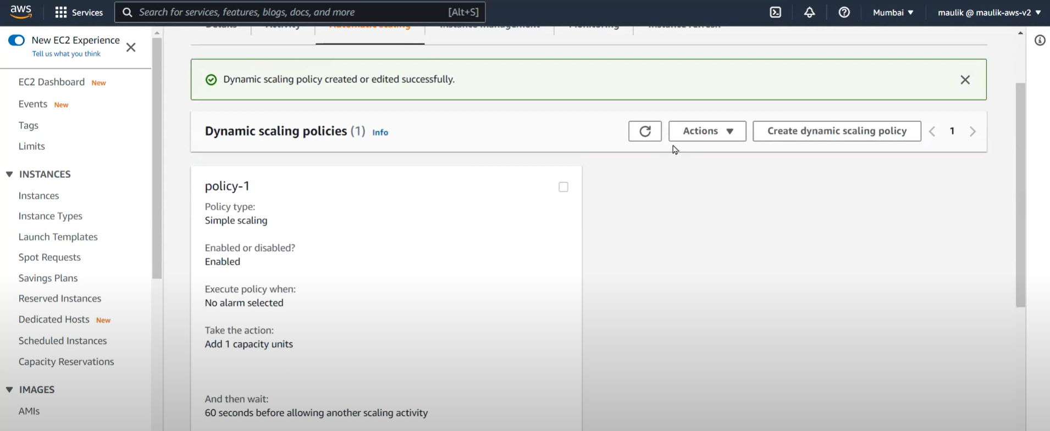

* Similarily, Create another policy. Enter Policy type as **Simple Scaling,** Policy name as **Policy-2**, Take the action as **Remove,** Quantity as **1,** And Then Wait as **60** seconds.

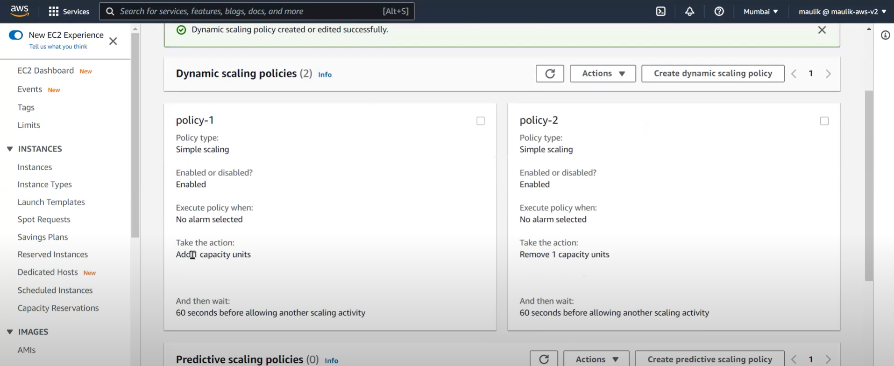

* You can update Desired capacity in Auto-scaling group as ‘1’ in Edit mode to create a new instance for the group.

### Step2: Create CloudWatch Alarm

* Go to AWS🡪 CloudWatch🡪 Alarm🡪 Create 🡪 our Auto-scaling group.



* Enter Metric name, Autoscaling group name, Statistics, Period as **1 minute**, Threshold type as **Static**, Whenever CPUutilization is **greater than 50 &** Click **Next**

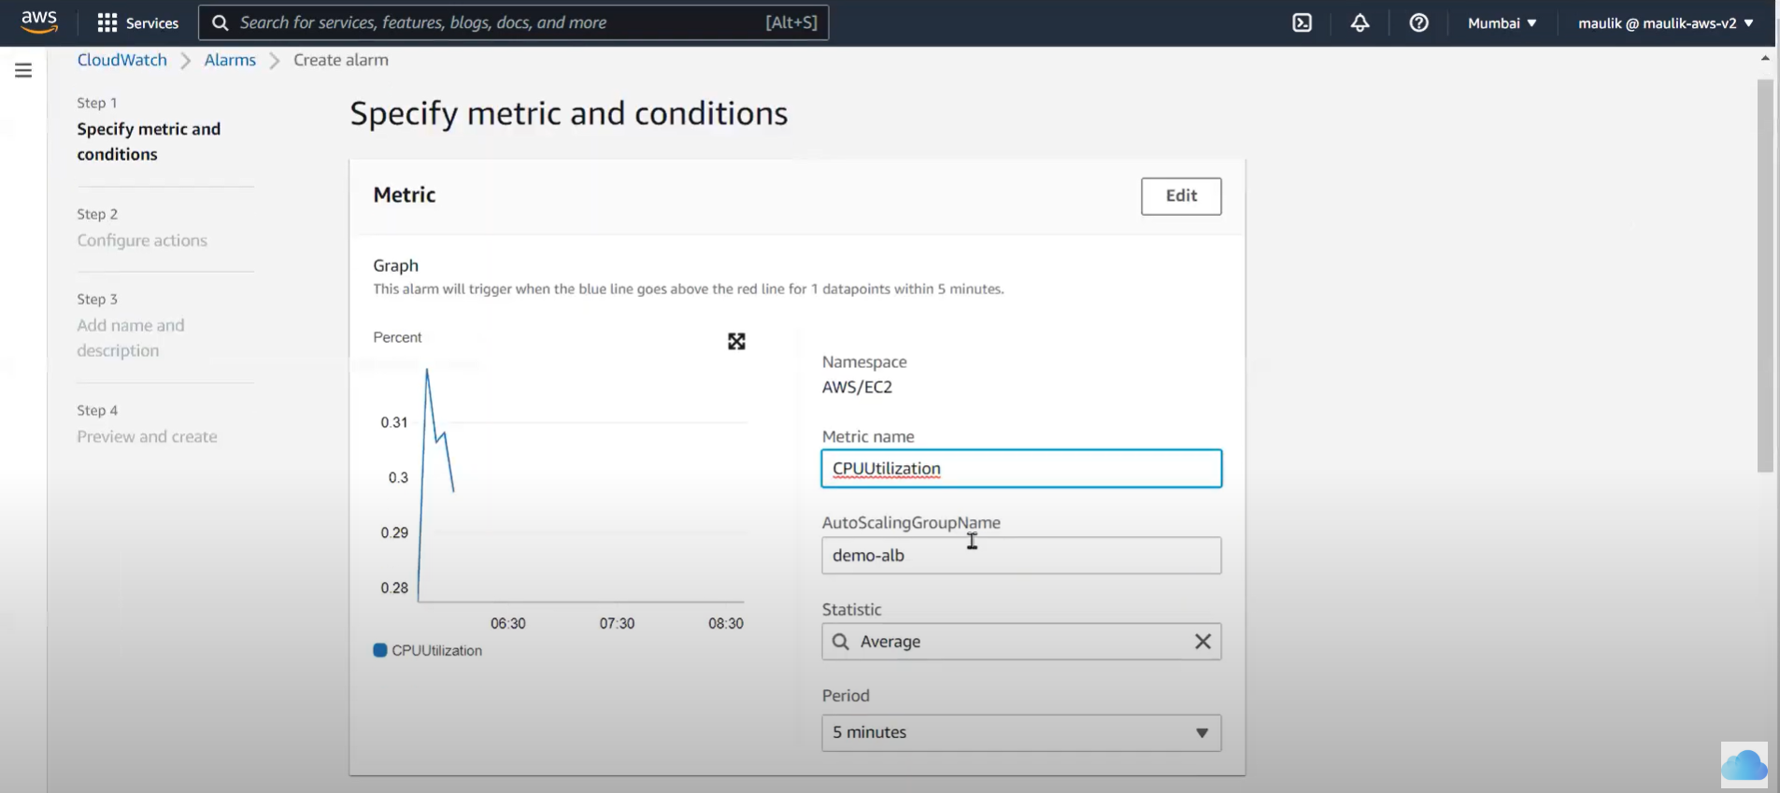 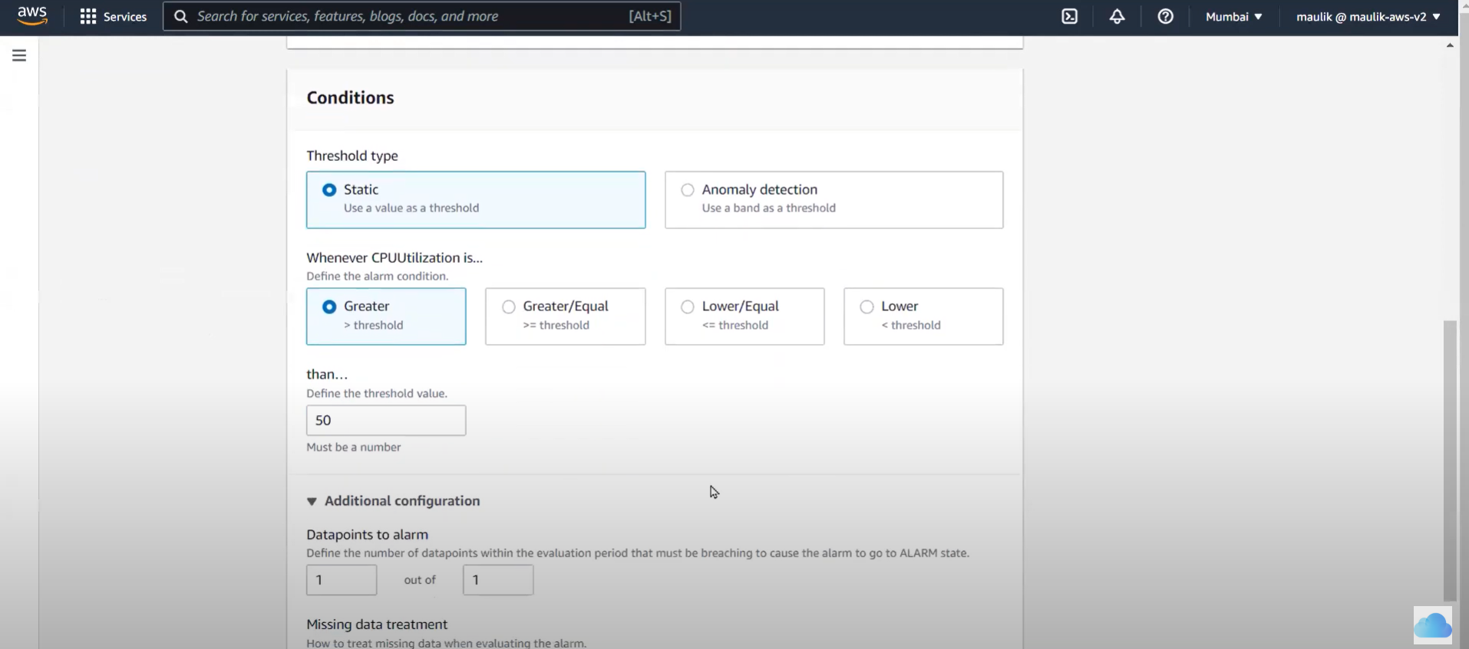

* In Configure actions, Remove Notifications. Click **Add Autoscaling action.**
  + Alarm state trigger as **In-Alarm,** Resource Type as **EC2-Autoscaling group &**  Select our **Auto-scaling group,** Take the following action as **“Policy-1”** & click **Next**

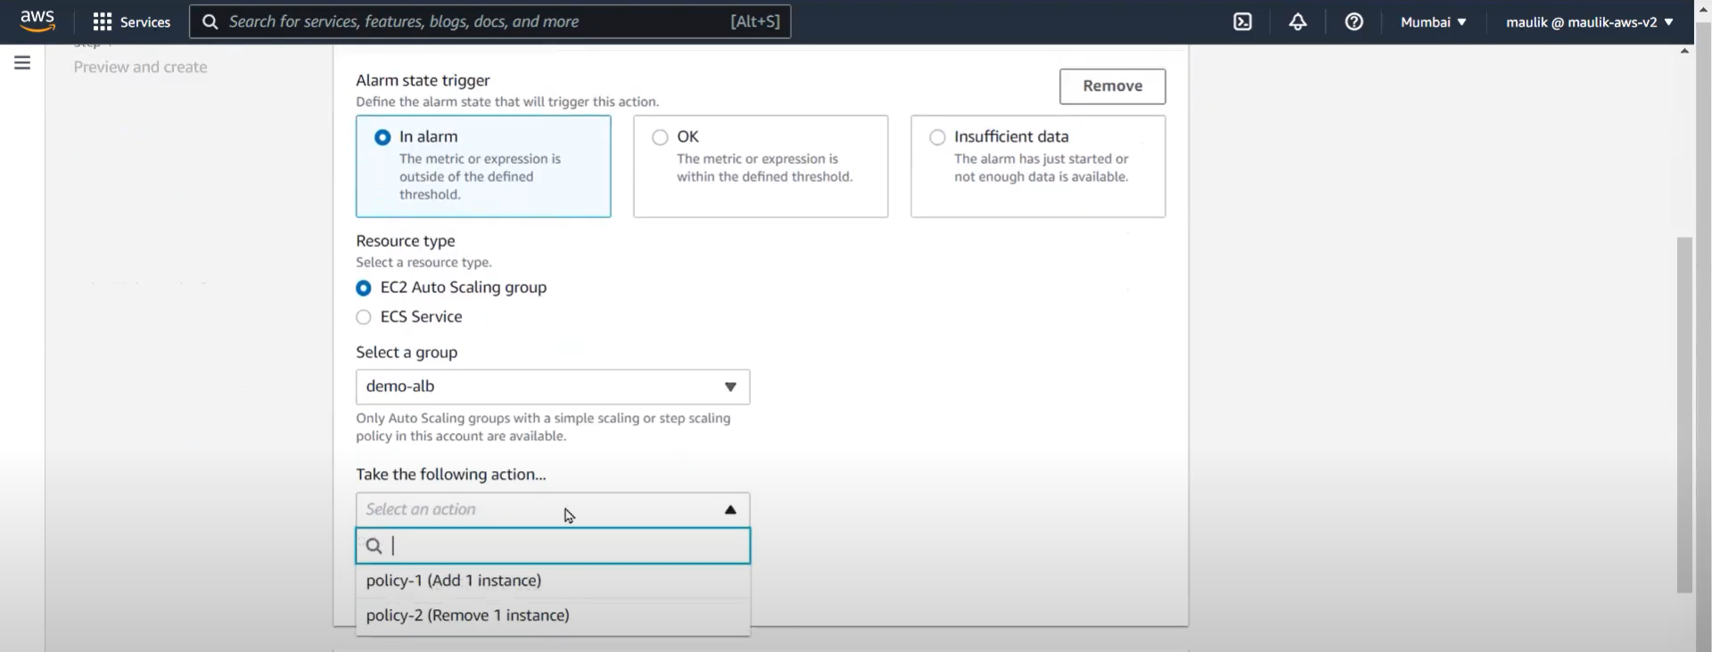

* Enter name for Alarm and click **Create Alarm**
* The Alarm will be created with state as “Insufficient Data”.

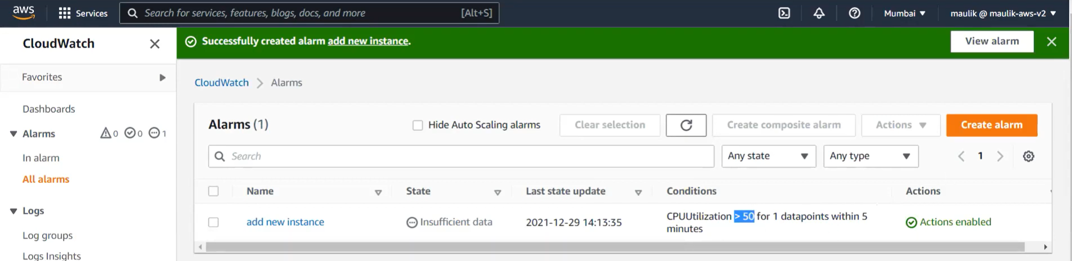

* You can select & click **‘Copy”** to copy this & create another Alarm for **Policy-2**

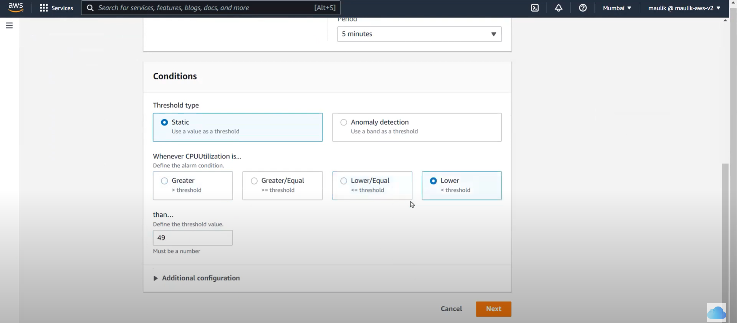 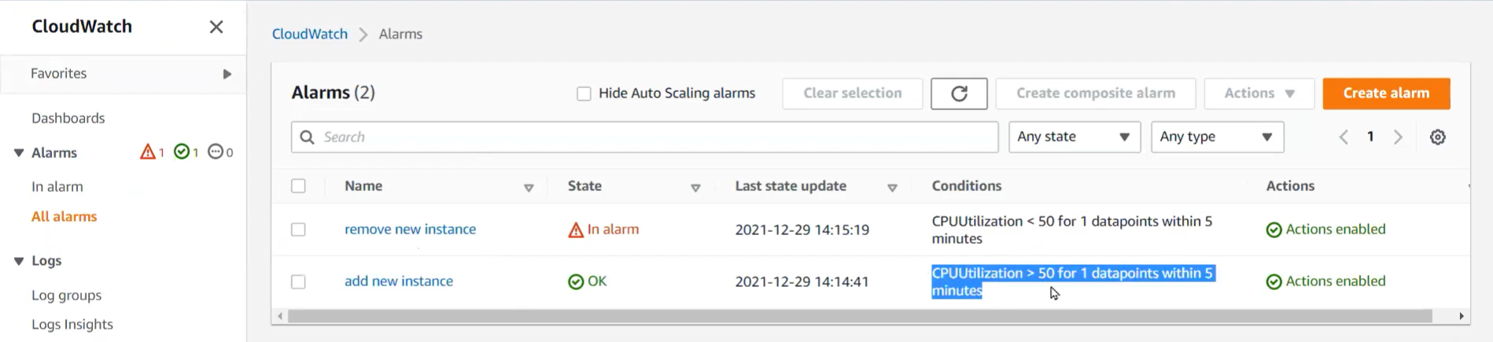

* If you go to our Auto-scaling group, we can find the alerts attached with respective scaling policies.

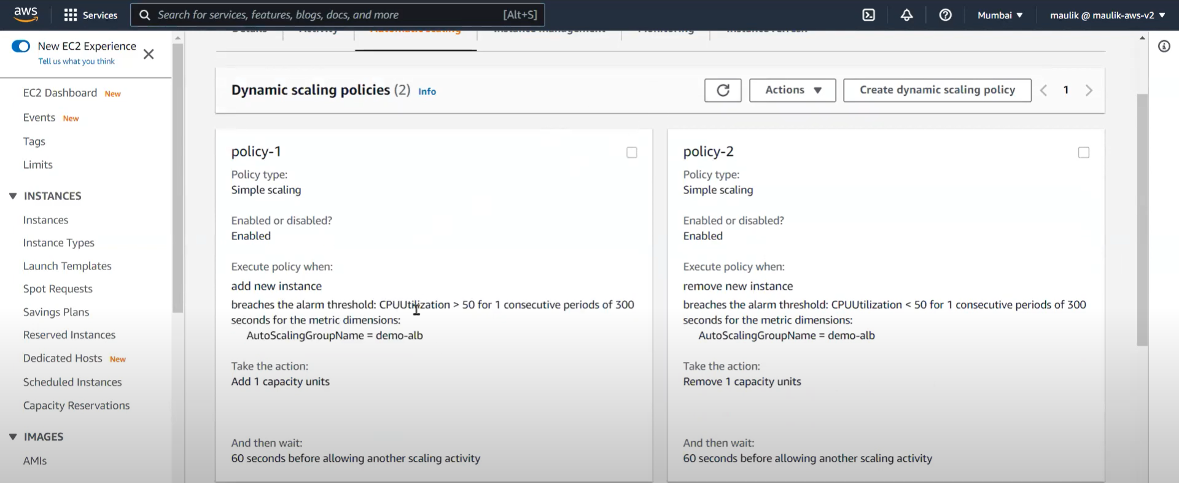

* To test this, install stress application in the Ec2 instance.

Cmd: Sudo amazon-linux-extras install epel -y

Sudo yum install stress -y

Stress –help

Stress –cpu 4 –timeout 180

# Amazon Elastic Container Service(ECS creation)

Amazon Elastic Container Service(ECS) is a highly scalable, faster container management service that makes it easy to run, stop & manage containers on a cluster. Your containers are defined in a task definition that you use to run individual tasks or tasks within a service. Amazon ECS enables you to launch and stop your container-based application by using simple API calls. You can also retrieve the state of your cluster from a centralized service & have access to many familiar Amazon EC2 features.

## Steps:

* Go to AWS🡪 Elastic Container Service🡪 Get started
* In Container definition, choose Sample App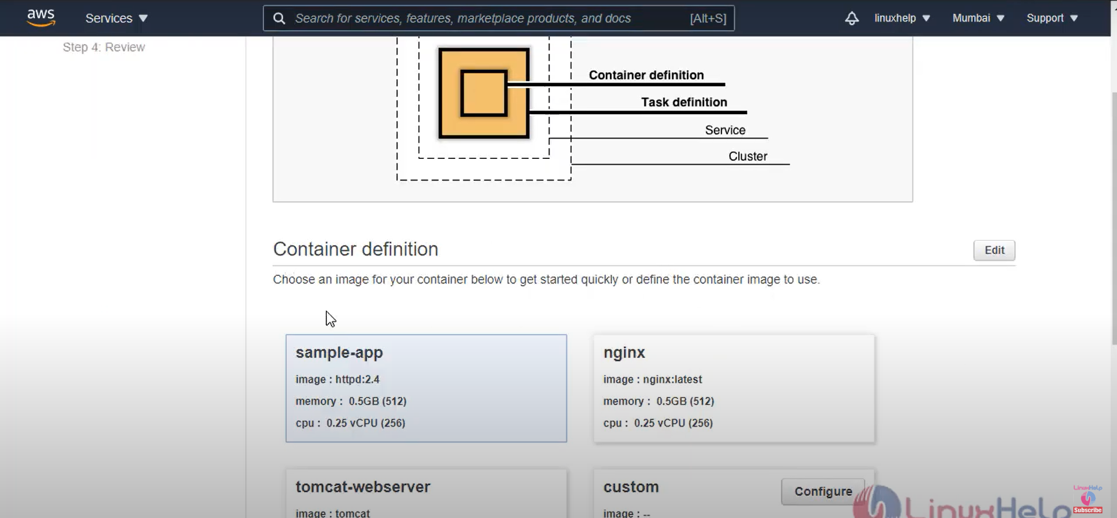
* Click Edit and Enter container name, you can also update memory limits, health check if required.

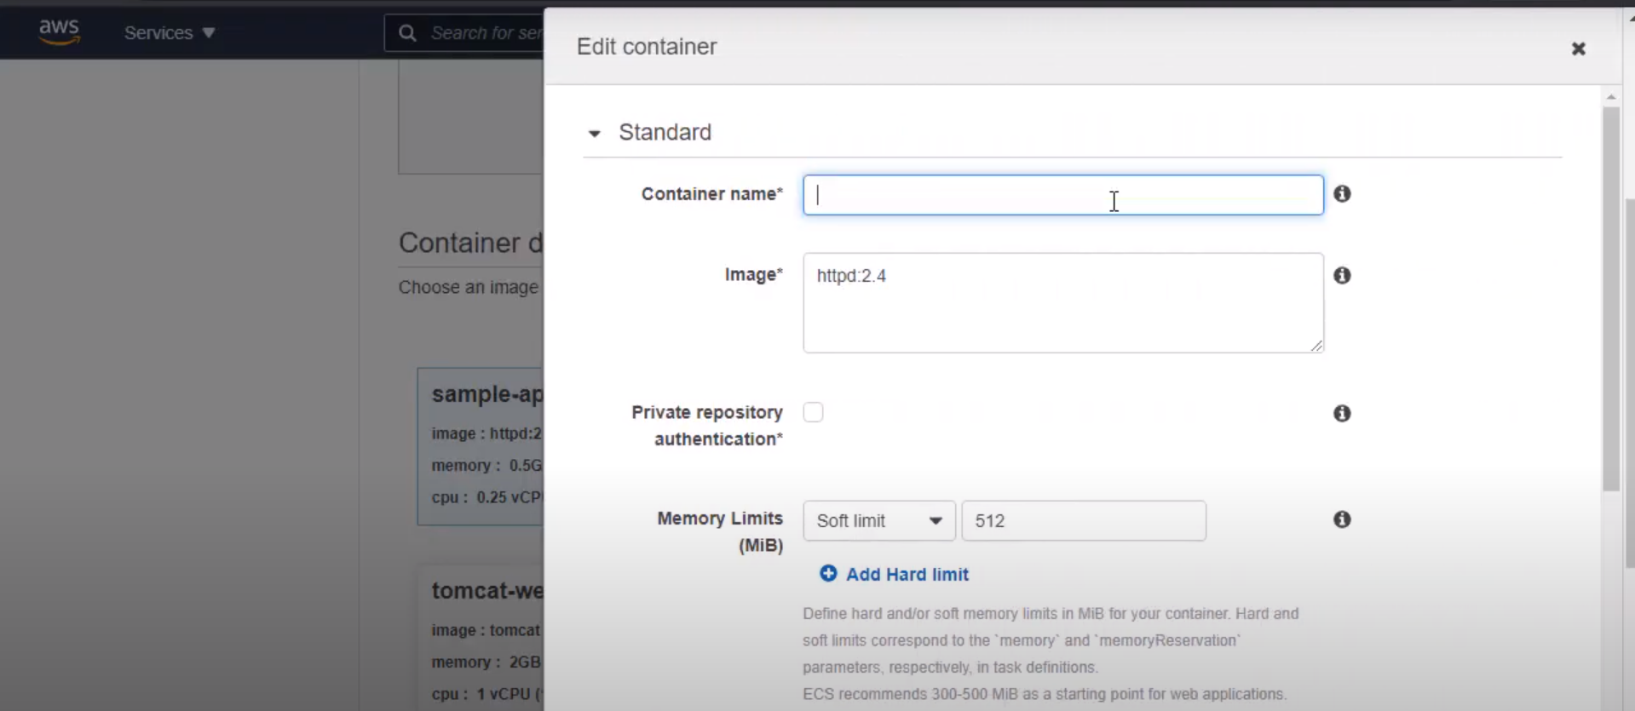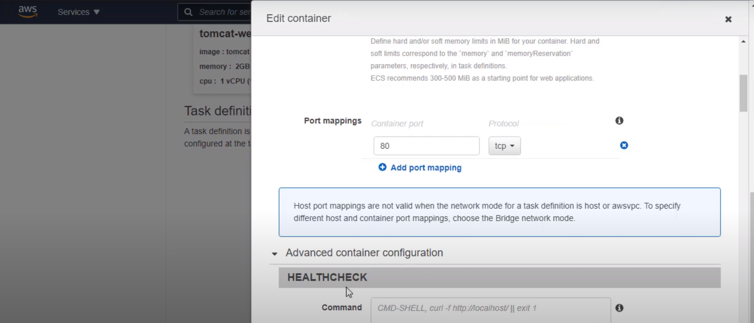

* In **Task definition**, you can update the Task memory & Task CPU & click Next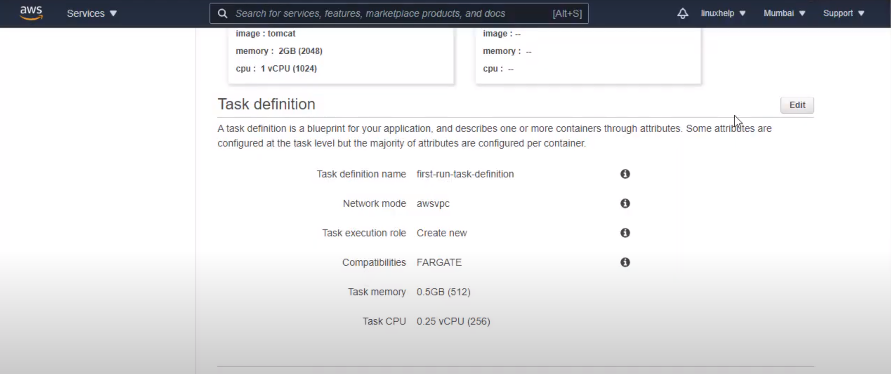
* In **Service definition**, you can enter Service name, Security group, Port range, ELB if required & then click Save.

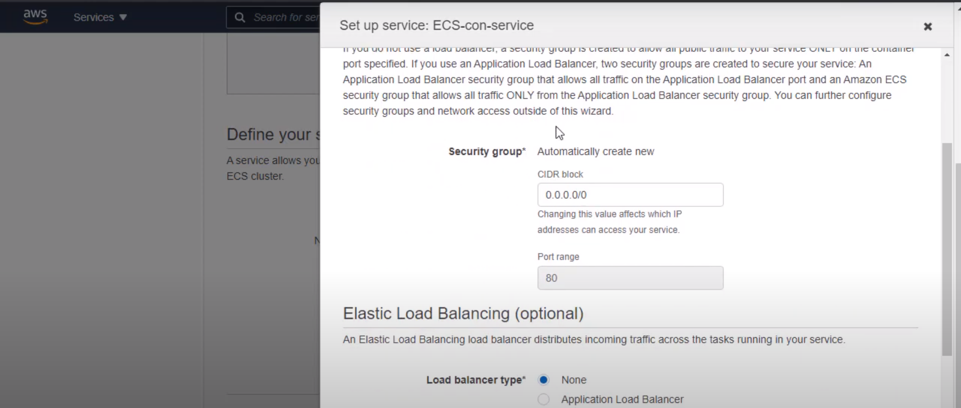

* In **Configure your cluster**, You can give your cluster name, VPC & Subnets if required and click Next

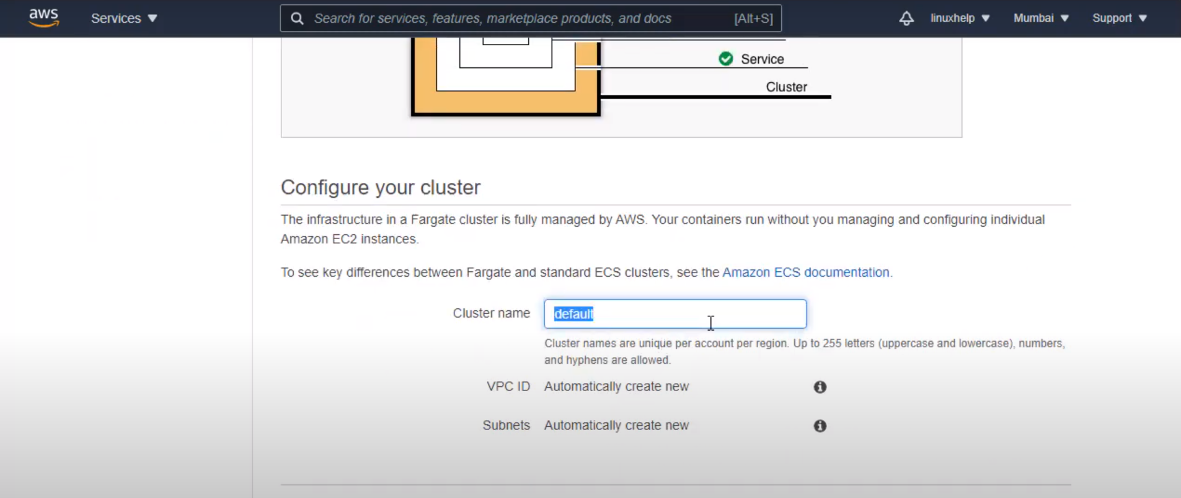

* You can review the configurations in the next screen & then click Create

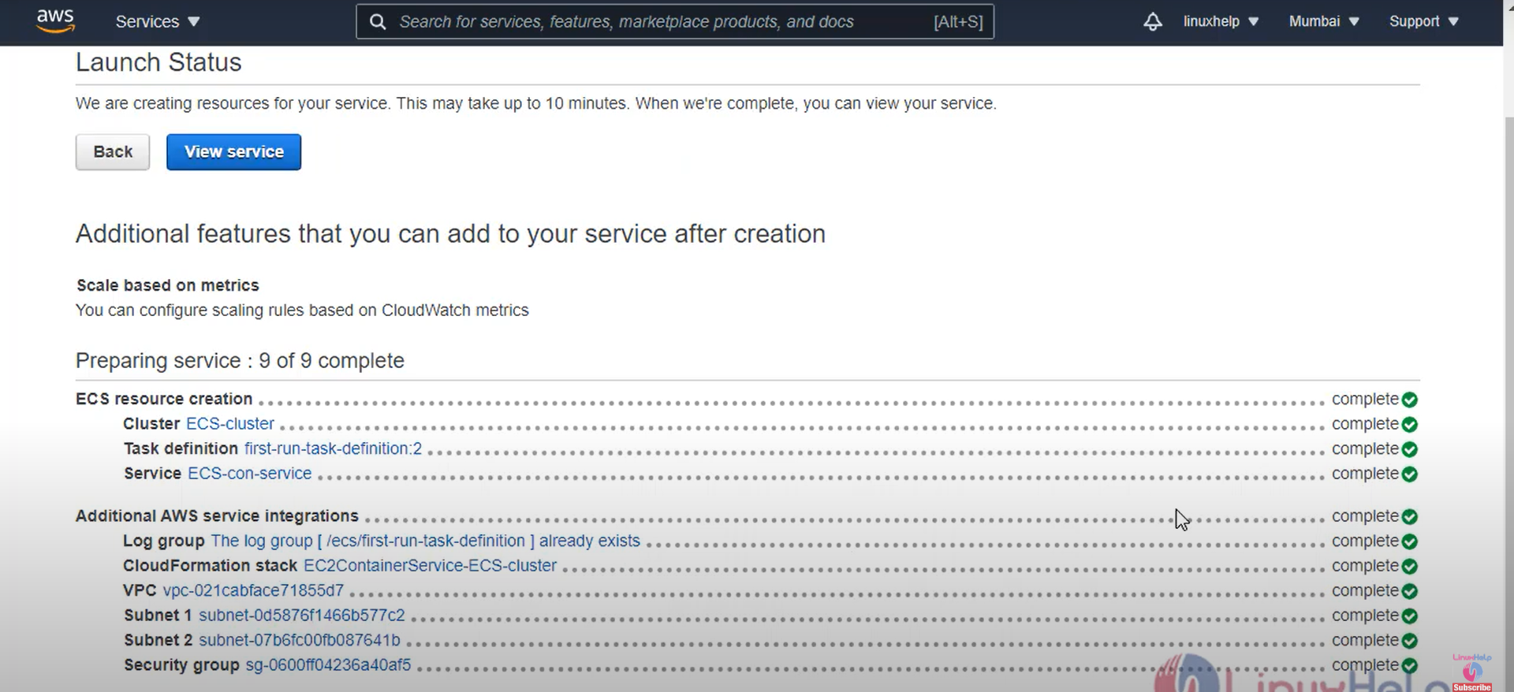

* Once the ECS Service is created, click **View service**

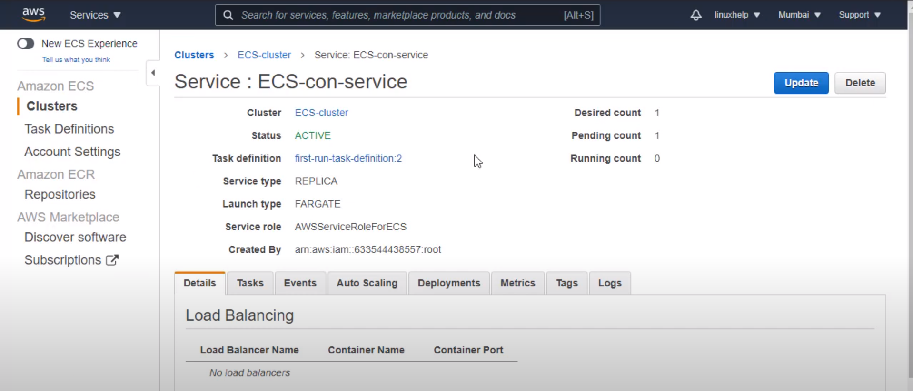

* Go to Tasks🡪 Select the Task definition created
* In selected task, go To Network🡪 Select ENI ID to open the network interface.

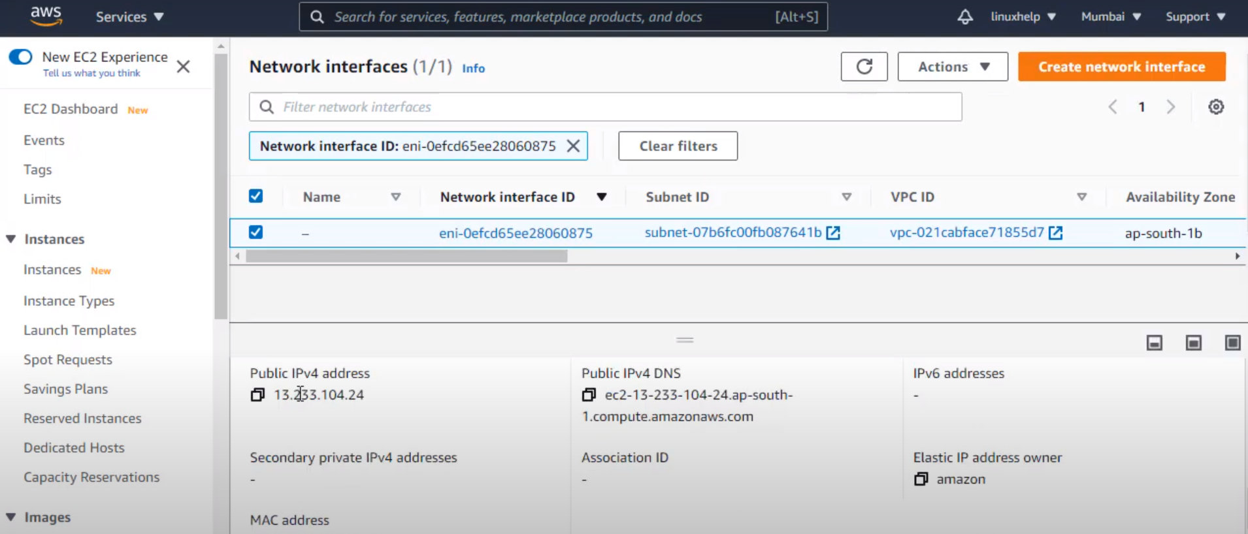

* Use the public IP to view the container running on web.
* To delete this configurations, delete the cluster and task definition created.

# AWS DEVOPS

## Code Commit:

Code Commit is the process used to store different formats of code/files in AWS repository. It is fully managed by AWS, Secured, has High availability.

### Steps:

### Step1: Create a New Repository

* Go to AWS Management Console and Search “Code Commit”
* Developer Tools🡪 Code Commit🡪 Repositories & click Create Repository.
* Enter Name & Tag(optional)

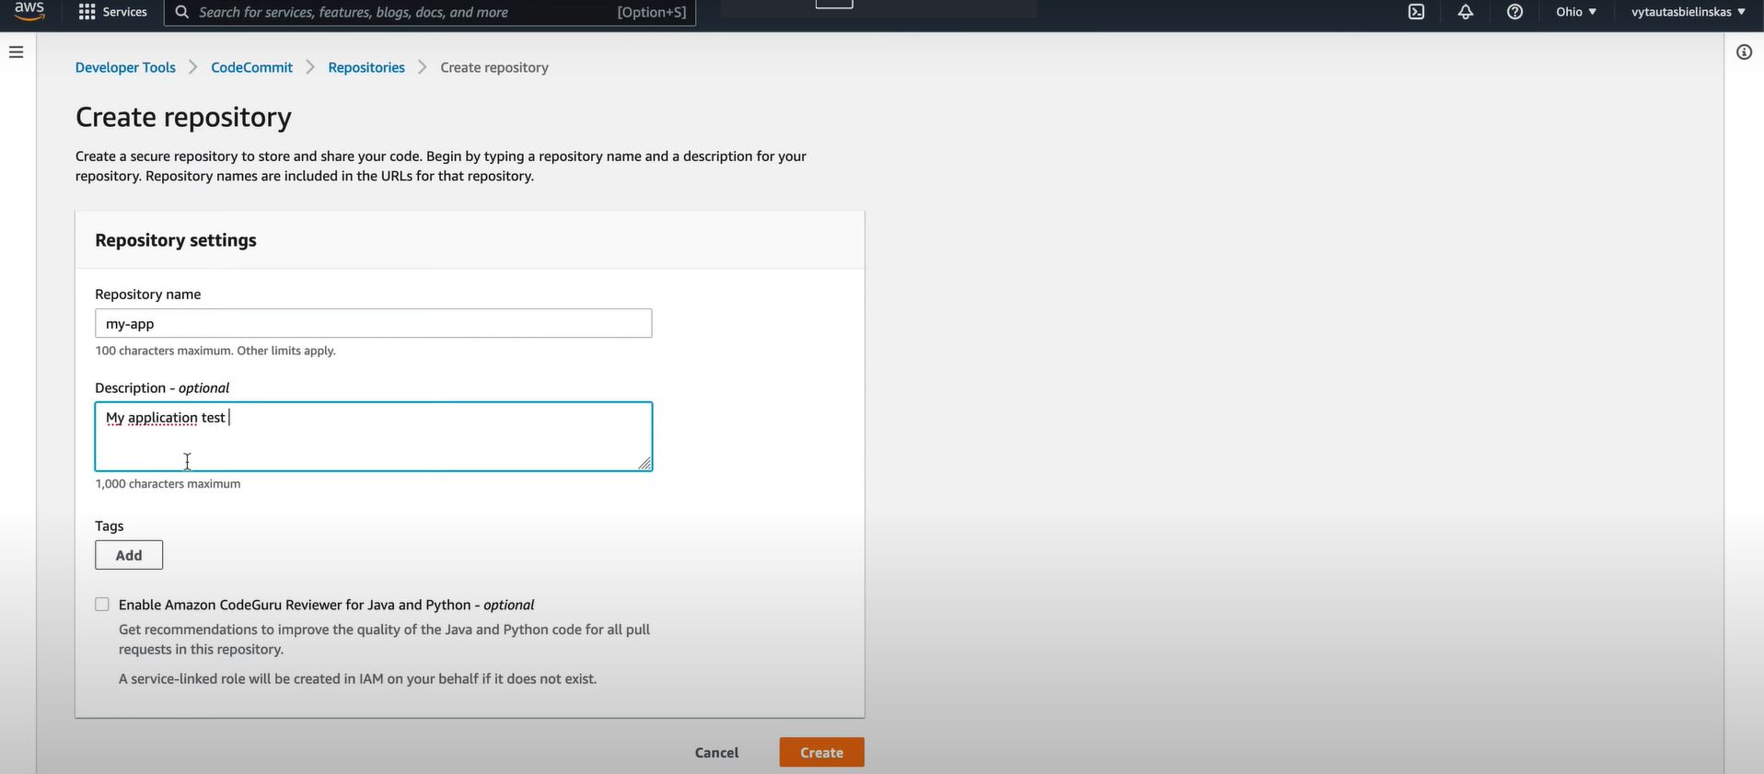

* You can select either HTTPS/SSH connection.  
  As root user, you cannot create SSH connection. To use SSH connection create a new user apart from Root user.

### Step2: Create a new user

* Go to IAM🡪User🡪 New User
* Enter User Name, Enable Access Key & Password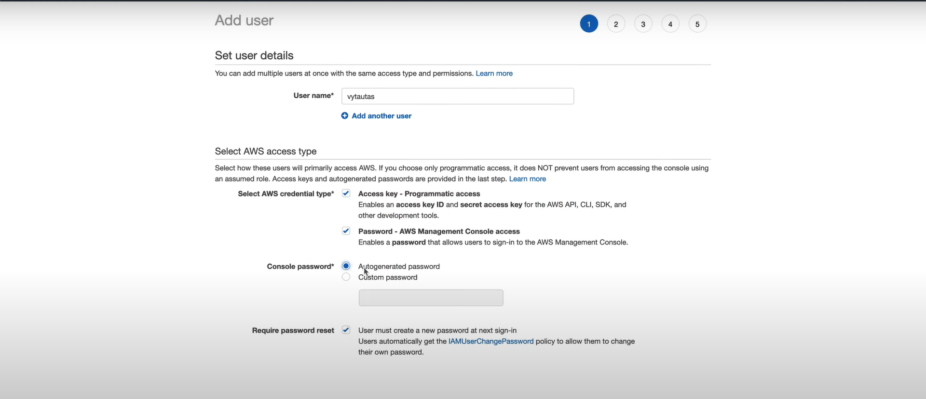
* In the Next screen, create a new group(IAM-codecommit) with Administration Access Policy attached & add the user to the group.

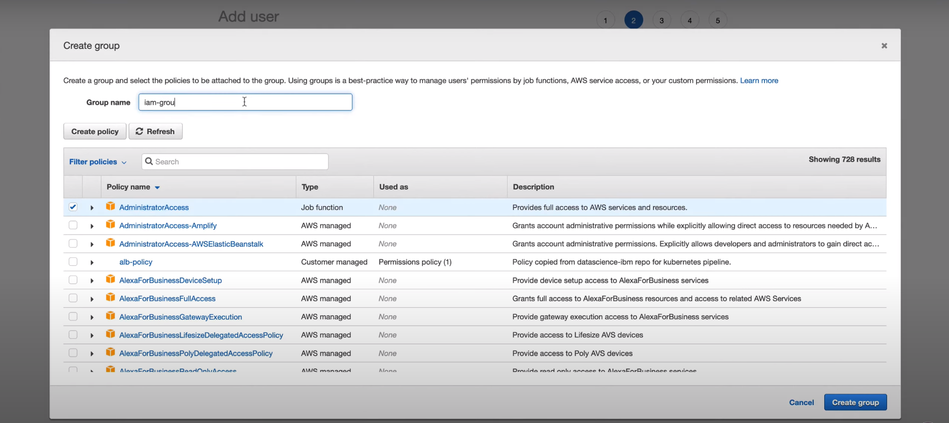

* Click Create User & download the Access Key & Password in .CSV format.
* Open the User created and go to Security credentials to generate the HTTPS Git credentials for CodeCommit. 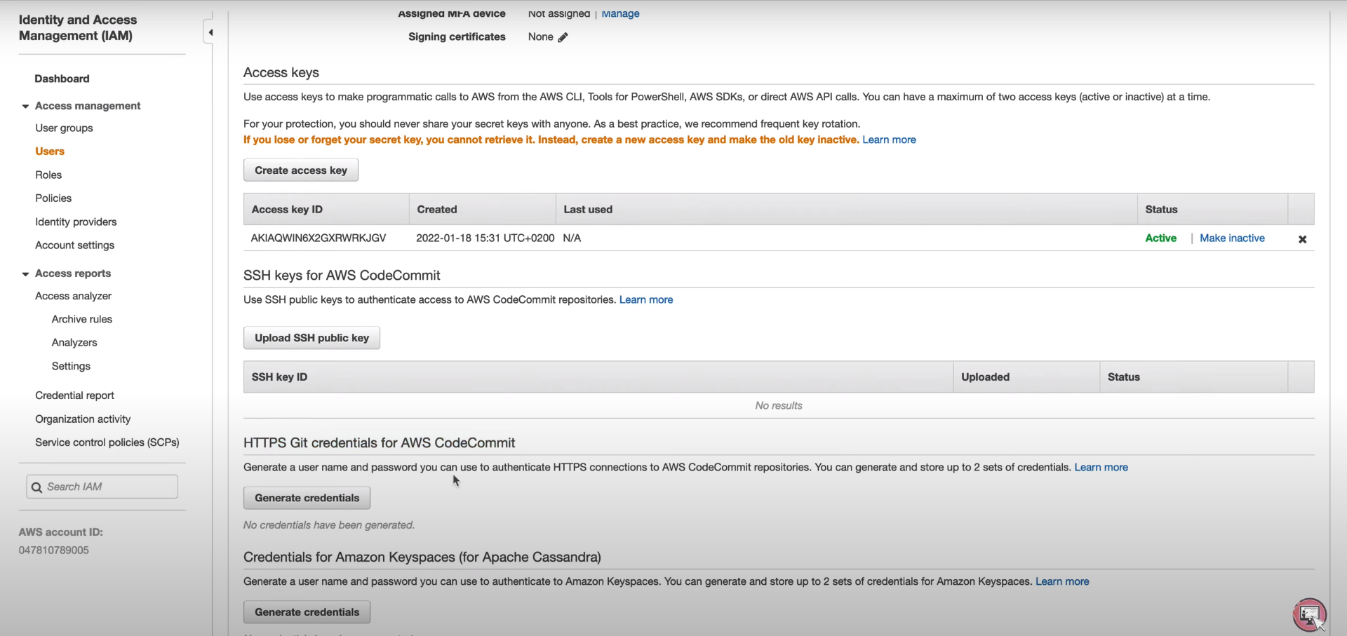
* Click Generate Credentials & download the same.

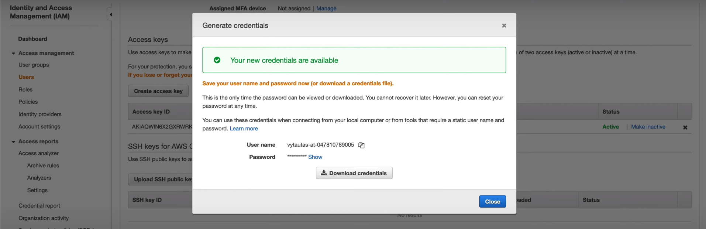

### Step3: Clone repository

* Go to the created Repository and click Clone URL🡪 Clone HTTPS & copy the HTTPS URL
* Open Linux CLI in the local system
* Cmd: git clone <https url>
* Give the Username & Password for Repository in Linux CLI when prompted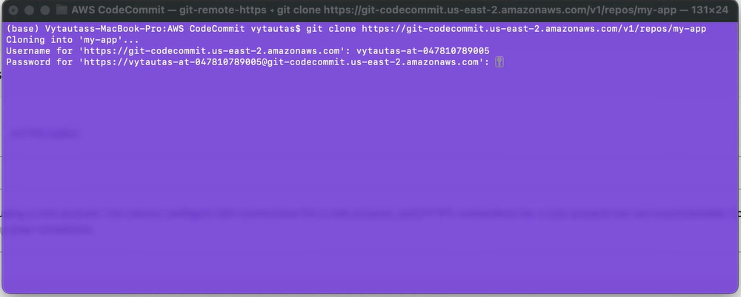
* Cmd: ls to view the cloned repository in Linux cli.

### Step4: Push to CodeCommit Repository

* Open the cloned repository, store some files/create some files
* Once the files are created/stored,   
  use cmd: git add .  
   git commit -m “files added to repository”

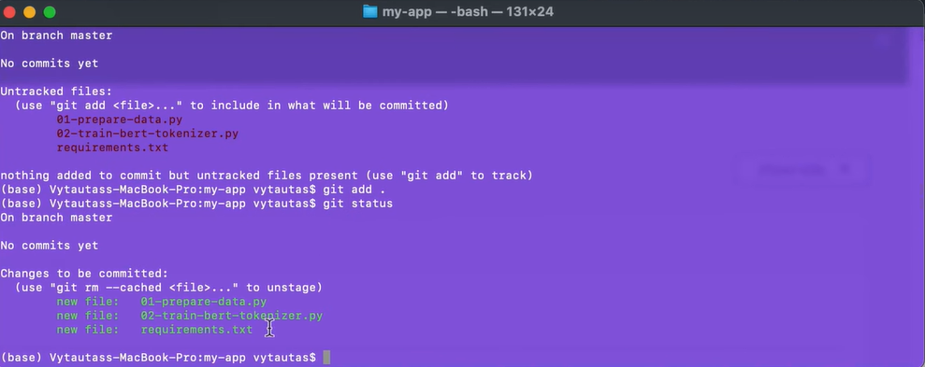

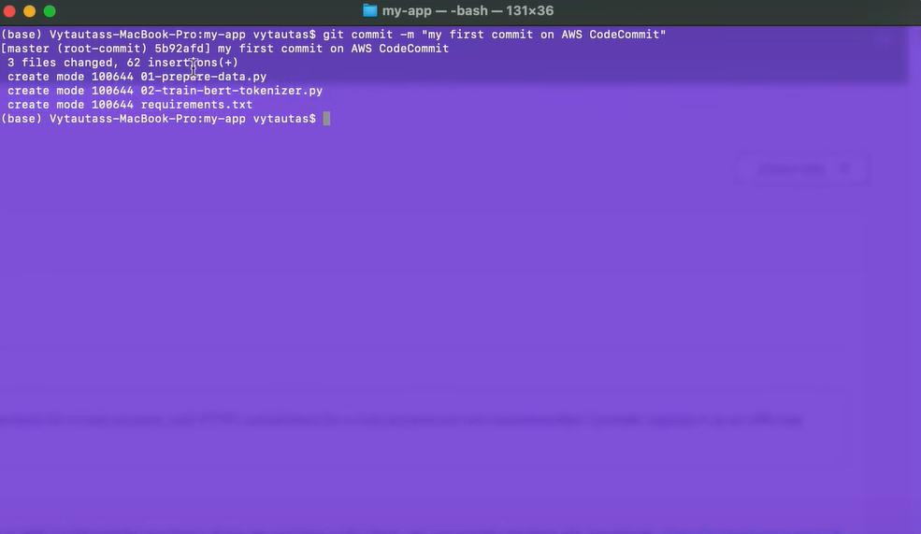

* Once the files are commited to Local repo, push it to AWS Repo using cmd: git push origin master/main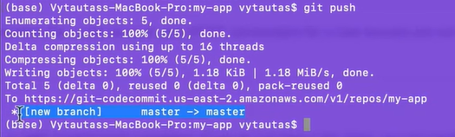
* If you view the AWS codecommit repo, you can see the files from Local system being pushed there. 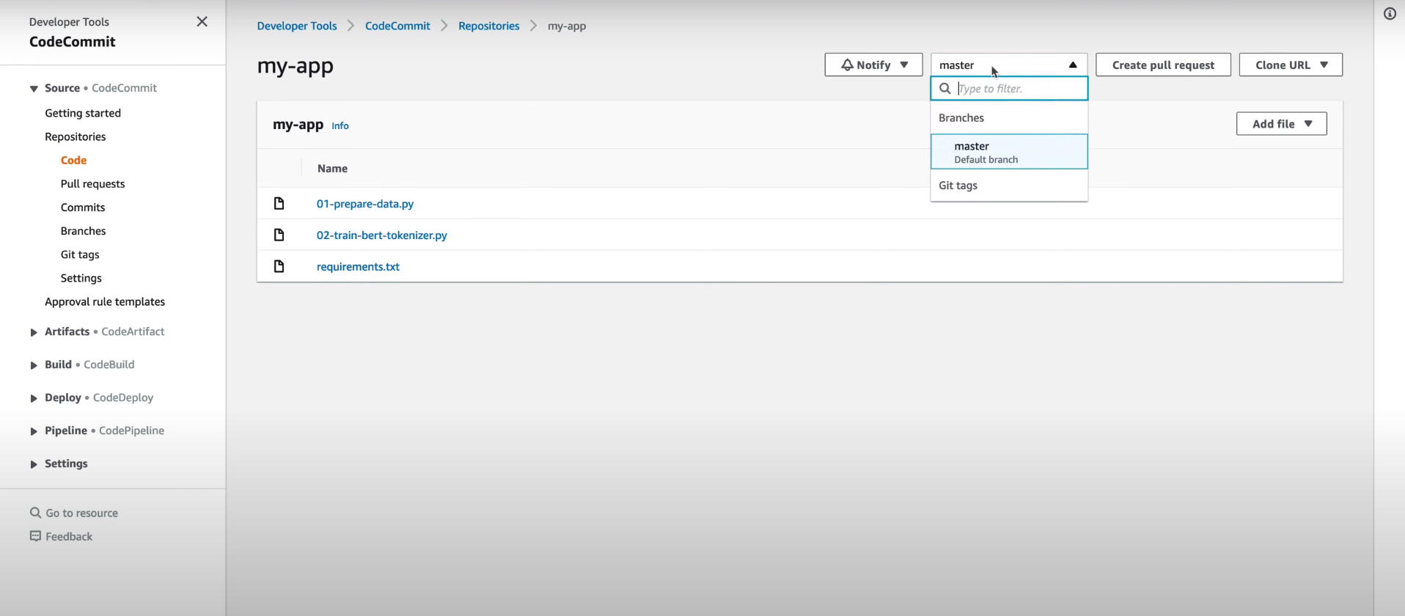
* Repeat step4 for every change you make in the local system/folder.

## Code Build :

Code Build is the AWS service which is used to build any code getting the code from Source repository and providing arifacts as output.

### Steps:

### Step1: Create Code Build Project

* Go to AWS Management Console and Search “Code Build”
* Developer Tools🡪 Code Build🡪 click Create Project.
* Enter Project Name & Description(optional)

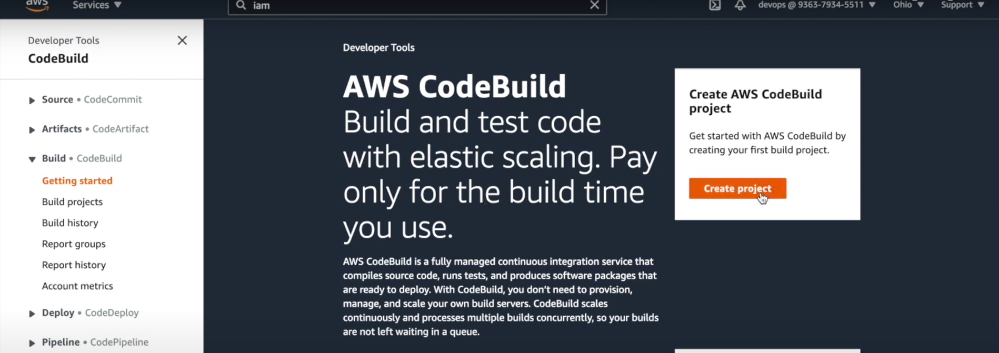

* Give Source as CodeCommit repository or any source code repository and provide the URL for the same.

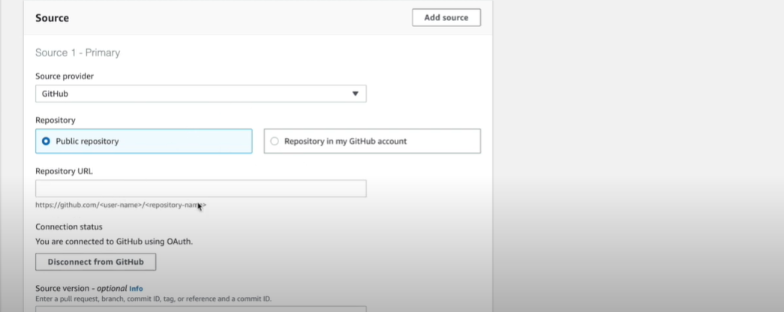

* Choose the Environment as Managed Image/Custom Image, Operating system as Amazon Linux, Runtime as Standard, Image as suggested.

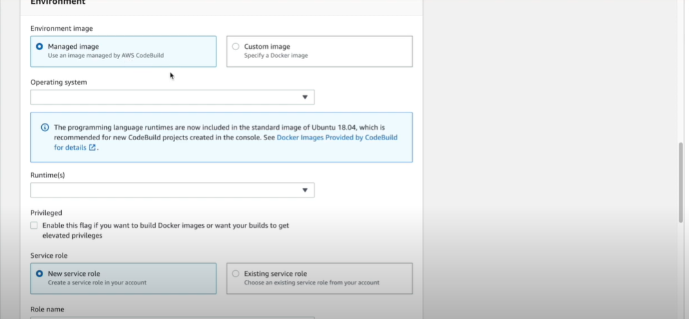

* Also, you can add new Service role/existing service role for this build action.

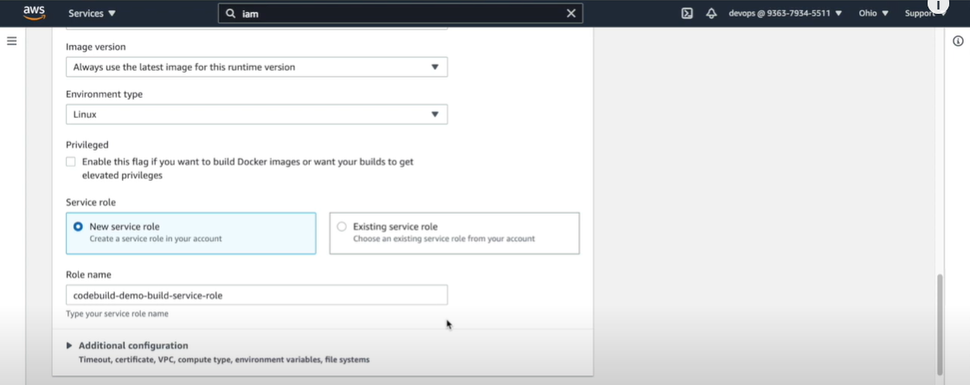

* You can also add BuildSpec file, this is similar to Dockerfile, you can specify details like how to build this project.

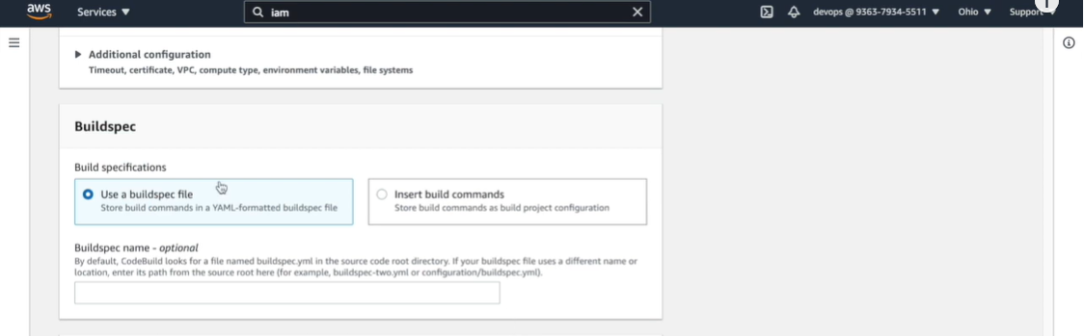

* + Build file has Pre-build & Build phase & also we can mention the files to be stored in the Artifacts section

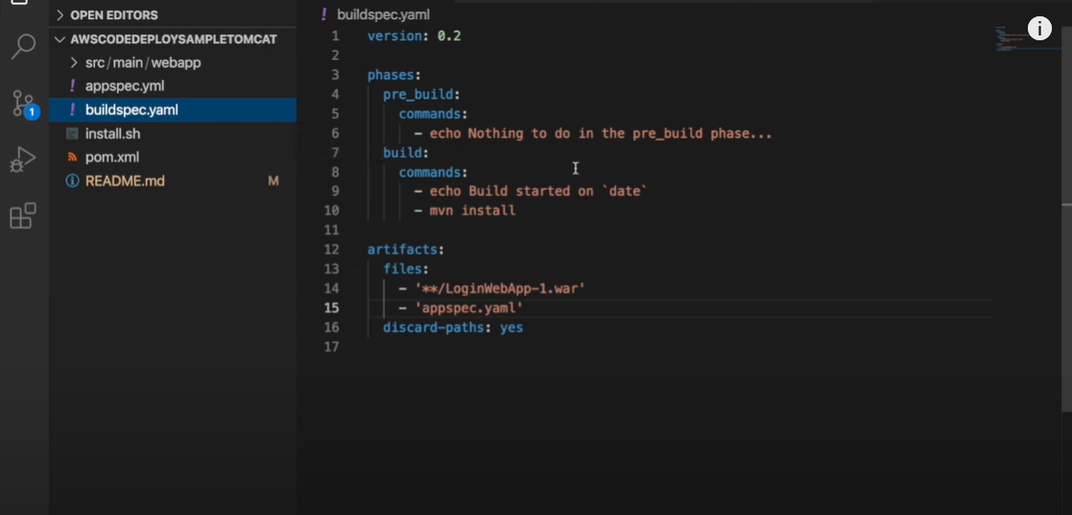

* We can the add Artifact type and where we want to store the Artifacts from the Code Build of this project.

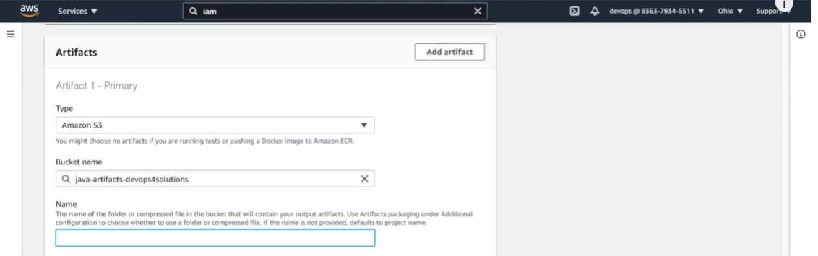 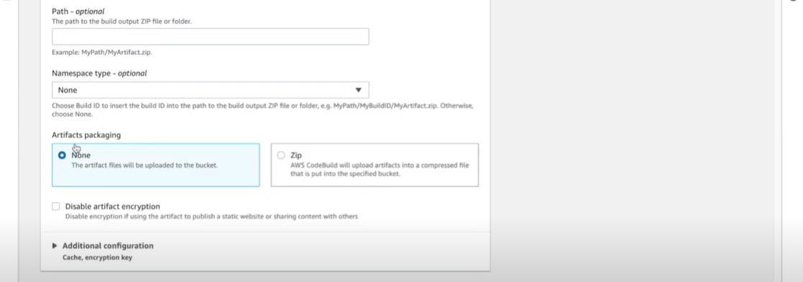

* Click Build Project

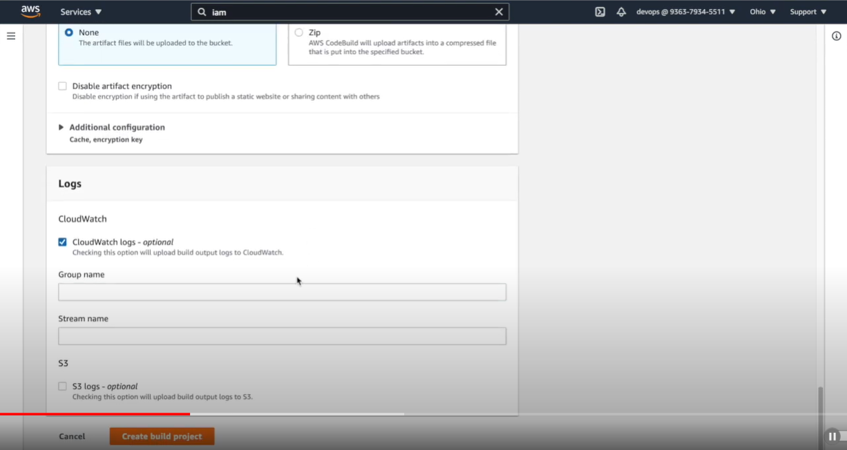

* Once the project is created, it will be added to the dashboard and has details like Source code repository, where to store artifacts.

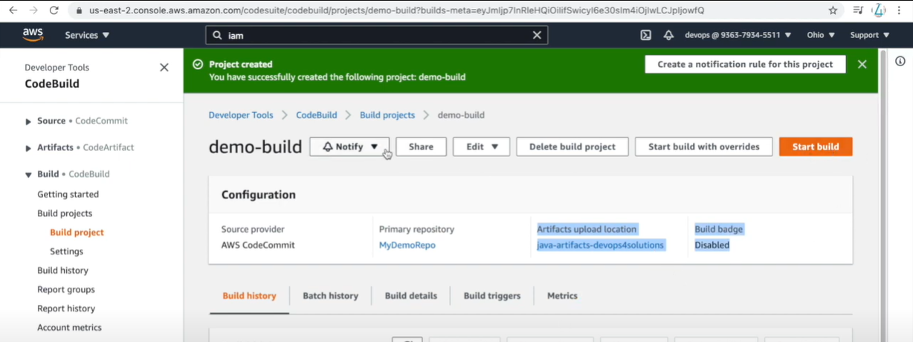

* Click on Start Build to initiate the build process.
* We can also use Notify for notifications, Edit for Editing configuration & Project, Build Logs to view the log for the project build.
* We can also view multiple builds of the project using Build History.

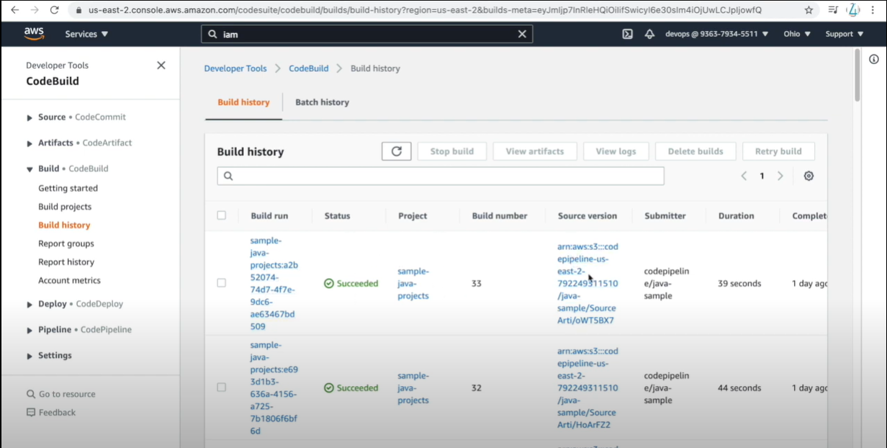

## Code Deploy

AWS CodeDeploy is a fully managed deployment service that automates software deployments to a variety of compute services such as Amazon EC2, AWS Fargate, AWS Lambda, and your on-premises servers.

CodeDeploy makes it easier for you to rapidly release new features, helps you avoid downtime during application deployment, and handles the complexity of updating your applications.

**Centralized control** - AWS CodeDeploy allows you to easily launch and track the status of your application deployments through AWS management console.

**Minimize downtime** - AWS CodeDeploy helps maximize your application availability during the software deployment process.

## Steps:

### Step1: Create IAM Role & Ec2 instances

* Create IAM roles for CodeDeployRole & EC2CodeDeploy and attach it to the EC2 Instances which we are creating for Code Deploy. Policies required:

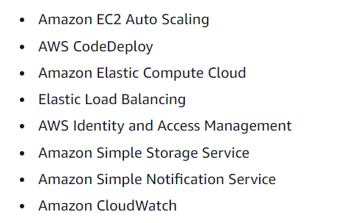

* User data:

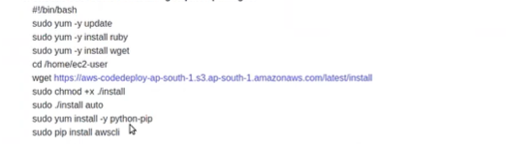

* Create New security group to expose port 80 (HTTP) for the Code Deployment instances

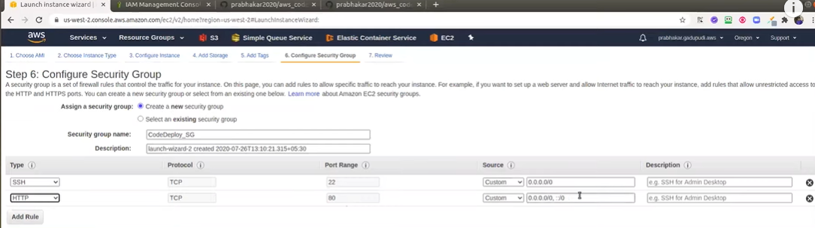

* Click Review & Launch Instance.

### Step2: Code Deploy Application

* Go to AWS Management Console and Search “Code Deploy”
* Developer Tools🡪 Code Deploy🡪 Applications🡪 Click Create Application
* Enter the Application name & Choose Platform as one of them(AWS Lambda, AWS ECS, AWS EC2) as required

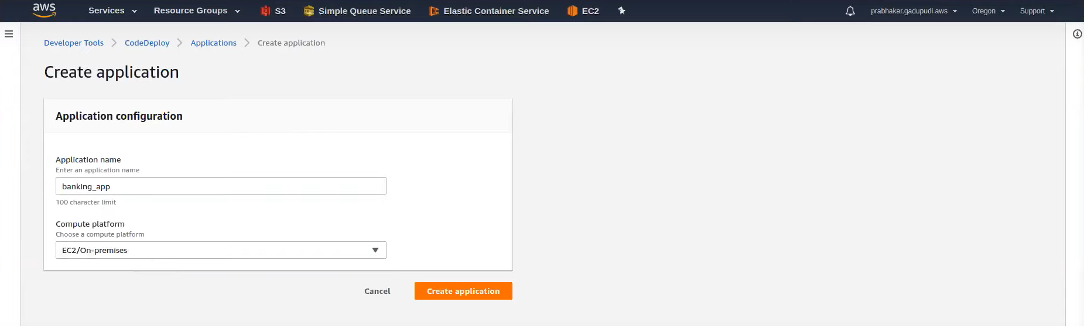

### Step3: Code Deploy: Deployment group creation

* Open the application created & click *Deployment group*
* Enter the Application deployment group name, Service Role as required (which is created to grant AWS codedeploy access to your target instances), Deployment Type as *In-Place*

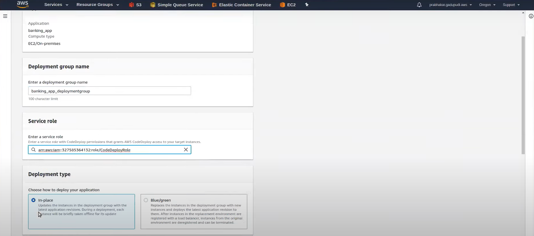

* In Environment Configuration, Choose *Amazon Ec2 Instances and* give the Tag as *Tag_name*(which is created for newly launched machines)

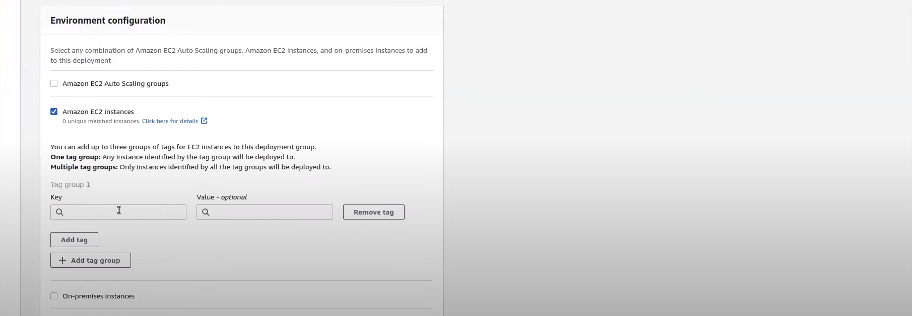

* In Deployment settings, choose *Deploy All At Once, Enable or Disable* ALB based on requirement & click *Create Deployment group*

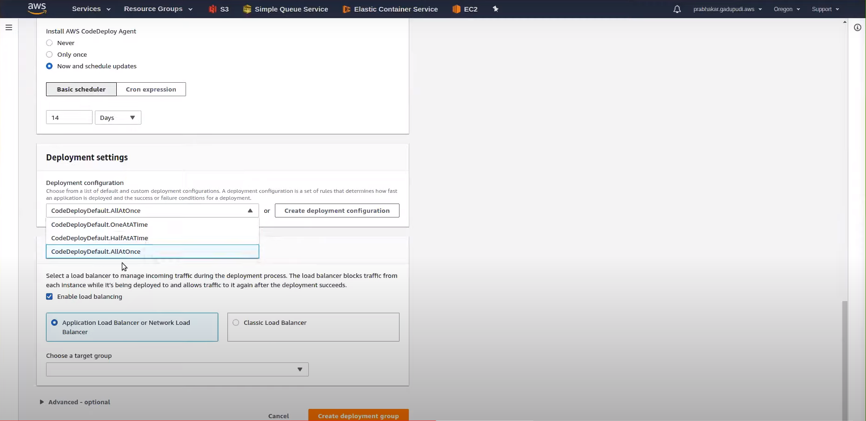

Code Deploy Setup is done

## Code Pipeline

AWS CodeDeploy is a fully managed pipeline service that automates application build, deployment using other AWS services like CodeCommit, CodeBuild, CodeDeploy

## Steps:

### Step1: Create Code Pipeline

* Go to AWS Management Console and Search “Code Pipeline”
* Developer Tools🡪 Code Pipeline🡪 Pipelines🡪 Click Create New pipeline
* Enter the Pipeline name as *Name,*  Service role as *New Service Role,* Artifact store as *Default*  & Encryption key as *Default &* click *Next*

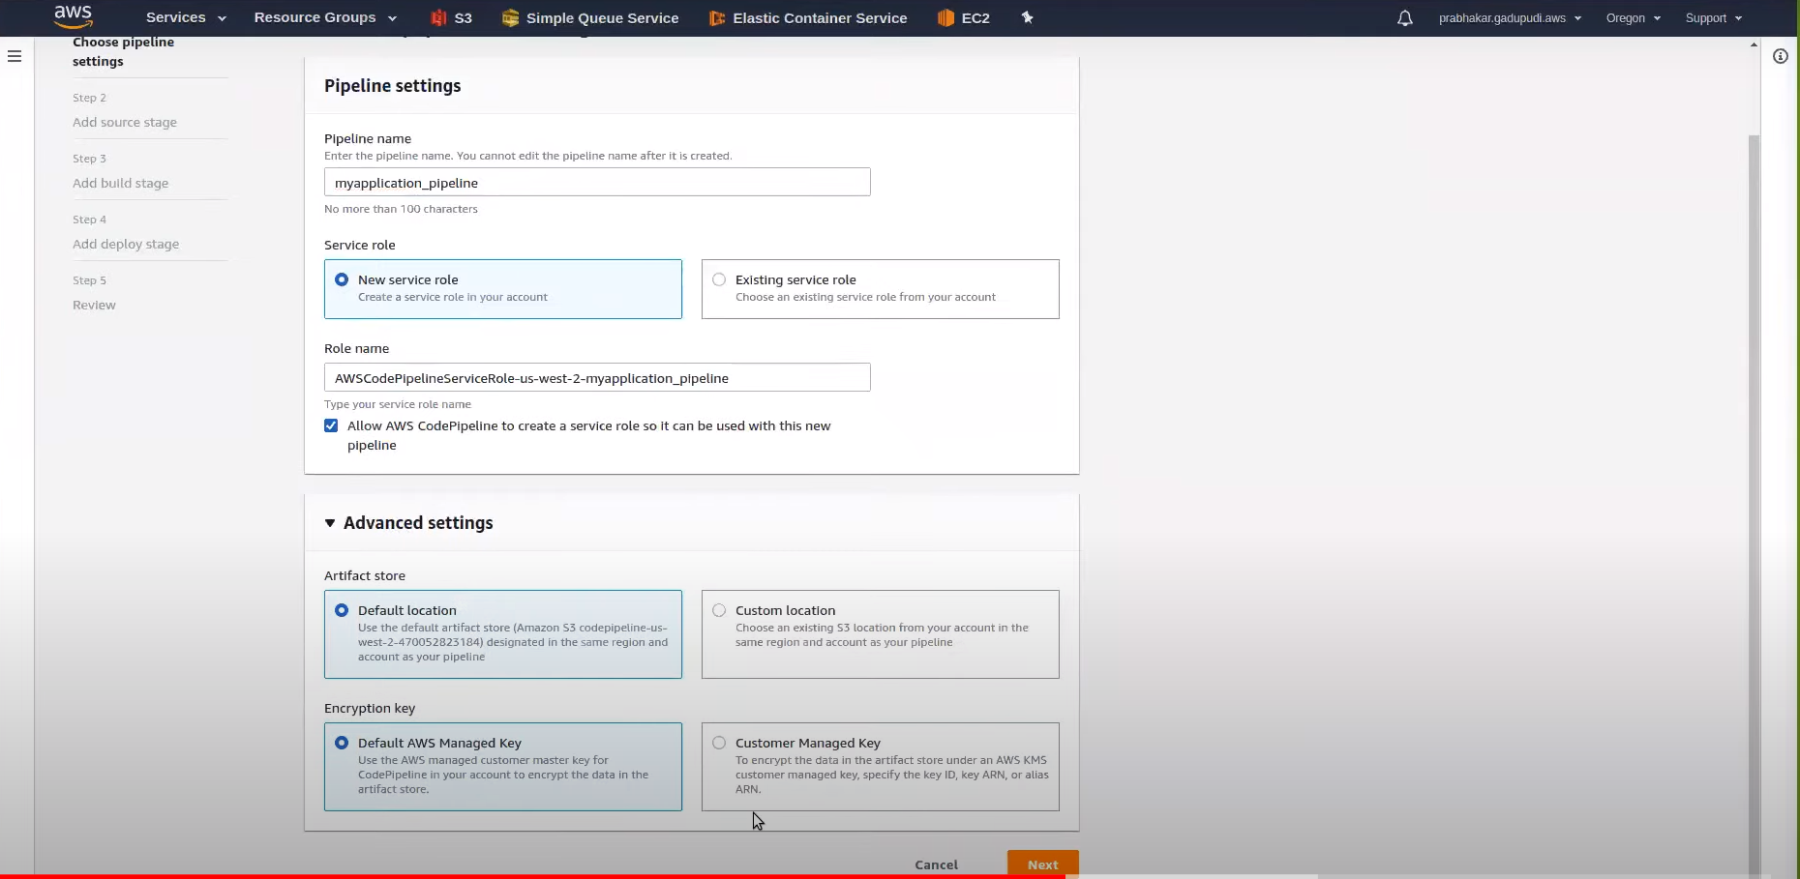

### Step2: Source Stage

* Enter Source Provider as *Github,* Enable *Github connection,* Repository as *public_github_repository,* Branch as *Master,* then click  *Next*

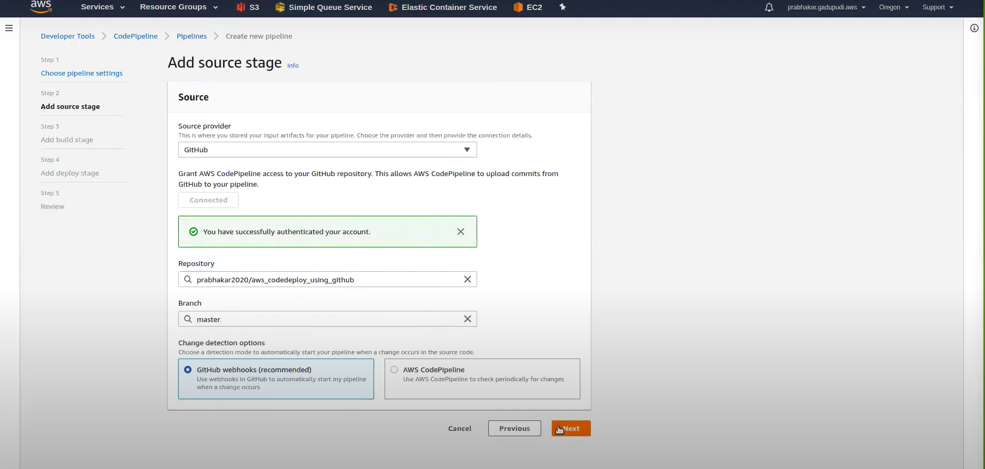

### Step3: Build Stage

* If Project doesn’t need build, you can ignore Build or choose between *Code Build or Jenkins*

### Step4: Deploy Stage

* In Deploy stage, choose Deploy Provider as *AWS CodeDeploy,* Region as *required,* Application name as *application_name,*  Deployment group as *Deployment group.*

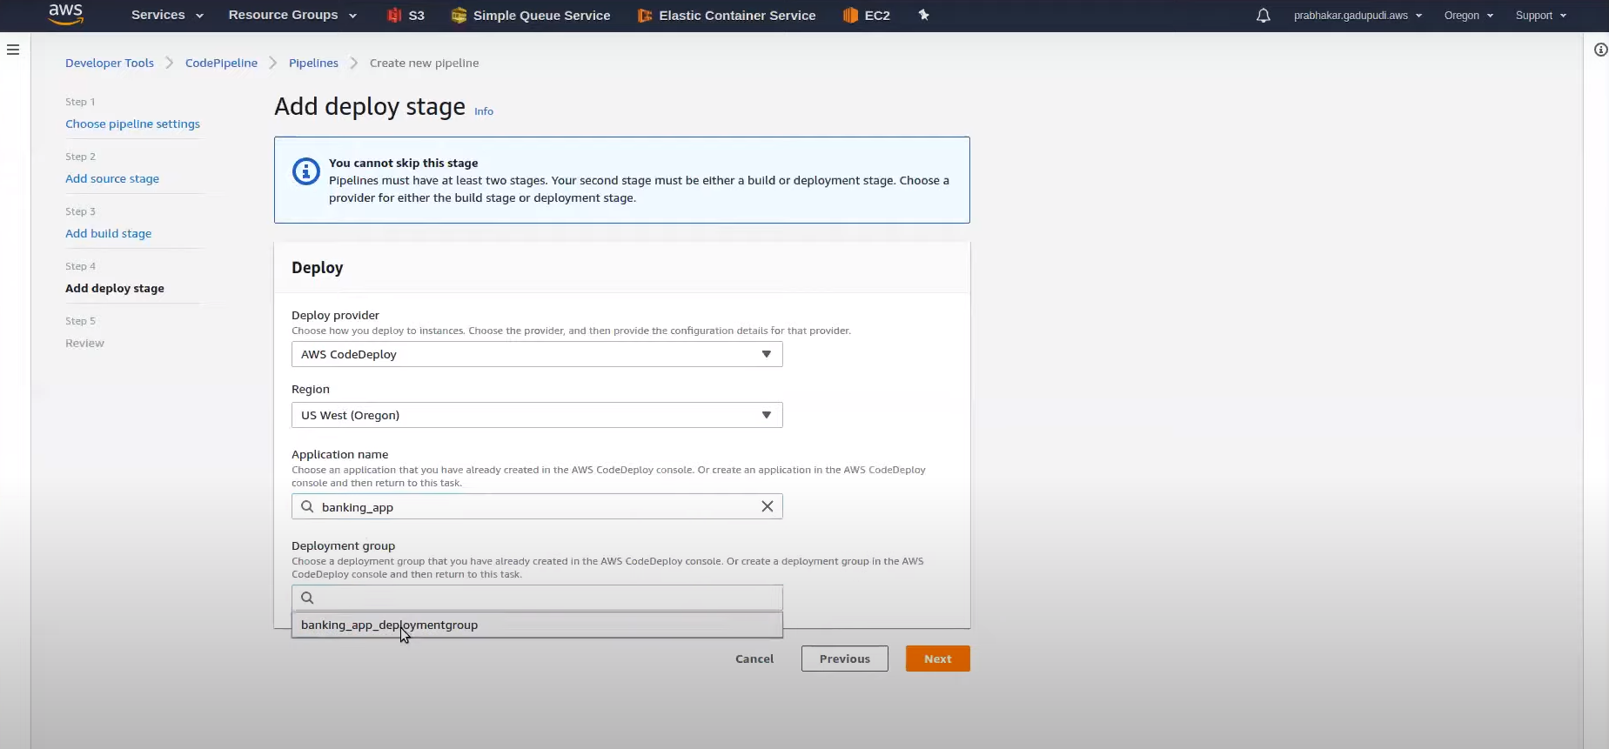

* Then click create Pipeline & Execute

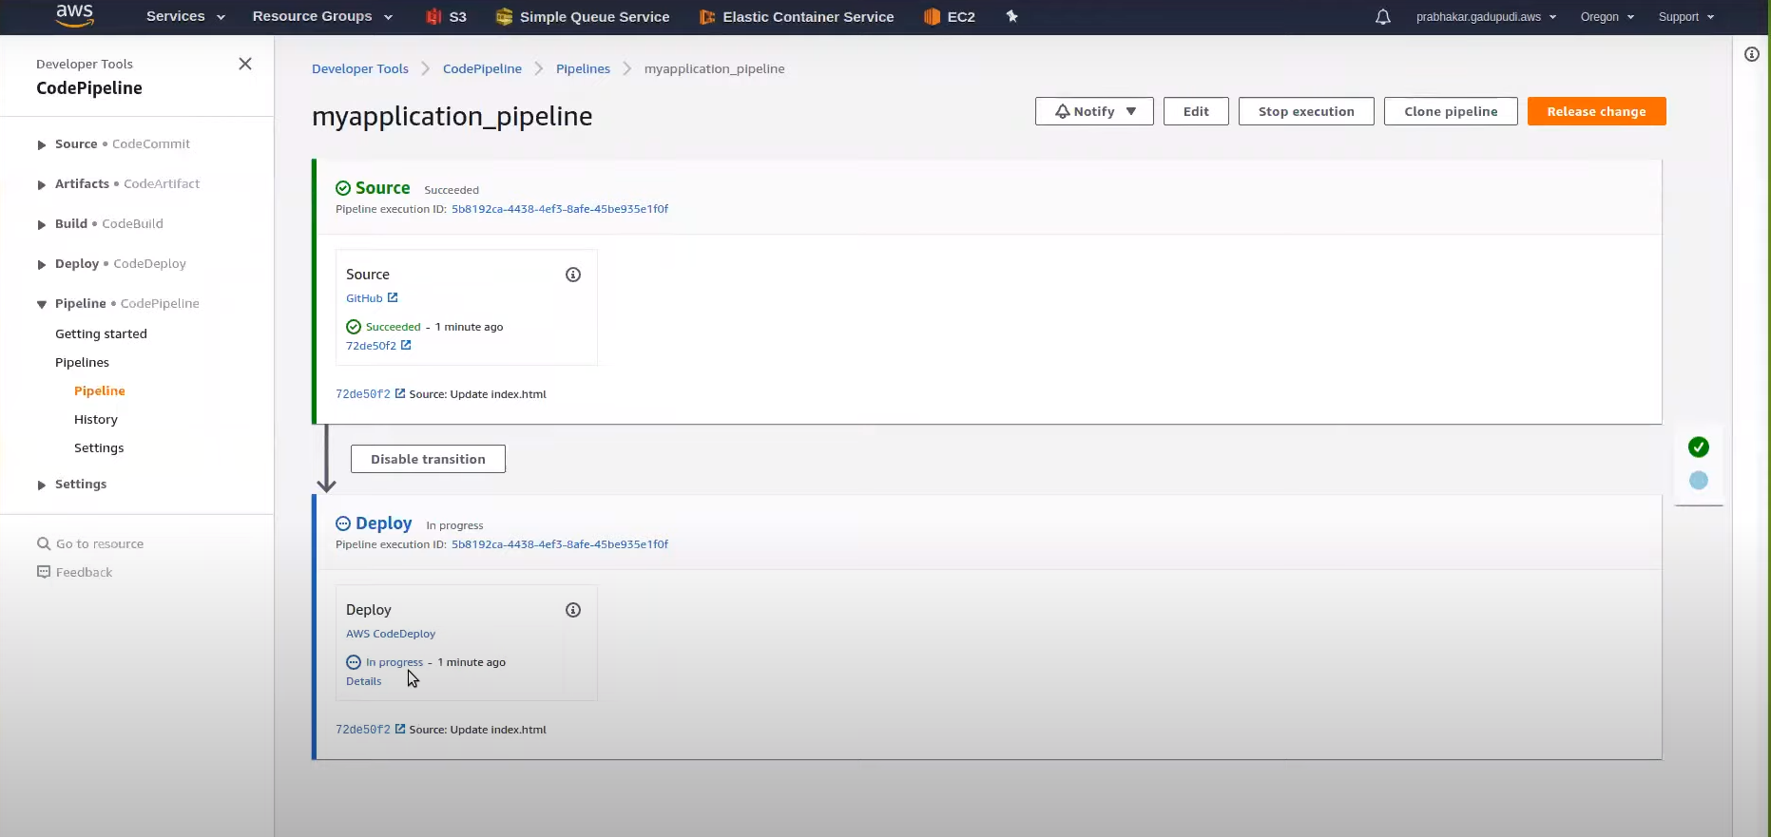

*Note: Since we didn’t have a build stage, make sure that all the dependencies are already in the Instances created for easy deployment.*